Brabin’s Endowed Primary School

BEHAVIOUR POLICY

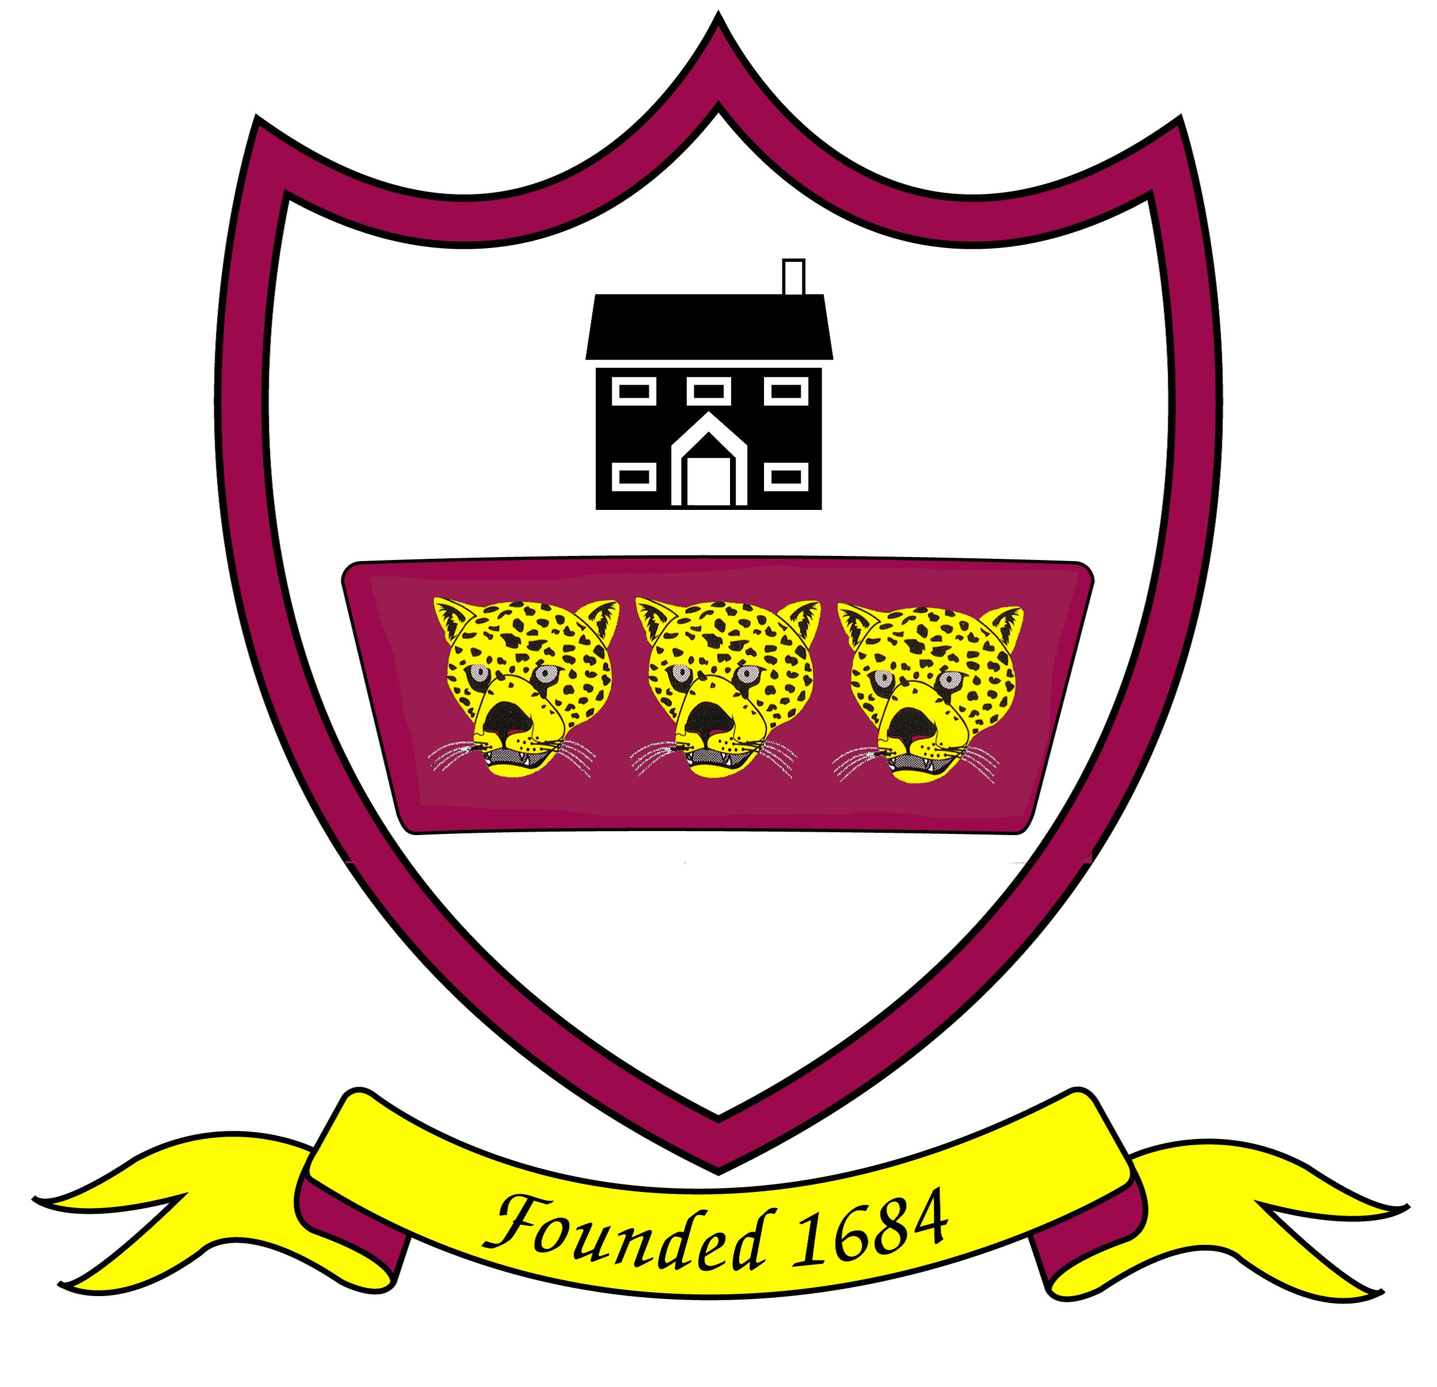

September 2025

“Love one another as I have loved you.”
John 15:12

At Brabin’s we are more than friends- we love and value one another as part of God’s family. We respect each other and strive to achieve our best when we are learning and in all we do.

OUR AIMS AND EXPECTATIONS
The happiness and the wellbeing of our children underpins everything we do. We understand that when children feel happy, safe, listened to and respected then they make progress with their learning. All school staff, parents and carers, and children are expected to maintain the highest standards of positive behaviour, to accept responsibility for their conduct and encourage others to do the same. When we work together to do this everyone can achieve excellence, love learning and feel they belong at our school.
The school’s Behaviour Policy is therefore designed to support the way in which all members of the school can live and work together in a supportive way. It aims to promote an environment where everyone feels happy, safe and secure and where expectations are high.
We believe that a child’s behaviour is of great importance and it is one of our chief aims to see strong Christian character formed in our children.

Our aims at Brabin’s Endowed Primary School are to:
- Teach positive behaviour, self-regulation, self-discipline to enable personal development
- Provide a safe, comfortable and caring environment for optimal learning to take place
- Use a visibly consistent and calm approach and language across the school
- Ensure all adults take responsibility for managing behaviour and follow up incidents personally
- Encourage children to care for each other
- Develop strategies to detect, prevent and react to bullying among pupils and staff
- Recognise the crucial role of parents/carers in the education process and aim to provide mutually supportive conditions for home/school links.
- To develop the pupils physical, mental, social, and spiritual growth and help them grow in the understanding of Christian teaching.

To achieve this, all members of Brabin’s Endowed Primary School must adhere to the simple rules of being:
‘Ready, Respectful and Safe.’

SCHOOL RULES

A clear structure of predictable outcomes will have the best impact on behaviour. This policy sets out the rules, relentless routines and visible consistencies that all children, families and staff must follow. Brabin’s Endowed Primary School has three simple rules: Ready, Respectful and Safe, which can be applied to anybody, in a variety of situations, are easy to remember, and are taught explicitly. Our three rules are based on the work of educator Paul Dix and his book, ‘When the Adults Change, Everything Changes’. Dix writes, ‘Visible consistency with visible kindness allows exceptional behaviour to flourish.’ This is in line with our school ethos and values.
Below are examples (not exhaustive) of what children being ready, respectful and safe might look like.
Ready | Respectful | Safe
Sitting tall, facing the speaker, listening and thinking.  Following instructions and tracking the teacher.  Keeping hands and feet in own space.  Using equipment as guided by adults.  Following the rules of a game.  Putting in 100% effort. | Being polite to everyone.  Taking turns to speak and listen.  Considering how other people feel - being kind.  Taking care of the school and its equipment.  Playing co-operatively and sharing.  Valuing each other’s work and contributions.  Telling the truth and listening to other people’s perspectives.  Accepting a solution or consequence without arguing.  Seeing an apology as a signal someone has learnt and reflected on their behaviour and wants to repair. | Using kind words that make others feel safe.  Gentle hands, gentle feet. Wonderful walking!  Following adult instructions. Staying in the classroom/playground as guided by adults.  Using equipment gently and as intended.  Reporting any damage noticed around the school.  Taking responsibility for their own behaviour and planning how to repair when things have gone wrong.

Alongside the ‘Ready, Respect, Safe’ rules. The whole school has written ‘The Brabin’s Promise’ which reflects on the school ethos and has been drawn up by the staff and pupils. (See Appendix A).
Discussion with children takes place in worship and classes to ensure children understand and take ownership of these rules. Consequences of breaking the rules will also be established with the children. The school rules (Brabin’s Promise and Ready, Respect and Safe) will be displayed around school and in each classroom as a constant reminder; e.g. misbehaviour can be interrupted by asking the child which rule is being broken, requiring the child to think and respond rather than just stop misbehaving - thus encouraging self-discipline.

Our Behaviour Policy is not primarily concerned with rule enforcement; it is a means of promoting good relationships, so that people can work together with the common purpose of helping everyone to learn. We treat all children fairly and apply this policy in a consistent way.
Our school will work with the Church and other partners to provide a Christian environment where all are:-
- Secure, valued and cared for by all other members of the community
- Confident in voicing concerns, raising questions and exploring and confirming values and beliefs
- Listened to with respect
- Appropriately supported
- Safe from bullying and discrimination in a community that respects and cares for others

The school rewards good behaviour as it believes that this will develop an ethos of kindness, cooperation and service. This policy is designed to promote good relationships, rather than merely deter anti-social behaviour. Good behaviour, healthy relationships and discipline are essential to an orderly working atmosphere where effective learning and teaching can take place.
The Behaviour Policy should be clearly understood by all members of the school community: – pupils, parents, governors, teaching and non-teaching staff.
The Behaviour Policy will offer support systems for staff who, in turn, have a responsibility in setting a good example to children and in contributing to the support systems if they are to succeed. Parents should be involved in all aspects of a child’s development and they should be notified at an early stage if a child is having behaviour and relationships difficulties. Good behaviour as well as wrong choices should be drawn to parents’ attention.

THE ROLE OF STAFF
School adults must strive to know the children extremely well and to relentlessly develop positive relationships and mutual respect with all of the children and adults in the school community. This requires deliberate engagement with children to ensure they feel valued. It enables adults to follow up on negative behaviour with genuine care. It’s important that families work together with school staff, reinforcing the same messages, and showing the same respect for our rules and staff. We tell parents and carers about progress and achievement academically, socially and with behaviour; we do this regularly and rigorously. This might be a quick chat at the classroom door, a phone call home, or a postcard with a written note. Again, any member of staff can and should be part of this. At Brabin’s we use children’s names, rather than ‘love’ or ‘sweetheart’, and we expect them to use our names respectfully too e.g. ‘Good morning, Natalie.’ We know that the children want school staff who are fair, consistent, kind, and who show unconditional care and compassion. Each lesson is a fresh start. What is excellence recognition?
The use of praise and positive encouragement is the best way to promote positive behaviour. Praise should be specific and the child should always know why they are being praised e.g. ‘Excellent effort with your writing today! That is really above and beyond!’ NOT just ‘Good boy.’ This helps to foster a growth-mindset where children are praised for their effort and progress.
How we teach positive behaviour and our wellbeing curriculum
Developing emotional literacy through our wellbeing curriculum goes hand in hand with achieving positive behaviour at Brabin’s. Each week we teach wellbeing lessons, which include the National Curriculum for PSHE (personal, social, health and economic education) with the aim not only to teach children strategies to support wellbeing and happiness but also to teach the expected behaviours, respect and empathy in order to learn and function in society. These are the core values that underpin successful peer relationships and exceptional learning attitudes. We aim that all children should be taught how:
● to maintain positive relationships with each other and adults;
● to build a happy life;
● to develop emotional literacy so they can label and recognise different emotions;
● to use strategies to regulate their emotions;
● to have positive learning behaviours which allow them and others to learn and make progress;
● to respect other people, their rights, property, beliefs and feelings… to respect difference;
● to be assertive, express their views and feelings and be constructive… but always be respectful; and to resolve disagreements peacefully.

Appendix B: Rewards and Incentives

All staff have a general responsibility for encouraging pupils to behave well at all times.
Teachers, teaching assistants and other paid staff with responsibility for pupils have the power to discipline pupils whose behaviour is unacceptable, who break the school rules, or, who fail to follow a reasonable instruction. Teachers, teaching assistants and other paid staff with responsibility for pupils can impose any reasonable disciplinary penalty in response to poor behaviour.

Key characteristics of “good practice” at Brabin’s are:
- Welcoming all children into the school and through the classroom door
- Refer to ‘Ready, Respectful, Safe’
- Model positive relationships
- A prompt start to lessons
- A calm, purposeful, well-planned and organised classroom atmosphere
- Clear procedures and instructions
- Plan lessons that engage, challenge and meet the needs of all pupils
- Pupils encouraged to reflect on progress and set goals for improvement
- High emphasis on learning
- Recognition of positive achievement
- Clear, specific expectations and guidance
- Enthusiasm and use of humour by the teacher
- Fair and professional relationships with pupils
- Active supervision in shared areas

Good order has to be worked for; it simply does not just happen. Pupils learn more in schools than they are taught. They learn from the messages carried by the way the school is run and the relationships between the people in it. As adults we can set good examples and model the standards expected from pupils. Below are 10 tips set out for prompting good behaviour:
- Adjust the volume Avoid raising your voice at any time. Lowering your voice can be much more effective. If the volume of your voice is always high, it loses its effect and doesn't help to control the situation.
- Move around Your presence is extremely powerful. Don't stay stagnant at the front of your class. Move around and don't allow the children to become distracted. Talk to them about their task. Give them deadlines. For example, say: "I'd love to see two more ideas by the time I come back as your ideas are really interesting." Then walk and visit another child/pair but make sure you come back. An effective teacher is an active teacher.
- Tackle negativity Don't allow negativity to enter your classroom. If a child isn't ready to come in, provide a distraction or a time of calm. Allow the child to calm down so that they can enter in a calmer frame of mind.
- Be prepared Prepare your resources before you start teaching. It allows you to challenge the children's energy as much as you can. Rustling papers and setting out resources while children wait only encourages low-level disruptions and sets the mood for the lesson.
- It's your classroom Control your space. You are the decisive element in your classroom. Stand at the door as they enter. Talk, change moods. Say hello to the children regardless of whether you have their eye contact or not. Always say goodbye.
- Keep calm Have a calm outlook and a calm voice
- Don't deviate from teaching There is no need for an excessive response to low-level disruption. Don't interrupt your teaching to deal with it. It can be corrected by including the child's name into your explanation, a look, a choice card or a signal of some sort.
- Be positive Deal with low-level disruptions by using positive language. "We sit in our chairs so that our handwriting is beautiful." It doesn't give the child the opportunity to opt out but also sets the expectation.
- Share your expectations Don't assume children understand what your version of acceptable is. Tapping, shouting, and throwing could be acceptable at home. A child needs to have reinforcement of your expectations.
- Have a routine Having a routine in your classroom can help. Children can be uneasy when they do not know what is going to happen in the day. Children need to feel secure in their classroom and with their activities. They like to know what is coming up in their day so if things are going to change give them warning that something different will be happening and explain what to expect. Timetables – written or visual can support this.
See Appendix C: Restorative Conversations Aide Memoir
OUR PUPILS’ ROLE
Pupils are not passive receivers of education. They have to participate in their own learning. We consider that children should have a part to play in achieving and maintaining high standards of behaviour.
Children will be given responsibilities to help with managing the school as they are likely to react by behaving more responsibly. Children of all ages will be encouraged to accept responsibility by participating within the School Council, Eco Council and Tech Team roles.
All children will be encouraged to take responsibility for setting a good example with regard to behaviour for the rest of the school to emulate. They will also support others positively through the school’s mentoring roles.
Children will be involved in behavioural reflections, agreements or action plans drawn up with parents regarding their behaviour and relationships.
Children will contribute to create a pleasant learning environment to achieve a sense of ownership. They should be given appropriate guidance to manage their belongings, self-control and leave areas tidy. This should be given repeatedly until it happens.

Children will be encouraged:
- To respect each other’s right to speak and give opinions
- Not to put other people down or laugh at them
- To ensure they look after their belongings and leave areas ready for others
- Not to make personal comments
- To help each other
- To reflect on our mission statement and put the mission into action
- To make a difference by working on their own behaviour and relationships
- Transformation of our teaching of Christian values into action

PARENTS’ ROLE
Parents are the first educators. They play a crucial part in shaping their children’s personalities and attitudes and continue to have a powerful influence over them throughout their school years. We believe that parents have a vital role in promoting good behaviour and relationships in school. If the school has to use reasonable sanctions to punish a child, we expect parents to support the actions of the school. If parents have any concerns about the way that their child has been treated, they should initially contact the class teacher. If the concern remains, they should contact the Headteacher. If these discussions cannot resolve the problem, parents should contact the Chair of Governors and a formal grievance or appeal process can be implemented.
Parents are under a legal duty to ensure that their child (aged 5-16) receives a suitable full-time education either at a school, or, by making other suitable arrangements.
Parents must ensure that their child attends punctually and regularly. If they do not, the school or local authority may ask them to sign a parenting contract or may issue a penalty sanction. The local authority may also prosecute a parent who fails to ensure their child’s regular school attendance.
Parents have a clear role in making sure their child is well behaved at Brabin’s Endowed Primary School. Support may be needed to solve specific problems such as reinforcing sanctions provided by school.
As a school, we will:
- Ensure parents are aware of our Behaviour Policy
- Provide a home-school agreement
- Involve parents when behaviour and relationships problems arise, at an early stage rather than as a last resort
- Expect parents to support school when applying sanctions
- Inform parents when initial concerns are raised
- Recognise that a pupil’s behaviour at school may be different than at home
- Aim to reach an agreement with parents about the nature of a problem and what needs to be done
- Draw to the attention of parents, good behaviour as well as poor behaviour
- Be sensitive and supportive to families under stress
- Establish partnership, home-school links and expectations of behaviour at induction evenings
- Be welcoming to all parents and encourage partnership by involving parents in the life of the school through informal contacts, classroom involvement and PTFA events
- Encourage parents to fulfil their responsibilities in supporting their child’s education and behaviour and relationships by supporting school policies and ethos

Sanctions
Behaviours which are immediately reportable to the Headteacher:-
- Swearing
- Physical assault
- Any behaviour which may constitute or develop into bullying
- Discriminatory behaviour of any kind

These behaviours should also be recorded on the school’s behaviour log (CPOMS system) within 24 hours. Parents must also be informed.

Responses to inappropriate behaviour:
- Children will be encouraged to reflect on their actions and make a plan for their own improvement.
- Children may lose privileges in response to unacceptable behaviour.
- Parental involvement
- Exclusion from activities, class, lunchtime or school
- Any incidents of physical assault or bullying will be immediately referred to parents.
- Individual children may need further support with their behaviour and relationships this may include report systems, daily parental contact or Individual Behaviour Plans.

All punishments will be proportionate to the circumstance, age, special educational need or disability. All actions involving physical aggression, swearing or discriminatory behaviour must be reported to the Headteacher.

See Appendix D – Steps to addressing negative behaviours and consequence chart.

PREVENTING BULLYING
Our work regarding bullying does not start at the point at which a child has been bullied. As a school we work proactively, gathering evidence, intelligence and information, however small, about issues which might provoke conflict and develop strategies to prevent bullying occurring in the first place.
Every year, we have a specific ‘Anti-bullying Week’ which provides a whole school focus on issues involved, raising awareness for all staff and children. Throughout the year, we have planned and unplanned activities which reinforce and complement this message. This might involve talking to pupils about issues of difference, perhaps in lessons, through dedicated events or projects, or through assemblies. Curriculum areas such as PSHE and RE all reinforce this message and enable open conversations and discussion. Staff themselves will be able to determine what will work best for their pupils, depending on the particular issues they need to address.
Records and logs are kept to track information and ensure action. Staff must record incidents which may be considered as bullying or may lead to bullying in the school behaviour log (CPOMS system). Bullying Concern forms are also to be completed as appropriate. Bullying incidents are reported to the governing body.

TYPES OF BULLYING
Bullying is behaviour by an individual or group, repeated over time, that intentionally hurts another individual or group either physically or emotionally. Bullying can take many forms (for instance, online bullying via text messages or the internet), and is often motivated by prejudice against particular groups, for example on grounds of race, religion, disability, gender, sexual orientation, or because a child is adopted or has caring responsibilities. It might be motivated by actual differences between children, or perceived differences. Stopping violence and ensuring immediate physical safety is obviously a school’s first priority but emotional bullying can be more damaging than physical; teachers and schools have to make their own judgements about each specific case.

ONLINE SAFETY New technologies have become integral to the lives of children and young people in today’s society, both within schools and in their lives outside school. The internet and other digital and information technologies are powerful tools, which open up new opportunities for everyone. Electronic communication helps teachers and pupils learn from each other. These technologies can stimulate discussion, promote creativity and increase awareness of context to promote effective learning. Children and young people should have an entitlement to safe internet access at all times. Pupils are responsible for using the school ICT systems in accordance with the Acceptable Use Policy, which they will be expected to sign before being given access to school systems. They will be expected to know and understand school policies on the use of mobile phones, digital cameras and hand held devices. They should also know and understand school policies on the taking/use of images and on cyber-bullying. Children should increasingly understand the importance of adopting good online practice when using digital technologies out of school and realise that the school’s Online Policy covers their actions out of school, if related to their membership of the school. Parents/Carers play a crucial role in ensuring that their children understand the need to use the internet/mobile devices in an appropriate way. The school will therefore take every opportunity to help parents understand these issues through parents’ evenings, newsletters and the website.

RECORDING BULLYING
If a child threatens, hurts or bullies another child, the class teacher records the incident using the behaviour log (CPOMS system) and informs the Headteacher who will follow it up appropriately with the child/children involved. If a child repeatedly acts in a way that disrupts or upsets others, the school contacts the child’s parents and seeks an appointment in order to discuss the situation, with a view to improving the behaviour of the child.
All staff are actively encouraged to deter any behaviour which could be deemed as bullying. The school does not tolerate bullying of any kind. If we discover that an act of bullying or intimidation has taken place, we act immediately to stop any further occurrences of such behaviour. We do everything in our power to ensure that all children attend school free from fear and feel safe.
We aim to reward positive behaviour and relationships and encourage children not to retaliate if they are attacked verbally or physically. If children cannot handle a quarrel themselves, they should ask a teacher or mid-day supervisor to intervene. Deliberate injury is forbidden under any circumstances, including self-defence, and a single instance of this is regarded as a serious matter. The correct remedy in all these situations would be to report the matter to an adult. This action may differ from advice given to children out of school, but if we are to maintain high standards of behaviour and relationships, within a Christian ethos, retaliation is not to be accepted and the correct procedures must be followed.
The class teacher discusses the school rules with each class. In this way, every child in the school knows the standard of behaviour that we expect in our school. If there are incidents of negative behaviour, the class teacher discusses these with the whole class and uses them in a non-threatening way as a learning point.
As part of securing good behaviour and relationships within our school, further actions may be taken. The power to discipline pupils applies to all staff with responsibility for pupils. The Headteacher has the discretion to limit certain powers to certain staff. Powers may be extended to other adults working with school as deemed appropriate. At all times, punishment will be reasonable and proportionate to the circumstances.

Searching & Screening of Pupils and Confiscation of property

As a school, we encourage the respect of each other’s property and personal belongings. However, members of teaching staff are enabled to confiscate items from pupils, retain or dispose of a pupil’s property as a punishment when appropriate. All confiscated goods are to be given to the Headteacher. They will decide whether the item will be disposed of or given back to the child or parent/carer.

All staff will be aware of the DFE document, Searching, Screening and Confiscation Advice for schools, July 2022 and will follow the advice within this document. https://assets.publishing.service.gov.uk/government/uploads/system/uploads/attachment_data/file/1091132/Searching__Screening_and_Confiscation_guidance_July_2022.pdf

SEARCHING
Teaching staff can search a pupil for any item banned under the school rules, if the pupil agrees and there must be two members of staff present.
The Headteacher and SLT have the statutory power to search pupils or their possessions, without consent, where they suspect the pupil has certain prohibited items. These items include knives or weapons, alcohol, illegal drugs, tobacco and stolen items.
When searching a pupil, there must be two members of staff present.
The school will consider the age and needs of the pupils being searched or screened. This includes the individual needs or learning difficulties of pupils with special educational needs and making reasonable adjustments that may be required where a pupil has a disability.
Staff can confiscate, retain or dispose of pupil property in reasonable circumstances as part of punishment. Any weapons or controlled drugs will be passed to the police without question.
The Headteacher and authorised staff (Deputy DSL and Assistant Headteacher) have a statutory power to search a pupil or their possessions where they have reasonable grounds to suspect that the pupil may have a prohibited item:
List of prohibited items:
• knives and weapons;
• alcohol;
• illegal drugs;
• stolen items;
• any article that the member of staff reasonably suspects has been, or is likely
to be used:
• to commit an offence, or
• to cause personal injury to, or damage to property of; any person
(including the pupil).
• tobacco and cigarette papers;
• fireworks; and
• pornographic images.

Other banned items in accordance with school rules:
- E cigarettes and vapes
- Mobile phones
- Electronic devices i.e. Ipad
- Sweets/chocolates (due to allergies)
- Make up
- Toys

In the event of a search taking place, the Headteacher will be informed and it will be recorded on CPOMS. Parents will also be informed.

USE OF REASONABLE FORCE
All members of school staff have a legal power to use reasonable force. In school, force is used for two main purposes- to control pupils or to restrain them.
Reasonable force may be used as a last resort where the safety of others is compromised and will at all times be proportionate to the incident/pupil/age/needs. The decision on whether or not to physically intervene is down to professional judgement. For example, teachers will physically separate pupils found fighting or if a pupil refuses to leave a room when instructed to do so.

BEYOND THE SCHOOL GATES
Brabin’s Endowed Primary School enjoys a good reputation within the school community. We endeavour for this reputation to continue. We therefore may exercise our statutory power to reasonably discipline pupils for misbehaving outside of the school gates. This may be applied when the child is involved in a school activity, travelling to and from school, wearing school uniform and also when identifiable as a pupil of the school. This is because poor behaviour outside of school could have repercussions within school; it may pose a threat to another pupil or member of the public and adversely affect the reputation of our school.
IN CIRCUMSTANCES OF PUPIL’S WORKING FROM HOME If interacting with other pupils or staff online, students should always be kind and respectful to each other and respectful towards staff.
Students should never attempt to contact staff via social media or make comments about staff on social media platforms. Any inappropriate comments to staff online, via Seesaw, or any other platform will be taken very seriously. This is also the case of for any online bullying towards other pupils or peer-on-peer abuse that is disclosed to the school during this time.

THE ROLE OF THE HEADTEACHER
It is the responsibility of the Headteacher to implement the school Behaviour Policy consistently throughout the school, and to report to governors, when requested, on the effectiveness of the policy. It is also the responsibility of the Headteacher to ensure the health, safety and welfare of all children in the school.
The Headteacher supports the staff by implementing the policy, by setting the standards of behaviour and relationships, and by supporting staff in their implementation of the policy. The Headteacher keeps records of all reported serious incidents of misbehaviour. The Headteacher has the responsibility for giving fixed-term exclusions to individual children for serious acts of misbehaviour. For repeated or very serious acts of anti-social behaviour, the Headteacher may permanently exclude a child. These actions are taken only after the school governors have been notified.

THE ROLE OF GOVERNORS
The governing body is responsible for setting general principles that inform the Behaviour Policy. The governing body must consult the Headteacher, school staff, parents and pupils when developing these principles. The governing body should also be aware of its responsibilities under the Equality Act 2010 to promote equality of opportunity and to reduce discrimination. The governing body has the responsibility of setting down these general guidelines on standards of discipline and behaviour, and of reviewing their effectiveness. The governors support the Headteacher in adhering to these guidelines.
The Headteacher has the day-to-day authority to implement the school’s policy on behaviour.

EXCLUSION
We do not wish to exclude any child from school, but sometimes this may be necessary. Exclusion is a sanction which will be determined as necessary only by the Headteacher. The Headteacher decides whether to exclude a pupil for a fixed term or permanently. This will be in line with the school behaviour policy, the evidence available and the need to balance the interests of the pupil against those of the whole school community. Parents have the right to make representations to the governing body about an exclusion and the governing body must review the exclusion decision in certain circumstances, which include all permanent exclusions. Where a governing body upholds a permanent exclusion, parents have the right to appeal the decision to an independent review panel.
Schools are under a duty to provide suitable full time education for an excluded pupil from the sixth school day of any fixed period exclusion of more than five consecutive school days.
Local authorities are under a duty to provide suitable full-time education from the sixth school day of a permanent exclusion.
It is reasonable to expect that we will endeavour to set and mark work for all excluded pupils during the first five days of any exclusion.

INCLUSION
Our Behaviour Policy is written in respect of all our children, however there are times when children with emotional/behavioural difficulties need further support to enable inclusion and access to the National Curriculum and wider school life. These strategies are different to the strategies which are used for the majority of pupils and should consider the needs and age of the child. It is paramount that all professionals who share in the life and work of the school, have an understanding of particular behavioural and emotional needs pertaining to individual children and share in the commitment to doing everything we can to include all children in our school recognising that sometimes we have to work harder and differently with different children. Additional strategies include:
- Attending a Nurture/Social Group
- Referral to outside agencies for specialist advice and support e.g. counselling, Educational Psychologists
- Anger management strategies
- Team building
- Drop-in advice sessions with staff
- SEN referral – ISP formulated and strategies to support
- Pastoral Support Plan – an improvement plan to support children at risk of exclusion
- Regular meetings with parents
- Referral to Family and Wellbeing Services or CAMHS (Child and Adolescent Mental Health Service)
- Specialist Resources

EQUALITY
The Single Equalities Act requires our school to be proactive to ensure we:

- Eliminate unlawful discrimination, harassment, victimisation and any other conduct prohibited by the Act
- Advance equality of opportunity between people who share a protected characteristic and people who do not share it
- Foster good relations between people who share a protected characteristic and people who do not share it.

In accordance with the act, we will ensure that we do not discriminate against, harass or victimise a pupil or potential pupil in relation to admissions, the way we provide education for pupils, provision of pupil access to any benefit, facility or service, or by excluding a pupil or subjecting them to any other detriment.
All children are to be treated equally regardless of race, culture, gender, disability or age. Staff should be aware of differences before tackling behaviour. Staff should listen to pupils’ perspectives; speak calmly rather than shouting; avoiding language that might humiliate. Rules relating to school uniform and appearance should take appropriate account of the cultural and/or religious needs of particular groups of pupils. This policy should be read in conjunction with our Single Equality Policy. All actions regarding behaviour and relationships must not breach any other legislation (for example in respect of disability, SEN, race and other equalities and human rights) and it must be reasonable in the circumstances.
MONITORING AND REVIEW
The Headteacher monitors the effectiveness of this policy on a regular basis. The Headteacher will also report to the governing body on the effectiveness of the policy and, if necessary, makes recommendations for further improvements.
The school uses the CPOM system to record instances of misbehaviour. The Headteacher keeps a record of any child who is excluded for a fixed-term, or who is permanently excluded. It is the responsibility of the governing body to monitor the rate of exclusions, and to ensure that the school policy is administered fairly and consistently.

COMPLAINTS (see separate Complaints Policy)
All complaints about the use of force will be thoroughly, speedily and appropriately investigated. Where a member of staff has acted within the law – that is, they have used reasonable force in order to prevent injury, damage to property or disorder – this will provide a defence to any criminal prosecution or other civil or public law action. When a complaint is made the onus is on the person making the complaint to prove that his/her allegations are true – it is not for the member of staff to show that he/she has acted reasonably. Suspension will not be an automatic response when a member of staff has been accused of using excessive force and reference will be made to the “Dealing with Allegations of Abuse against Teachers and Other Staff” guidance where an allegation of using excessive force is made against a teacher. This guidance makes clear that a person should not be suspended automatically, or without careful thought. We will consider carefully whether the circumstances of the case warrant a person being suspended until the allegation is resolved or whether alternative arrangements are more appropriate. Governing bodies should always consider whether a teacher has acted within the law when reaching a decision on whether or not to take disciplinary action against the teacher. As employers, schools and local authorities have a duty of care towards their employees. It is important that schools provide appropriate pastoral care to all members of staff.

Date of Review:- September 2026

Our Complaints procedure is available from the school office or on the school website.

Appendix A
The Brabin’s Promise

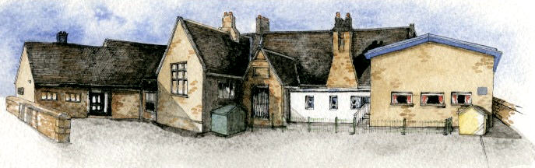

We want our school to be a safe
and happy place where we can
play and learn together.

So we promise to:
- Be kind to everybody
- Listen to adults and each other
- Always try our best
- Move sensibly and quietly around school

- Respect school property

Appendix B Rewards and Incentives at Brabin’s Endowed
At our school we believe that a healthy balance should be created between rewards and sanctions. As well as applying strategies to control unacceptable behaviour we believe that the recognition of strengths and achievements is crucial to promoting our aims. We place a great emphasis on praise and reward because this fosters a positive approach to work and creates a motivating climate within the school.

All class teachers will use the following rewards:
- Verbal recognition in front of the class
- Showing work to the rest of the class
- Writing positive comments on work
- Merits
- Sending child to the Headteacher for praise
- A note home from the Head teacher
- Verbal feedback to parents
- Star of the Week
- Golden Time
- Share work with other classes
- House Points

Class Rewards and Incentives

Foundation Stage
Foundation Stage class has:
- Stickers
- Certificates
- Bee proud of your work display

Key Stage 1
Elm class has:
- Stickers
- Superstar Listener
- Tree of Kindness
- Busy Worker Award

Key Stage 2
Sycamore class has:
- WOW Work Display
- Stickers

Oak Class has:
- Privileges (use of computers, use of library)
- Responsible roles in school i.e. librarian, sports leader, running clubs for younger pupils

Whole School:
Weekly, from each class, awarded at Celebration assembly:
- Star of the Week Award and stickers for a child from each class who has worked and achieved well that week.
- Dinner Time Award - Welfare staff to decide who receives these.
- Headteacher Award
- House Points
- Brabin’s Kindness Award

Whole School Awards Termly and Annually:
We also present a further selection of awards to pupils who have achieved success in various subjects on both a termly and annual basis:
- Remarkable Reader (termly)
- Wow Writer (termly)
- Magnificent Mathematician (termly)
- Merit Award (termly)
- Sports Award (termly)
- James Berry Courtesy Award (annually)
- Progress Award (annually)
- Creative Writer Award (annually)
- Stem (Science, Technology, Engineering and Maths) Award (annually)
- Star of the Year Award (annually)
- Drama Award (annually)

Appendix C: Restorative Conversations Aide Memoir

Restorative Conversations

- What happened?
- Who has been harmed/affected by what happened? In what way?
- What have you thought about since?
- What do you think needs to happen to make it right?
- What will you do if it happens again?

- Restorative conversations are not just a prelude to an apology
- Restorative conversations are only relevant if impact is expected

Scripts to support staff with a common language and consistency:

I understand… and yet… (this can be used to respond to a child’s point of view
Remember about our rule about…? (all redirections should refer back to our Ready, Respectful, Safe rules)

I’ve noticed…. (this can be for ‘positive noticing’ or reminders /warnings

I wonder if…

I need you to…

This is how we do it here. This is the Brabin’s way.

Appendix D- Steps to addressing negative behaviours

Steps to addressing poor behaviour will always be taken with care and consideration, taking individual needs into account where necessary. When negative behaviour occurs and the ‘Ready, Respect Safe’ school rules are broken, consequences are faced by individual pupils.

Consequence Chart:

To ensure consistency, we have levelled the types of behaviour likely to cause concern with appropriate sanctions:

Levels | Behaviours | Sanctions
1 | Persistent:  - Calling out  - Getting out of their place  - Not following simple instructions  - Distracting others from learning  - Damaging equipment  - Not completing set work  - Not completing homework | - Warning given  - 5 minutes at break time  - Restorative Conversation  Completing work at break times if the work has not been done in lessons due to misbehaviour.  Loss of golden time to complete missing work.
2 | - Repeated Level 1 behaviour within the same day  - Rudeness to others  - Name calling  - Deliberate use of swearing  - Not applying themselves in class | Class sanctions put into place and loss of playtime  Entry into Behaviour Log on CPOMS if there is a pattern of unkind behaviour to others/deliberate use of swearing or other behaviours that are causing concern.  Loss of Golden time.
3 | - Repeated Level 1/2 behaviour within the same day  - Physical violence  - Stealing  - Possession of inappropriate items  - Causing wilful damage to property  - Spitting  - Racial Abuse  - Bullying  - Manipulating others | Entry in Behaviour Log on CPOMS – Headteacher informed.  Parents to be informed at  Headteacher’s discretion.  (On a second occasion of same behaviour, a meeting with parents will be arranged)  (See Anti Bullying Policy)

