EYFS Curriculum Statement and Policy
“Every child deserves the best possible start in life and support to fulfil their potential. A child’s experience in the early years has a major impact on their future life chances. A secure, safe and happy childhood is important in its own right and it provides the foundation for children to make the most of their abilities and talents as they grow up.”
Early Years Foundation Stage Profile: Department for Children, Schools and Families 2012
We aim to provide a fun, secure, challenging and rich educational environment that enables each individual to thrive. All children deserve to be valued as an individual and we are passionate in allowing all children to achieve their full, unique potential. Our mission statement ‘learning together, memories forever’ is at the heart of everything we do.  More Able Learners in EYFS  HOW LEARNERS ARE CHALLENGED  All children are challenged through quality first teaching within every lesson. Children will be encouraged to ‘aim high’ and be the best they can be. High expectations will nurture the higher level vocabulary and the most effective language structures. Children will be exposed to a wide range of resources and will be challenged through high level questioning and vocabulary.  Challenge will also be provided through the continuous provision opportunities and adult led learning.  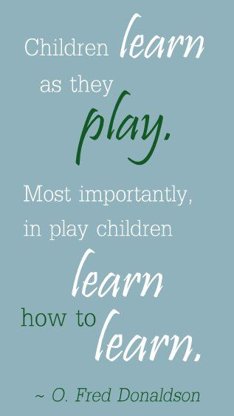 |  | 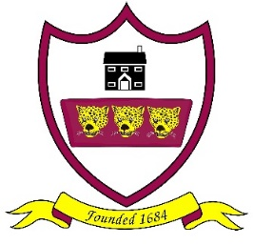  Aims of the EYFS Curriculum  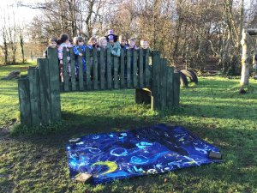  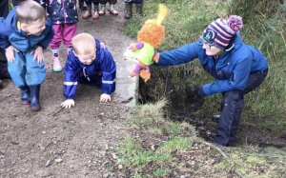  Visit to Beacon Fell – November 2024 Weekly Forest School sessions 2024  “The wider range of possibilities we offer children, the more intense will be their motivations and the richer their experiences”  Loris Malaguzzi
  What we intend to do  At Brabin’s we intend will provide a broad and balanced curriculum that will allow each child to develop personally, socially, emotionally, spiritually, physically, creatively and intellectually to their full potential. We intend to provide an engaging first experience of school that will be happy, positive and enable children to develop a lifelong love of learning.  The children will have access to a rich, stimulating and purposeful environment which supports learning indoors and outdoors. Where adults can scaffold learning through skilful interactions and questioning. |  | As a school we work in partnership with parents to encourage happy learners who thrive in school and reach their full potential. For example star moments from home.  We understand and follow children’s interests and provide opportunities throughout the curriculum to support learning, consolidate knowledge and ensure children meet their next steps.  We prepare children to reach the Early Learning goals at the end of the Foundation Stage and ensure children make at least good progress from their starting points. This intern will support a smooth transition into year 1 which is a crucial next step in their learning.
All children will access… |  |  |  | Terric teeth afternoon with Pre school  February 2025  .  Supporting Learners  Children with special educational needs will be supported as appropriate to enable them to access the curriculum fully. This includes children that are more able and those with specific learning difficulties and disabilities. Individual Education Plans identify targets in specific areas of learning for those children who require additional support commensurate with the school’s Special Educational Needs Policy. The school’s SEN Co-ordinator is responsible for providing additional information and advice to staff and parents and for arranging external intervention and support as necessary.  June 2024  Reception class enjoyed a visit to Williamson park linked to our minibeast topic.
  - A rich, broad and balanced curriculum.  - Adult led and child led learning experiences.  - Practical, interactive and inclusive approach to learning.  - Stimulating continuous provision indoors and outdoors.  - High level Literacy and Mathematics opportunities.  - Daily phonic sessions.  - Author studies and rich texts.  - New skills, knowledge and demonstrate understanding through the 7 areas of the curriculum.  - Daily dough gym sessions and finger gym challenges to develop fine motor skills.  - Weekly forest school sessions with Preschool.  - First hand experiences and opportunities such as visits.  - Strong links with our Preschool.  May 2024  Releasing our butterflies linked to our Minibeast topic. |  | Visits, enrichment days, and examples of learning  Class assembly and showcase with parents  December 2024  -  November 2024  We have been learning all about Diwali and how it is celebrated.
.

January 2024
As part of our food topic, we have been designing and making our own pizzas with our cook Mrs Stead.
Making autumn jelly
November 2024

Parental involvement

At Brabin’s we work in partnership with parents to encourage happy learners who thrive in school and reach their full potential,
- Phonic information session at the start of the year.
- Questionnaire for parents,
- Seesaw observations sent weekly..
- Star moments from home shared in school.
- Parents evening.
- Special news shared through Seesaw.
- Transition meetings.
- Welcome Wednesdays
- Class assemblies and showcases.

Implementation
At Brabin’s we follow the Early Years Statutory Framework. This specifies the requirement for learning and development in the Early Years and provides prime and specific areas of learning we must cover in our curriculum.
EYFS development has seven areas of learning:
Prime Areas – Personal, Social, Emotional development, Physical development and Communication and Language.
Specific Areas – Literacy, Mathematics, Understanding the World and Expressive Arts and Design.
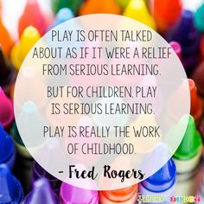
Our curriculum is based upon child led learning, providing wow experiences and topics which engage the children. We encourage active learning to ensure the children are motivated and interested. We take time to get to know children’s interests and their likes to support learning. All areas of the EYFS curriculum are followed and planned for to ensure there is a broad, balanced and progressive learning environment and curriculum. The children will learn new skills, acquire new knowledge and demonstrate understanding through the seven areas of the curriculum.
A key part of the EYFS is the Characteristics of Effective Learning. We strive to develop these key characteristics of
- Playing and Learning
- Active Learning
- Thinking Critically

All of these skills, knowledge and vocabulary are delivered throughout the year. This includes a range of topics, which are planned with their interests in mind and supporting children to develop their experience and knowledge across a range of themes.
Our provision indoors and outdoors are regularly adapted to meet the needs of the children, to support their development and provide stimulating continuous provision opportunities. We ensure that these areas are always stimulating and that they are accessible and challenge all children. The environment is planned to promote independence within our children and allow them to access the curriculum independently and confidently with the necessary level of support.

The EYFS curriculum is based upon four principles: • A Unique child • Positive Relationships • Enabling Environments • Learning and Development.
• every child is a unique child, who is constantly learning and can be resilient, capable, confident and self-assured;
• children learn to be strong and independent through positive relationships;
• children learn and develop well in enabling environments, in which their experiences respond to their individual needs and there is a strong partnership between practitioners and parents and/or carers; and
• children develop and learn in different ways and at different rates. The framework covers the education and care of all children in early years provision, including children with special educational needs and disabilities.
- Play is fundamental to children’s development, building their confidence as they learn to explore, to think about problems, and relate to others.
- Children are assessed continuously through accurate and specific observations. These provide us with information for immediate and future planning and next steps in their learning.
- Each area of learning and development is implemented through planned, purposeful play, and through a mix of adult-led and child-initiated activities. Practitioners respond to each child’s emerging needs and interests, guiding their development through warm, positive interaction.
- Learning journeys are used to build evidence to demonstrate the children’s learning and progress over time. This can take the form of photographs, quotes from the children, independent writing and observations. Evidence of learning will also be recorded within their books such, both will be used as the basis of moderation within the year at school.
- Observations enable the teacher to ensure learning is embedded, consistent and that all children continue to make outstanding progress within our setting. This includes focus child observations to ensure that children’s individual interests are developed alongside the curriculum. These observations are sent home for parents to make a comment and are used as way to communicate with parents their child’s learning.
- In the summer term the balance gradually shifts towards more adult-led activities to help children prepare for more formal learning, ready for year 1.
- Children take part in whole school worships and class worships. Children are taught weekly RE sessions linked to topics such as friendship and stories Jesus told us.
- Children take part in weekly PE lessons which are taught through fundamental skills.
Planning
A mixture of directed sessions and continuous provision opportunities are planned, children’s choices are carefully are observed to ensure a balanced programme. The children begin by having access to continuous provision activities for most of the sessions. This approach is gradually directed by staff as children get older and more mature, so they can prepare for transition into key stage 1and they are prepared for the new curriculum.

Yearly Plan: this forms an overview and helps us focus on our medium term planning:
- Reflecting on the four EYFS overarching principles and review our practice.
- Ensuring coverage of all areas of learning in line with the EYFS Framework & whole school initiatives.
- Plan the coverage skills and knowledge which will be delivered through the topics and experiences.
- Identify how we meet the requirements of the seven areas and the Characteristics of learning.
- We follow the requirements for the locally agreed syllabus for RE as appropriate.

Medium Term Planning: this is based on the children’s interests and helps us focus on short term planning. The children take part in a planning meeting to share their ideas for activities and what they would like to learn about during each topic.
- The length of the units can vary from a couple of weeks up to a half term depending on the children’s learning.
- Review and plan for the balance between activities both indoors and outdoors, to meet the needs and interests of individual and groups of children
- Include a range of experiences and activities appropriate for children.
- Planning for areas of continuous provision indoors and outdoors.
- Review and plan for the balance between activities both adult directed and child initiated to meet the observed needs and which will change throughout the year.
- Evaluate our provision in relation to the principles of the EYFS and the educational programmes.

In the moment (short term plans) - take account of the observation, assessment and planning cycle. It provides a weekly overview of teaching and learning activities covering the seven areas of learning and opportunities for the development of the characteristics of effective learning.

Organisation and management of provision
Early Years provision at Brabin’s Endowed School is organised in one classroom that has a maximum intake of 15. There is access to an outside play area and an adjoining bathroom and cloakroom.
The environment
A wide range of indoor /outdoor equipment and resources are available to meet the needs of the children in the early years and the children will have access to other equipment and facilities in the school such as the hall and library.
The children start school at 8:45 and enter school via the front of school. Their parents have an opportunity to speak to the class teacher to pass on important information or to express any concerns. Initially, in the first week, the Reception children often have break times separately, staying in their outdoor area. However, once confident, the children are integrated with the rest of the school and have the same playtimes. Lunchtime is at 11:45am and the children are supervised by Miss Doxey and the welfare staff until 12:10pm. The children are then supervised by the welfare assistants on the field or on the playground.

Staff/Adults in the Early Years are:
- Miss Claire Doxey - Class Teacher and Key Worker
- Mrs Rachel Wallace – Headteacher
- Miss Jacquie Garth - Early Years Co-ordinator
- Miss Hannah Whitehead- Teaching Assistant – delivers PE/RE/Music for PPA cover
- Mrs Jackson – Pre-school manager
- Mrs Maxine Selby – Early Years Governor
- Mrs Elaine Wardle – French Teacher

Parental Engagement & Involvement
At Brabin’s we have an open door policy and parents are welcomed. Parents have the opportunity to talk to the class teacher at the start and end of the day. However we also strive to inform and involve parents regularly and use a number of initiatives.

Parental questionnaire
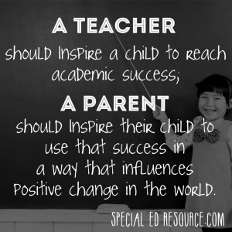
Parents are asked to complete a questionnaire during the 1st half of autumn term, this is important as it allows staff to understand how their child has settled in to school and if there is anything we can implement in future practice.

Special News
The children share special activities they have done at the weekend through Seesaw. Any new interests of the children could be taken into account when planning for future activities.

Star Moments
Parents are given star templates to write in when their child has had a ‘star moment’ at home. The stars are then sent into school so their child’s achievement can be celebrated in class. This information could also be used to aid assessment.

Phonics Information Meeting
At the start of the year the class teacher and early years co-ordinator invite the parents into school to discuss how phonics is taught at school. Flash cards, and actions, are sent home weekly so the parents can re-enforce the work being done in school.

Seesaw app
The seesaw app is used a communication tool to share information, observations, photographs, activities and useful websites with parents. Children can also send achievements or homework via the app which is approved and marked by the class teacher.

Transition (Nursery to Reception)
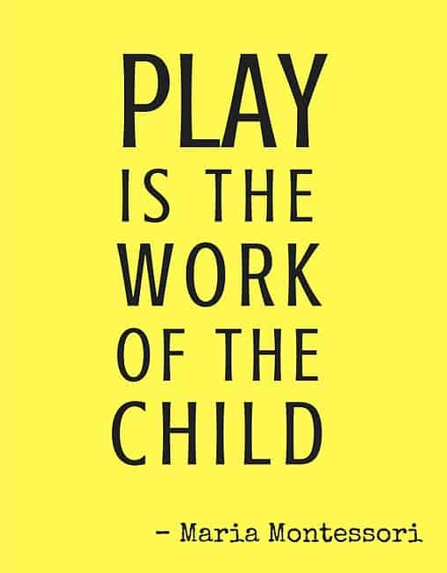
Starting school can be a difficult time for young children; we therefore plan this time carefully to support children with the transition and ensure it is as smooth as possible for each child and that they settle in to their new class quickly and happily. The children are invited to three sessions where they come in to school to meet their new teacher and other children in their class.
Before the first session the children will receive an invitation to a teddy bears picnic by the current class. The children are asked bring their favourite teddy and they take part in lot of fun activities.
The parents will have an induction meeting with the headteacher whilst the children are involved in the picnic.
This is an opportunity for staff to
- EYFS curriculum, provision and staff.
- To go through the school handbook
- Explain about uniform, PE kit and school dinners/ free school meals
- Explain about holidays and absences
- Order uniform and book bags
- Explain the arrangements for the induction into reception
- Discuss and our intimate care documents.
The second and third session is where the children become more familiar with the setting and get to know their new teacher. This means that before they join their new class the environment is already a familiar to them.
The class teacher makes appointment during the summer term to visit them in their current nursery, this is an opportunity to see the child in their current setting. This is crucial as the teacher can talk to their key worker and look at the learning journey with the child.
Starting in Key Stage 1 (Year 1) - Throughout the Reception year, each child’s involvement in whole school life will have been built upon; many of the teaching and support staff will already be familiar people to them. They will have taken part in whole school assemblies as well as sharing lunchtimes and playtimes with the Key Stage 1 children.

Safeguarding

As a school and in our early years provision safeguarding is a priority. We look to ensure children feel safe, and we aim to promote children’s welfare and strive to safeguard children at all times. This includes:

- regular safeguarding training, including child protection training and updates for staff.
- having a recognised DSL (Rachel Wallace) and Deputy DSL (Jacquie Garth)
- having safeguarding policies and procedures that cover the safe use of mobile phones and cameras in the setting and how staff should respond if they have concerns
- promoting good behaviour that allows children to play and learn in ways that are safe for themselves and others
- developing children’s understanding of dangers and how to stay safe
- the extent to which children show that they feel safe and are confident to confide in adults at the setting/school
- steps taken by the key people to safeguard and promote the welfare of children and how well adults teach children about keeping safe
- necessary steps taken to prevent the spread of infection, and appropriate action is taken when children are ill
- the suitability and safety of outdoor and indoor spaces, furniture, equipment and toys
- maintenance of records and policies and procedures required for the safe and efficient management of the Early Years Foundation Stage and for ensuring that children are safeguarded and their needs are met
- the suitability and qualifications of the adults looking after children or having unsupervised access to them,
- effective risk assessments and actions taken to manage or eliminate risks.
- Our Safeguarding policy can be accessed through our school website.

We have rigorous safeguarding policies and procedures that are used to identify anyone at risk of harm, this sets out a clear procedure for reporting any concerns from minor to major. All staff are regularly trained in Safeguarding, which is updated on a yearly basis. The school has rigorous checks when employing members of staff, ensuring that they have the relevant qualifications and DBS are checked. All DBS checks are updated in a rolling basis as required.

Online safety

We have an online safety policy which stipulates and advises how to keep children safe when online, which is available on our website. All staff are regularly made aware of how to keep safe online, and have training around this. This is also regularly promoted throughout the school during e-safety weeks. The school as a whole also has a filtering system that blocks any unknown or suspect websites. However, professional judgement is always advised and promoted throughout the school. Our school online safety policy can be accessed on our school website.

Intimate care

We are committed to ensuring that all staff responsible for the intimate care of children will undertake their duties in a professional manner at all times. We recognise that there is a need to treat all children with respect and dignity when intimate care is given. No child should be attended to in a way that causes distress, embarrassment or pain. Children’s dignity will be preserved and a high level of privacy, choice and control will be provided to them. Staff that provide intimate care to children have a high awareness of safeguarding issues. Staff will work in partnership with parents/carers to provide continuity of care.

During the first transition meeting the headteacher discusses our intimate care policy and parents can decide to give or decline their permission to their child being supported if they have an accident in school. When changing a child they will be two members of staff present to sure both staff and children are protected.

The child will be supported to achieve the highest level of autonomy that is possible given their age and abilities. Staff will encourage each child to do as much for him/herself as they are able. In the case of an isolated accident the child’s wet or soiled clothes will be put into a carrier bag to take home at the end of the day.

Health and Safety

Accidents and First aid

There is a trained Pediatric First aider on site at all times, first aid packs are clearly labelled and regularly updated. All accidents are recorded in our EYFS accident book, parents are the asked to sign the book and informed at the end of the day.
If child bumps their head, parents receive a bumped head text when this happens. Parents will sign our EYFS accident book and receive a bumped head letter which will be returned to school the next and kept with our records. If a more serious accident occurs parents will have a phone call home to inform them as soon as possible.

- Fire alarms – A fire alarm practice is organised at least once a term and all of these are timed and recorded. We have set fire doors throughout the setting and the caretaker carries out regular safety checks.
- Snack – Fruit is provided for children to eat and free milk is available until the child turns 5, when parents can choose to pay for it.
- School meals – children when they enter Reception are entitled to a free school meal and are provided with this. The school meals are carefully catered and follow a healthy food model.

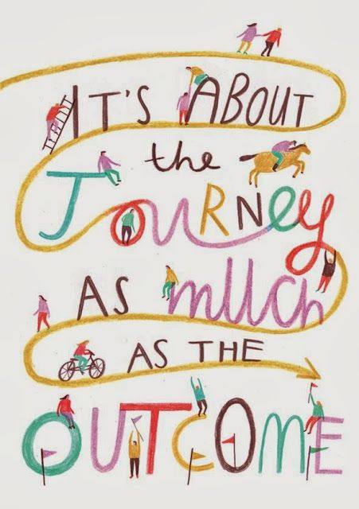

Professional Development in Early Years
At Brabin’s, we intend to keep the subject of EYFS rigorous and alive so it is reflective of pedagogical research and is ambitious in its aims. To do this, we invest in Continued Professional Development for staff. The Headteacher, subject leader and EYFS teacher attends courses when this appropriate and this is fed back to ensure all staff members are up to date when appropriate.
Opportunities for professional engagement with cluster colleagues are highly valued, where appropriate, this can include EYFS teacher taking part in moderation and training events. As small team of teachers, close communication is a key strength and teachers regularly share good practice with one and other.

Examples of Spiritual, Moral, Social & Cultural Development in EYFS

Spiritual  Explore beliefs and experience; respect faiths, feelings and values; enjoy learning about oneself, others and the surrounding world; use imagination and creativity; reflect.  Explore a sense of enjoyment and fascination in learning about themselves, others and the world around them Use of imagination and creativity in their learning and willingness to reflect on their experiences. | Moral  Recognise right and wrong; respect the law; understand consequences; investigate moral and ethical issues; offer reasoned views.  Develop an understanding of the consequences of their behaviour and actions. Begin to investigate and offer reasoned views about moral and ethical issues and ability to understand and appreciate the viewpoints of others on these issues. | Social  Investigate moral issues; appreciate diverse viewpoints; participate, volunteer and cooperate; resolve conflict; engage with the fundamental values of British democracy.  Use of a range of social skills in different contexts, for example working with other pupils, including those from different religious, ethnic and socio-economic backgrounds | Cultural  To appreciate cultural influences; appreciate the role of Britain’s parliamentary system; participate in culture opportunities; understand, accept, respect and celebrate diversity.  Have a willingness to participate in and respond positively to artistic, musical, sporting and cultural opportunities.
CULTURE CAPITAL
In Early years it is all about providing children with experiences and opportunities to help them progress, by giving the children all they need for what comes next in their learning and development.
At Brabin’s, we want to build on these early experiences and give opportunities to ignite curiosity, explore and try new activities to spark awe and wonder in the world, which in turn will inspire learning. When our planning our continuous provision and learning activities we want to provide the children with;
- Real first hand experiences.
- Local visits and trips in the wider world.
- Visit to the settings.
- Activities to celebrate festivals and cultural events.
- Opportunities in the outdoors and being active - forest schools.
- A range musical instruments.
- Chances to share news and activities they do with family.
- A range of rich texts that interest them.
- Experiences to observe seasonal changes or the weather.
- Lots of different media and materials to explore.

CULTURAL CAPITAL
History presents broad and engaging opportunities to highlight to our pupils the best that has been thought and said through key events in Britain’s past and that of the wider world.
Through a rich provision of, high-quality texts, resources, learning experiences the children will become confident Historians and this will inspire pupils to have curiosity and fascination about History.
Children will have the opportunity to perform on stage for example in a Shakespeare festival. They will visit our local area, take part in theme days and extra-curricular clubs. This will give the children a secure foundation when they leave Brabin’s.
DEVELOPING BRITISH VALUES WITHIN EARLY YEARS
We have ensured that our EYFS curriculum and enrichment opportunities reflect the rich tapestry of our society. This involves children having access to a wide range of different learning experiences in the continuous provision and opportunities such as visits.
We want to ensure that children have respect for all and we support children to gain a positive sense of themselves. We encourage the children to speak up during circle time and learn to listen to what their friends are saying. Children are involved in the planning process to show that their opinions matter and that they are valued. By reading books on communities from around the world and sometimes having a country as our topic we are educating the children that people have different ways of life and are a valuable part of our multi-cultural world.


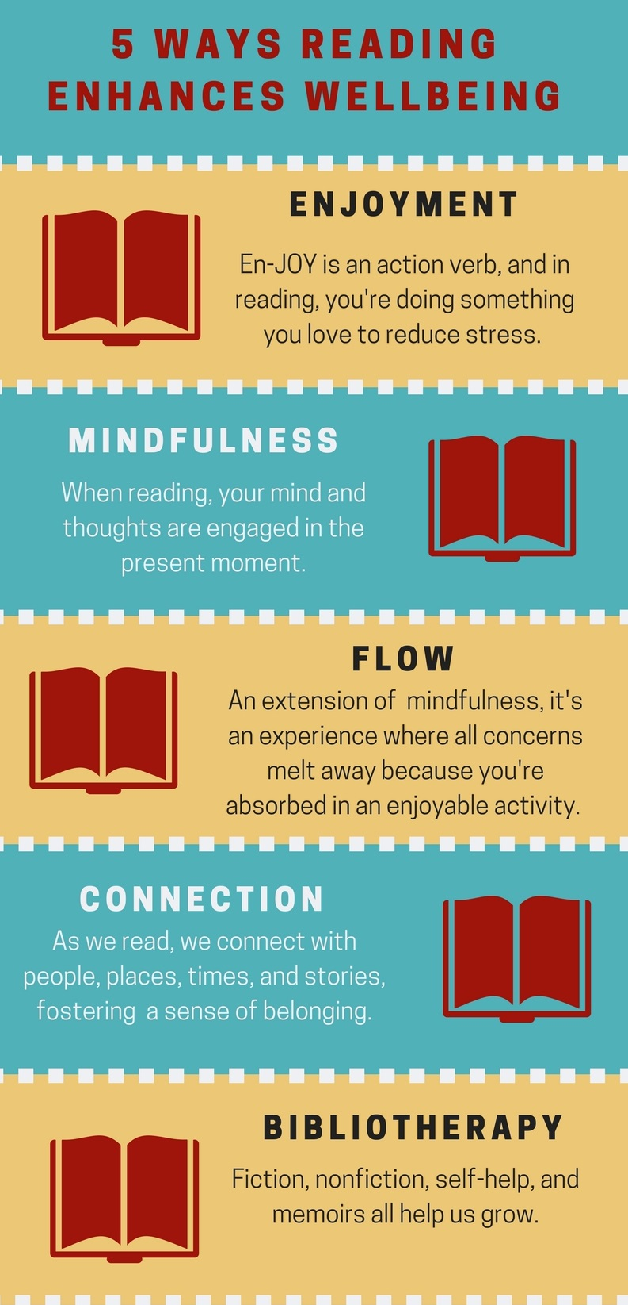
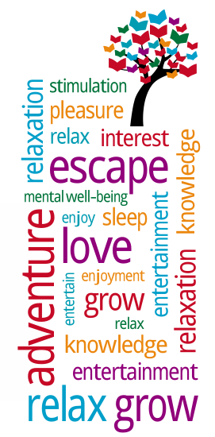

WELLBEING AND MENTAL HEALTH

The early years play a large role in determining mental health through childhood and beyond.
A mentally healthy child is one with a clear sense of identity and self-worth, the ability
to recognise and manage emotions, to learn, play, enjoy friendships and relationships,
and deal with difficulties. A wide range of interrelated factors play a role, such as
individual, family, wider society and environmental issues.

A child’s wellbeing is the result of healthy development within a nurturing environment.
In the early years, infants make emotional attachments and form relationships that lay
the foundation for future mental health. Attachment relationships are particularly
important and have far-reaching effects on developing emotional, social and
cognitive skills.

At Brabin’s, we recognise the research which shows how a whole school approach
can promote wellbeing and positive mental health.
This Government report from 2018 states the importance for creating a whole school
culture. The culture, ethos and environment of the school can have a profound
influence on both pupil and staff mental wellbeing.
A whole school approach is one that goes beyond the teaching in the classroom
to pervade all aspects of school life including, partnerships with parents, teaching
through the curriculum and wide range of cultural experiences.

https://www.gov.uk/government/publications/mental-health-and-behaviour-in-schools--2 document

Assessment in Early Years

We begin each new year by observing the individual needs of our children and taking into account their different starting points from summer term transition meetings. We carefully develop our provision to ensure that it is suitable for their unique needs and stages of development of all our children.

Each term a gap analysis is carried out to assess the cohort’s learning needs and interests in the learning environment. Staff identify the needs of the cohort, any gaps in their learning and how we respond using our planning in the continuous provision. From this we record what we expect to see from observations and interactions we put in place. This process is a key part of our assessment and understanding of where each child is at in their learning and informs our next step planning.

Children will be assessed in the first half term using RBA (Statutory Reception baseline assessment) and teacher observations, this will provide a picture of the whole child during their first six weeks at school. Throughout the year, the child’s individual development will be assessed in relation to the ages and stages of development in the EYFS using teacher assessments and observations. There are two formal parent’s evenings during the year where the teacher will share the child’s tracker and discuss their progress with parents. We believe that this is an important feature of the EYFS assessment process and the ongoing dialogue between parents/carers and staff.

As a school we take part in NELI programme (Nutfield Early Language Intervention) NELI is an evidence based oral language intervention to support the children with their oral language. The assessment informs us if the child is at expected for their age or requires intervention from NELI practitioners.

Pupil Progress meetings take part every term with the headteacher and EYFS coordinator to ensure that all pupils achieve a good level of development by end of the year. Those identified as not making expected progress are rapidly identified and strategies put in place to address under-performance. Class summary sheets with tracking information are completed each half term, these are sent to the headteacher for monitoring purposes. The teacher makes comments about each individual child and their progress in the 7 areas of learning, this helps to clearly monitor each child and provide support and challenge when needed.

At the end of the Reception year, each child is judged to be emerging or expected for each of the 17 Early Learning Goals. These assessments are made on the basis of the teacher’s accumulating observations and knowledge of the whole child which will also include all written and recorded work. The child’s tracker is evidence of the progress they have made throughout the EYFS. Written reports are sent to parents during the 2nd half of summer term with a judgement for each area of learning and a comment on the characteristics of learning. Parents have the opportunity to discuss progress with the class teacher if necessary. The statutory assessment for Reception is the EYFSP (Early Years Foundation Stage Profile) this is completed and reported to the local authority in the summer term.

ASSESSMENT
All children are encouraged to be involved in the process of learning.
In lessons, across the school, teachers will strive to provide instant oral feedback. When appropriate, the children have the opportunity to respond to written marking and complete ‘fix it’s’ in red pen in line with our whole school marking policy.
Children will add learning they are proud of to their Learning Tapestries during the year. They will take this home when they leave school.
Pupil progress data is shared with the Subject Leader on a half termly basis. More formal assessments, Pupil Progress meetings and moderation takes place each term.
In the EYFS, formative assessments are carried out on a daily basis. This type of assessment informs planning, the children’s next steps and demonstrates progress. Summative assessments are completed at the end of each phonic phase, this provides a good understanding of what the children have learnt and any areas that need to be reinforced.
At the end of EYFS, the teacher completes an end of year report and makes a judgment for each of the 17 Early Learning Goals and comments on the characteristics of learning.

MONITORING

Monitoring is undertaken by the Headteacher/Subject Leader. This is conducted regularly and includes: -
- Monitoring of planning.
- Book Scrutiny.
- Learning Environment Walkthroughs.
- Talking to children.
- Data analysis.
- Lesson Observation.

Information will be shared with all governors through the Curriculum Committee, the Headteacher Report to Governors.

IMPACT
From the well-planned and challenging curriculum we aim that the pupils will leave the EYFS with transferrable skills needed to start Key Stage 1. We aim that the pupils will leave the Early Years:
- With a love of learning.
- Being able to read and write.
- Have good mathematical understanding.
- Demonstrate secure personal, social and emotional skills.
- Show a good level of listening.
- Be resilient learners who are keen to learn.
By the end of the Early Years Foundation Stage the majority of children will have achieved a good level of development (GLD). They will have achieved on track in the ELGs across the Prime Areas and Specific Areas of learning. All children will have made significant personal progress across all areas of learning. There could be some children that will have a particular strength in one or more areas of learning with the Early Learning Goals.

