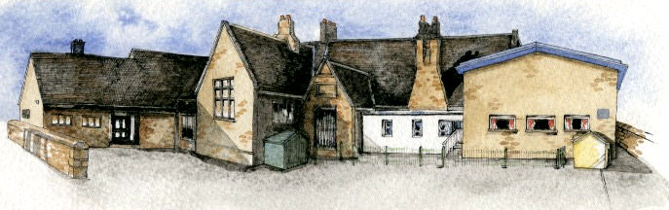

**Writing Opportunities**-

The children will write:

* explanation texts showing the life cycle of plants
* innovated traditional tales with a twist
* setting descriptions

**Key Learning Overview**;-

**Science -** The children will observe and describe how seeds and bulbs grow into mature plants. They will investigate what plants need to grow and stay healthy.

**Art-** The children will observe plants and flowers and explore the detailed work of botanical artists. The children’s drawings will be developed into collages, learning and applying different collage techniques.

**DT –** The children will follow recipes to make their own healthy snacks using vegetables.



Class: Elm Class Year 1/2 Term: Summer

**Curriculum Unit – The World of Plants**

**Class Novel, key texts and extracts-**

The Secret Garden

Jim and the Beanstalk

Jack and the Beanstalk

Video clip – The Clocktower

Other traditional tales with a twist

Reports and information texts about plants

Explanation texts of life cycles

What do plants need to stay healthy?

What happens if a plant is grown in the dark?

What artists were inspired by plants?

What shape are leaves?

What is a collage? How can I create my own?

What is a healthy snack?

* Be Curious: Development a responsibility and appreciation of the environment. *Engage in first hand experiences of growing plants.
* Be Knowledgeable: Nurture a thirst for knowledge
* Be Adventurous: Experience exhilaration, challenge and achievement when growing a healthy plant
* Be Ambitious: Develop an open outlook
* Be Creative: Developing hobbies and interests (cooking/collage) *Apply skills to new situations when using collage materials
* Be Collaborative: Work with others in an interactive learning process
* Be Reflective: Make lifestyle choices in response to thoughts
* Be Positive: Manage one's own behaviour *Develop own opinions

**Curriculum Shapers**

**Key Questions**

**Key Skills Coverage – Science**

**Prior Knowledge**

**EYFS – Understanding the world**

|  |
| --- |
| *Children know about similarities and differences in relation to places, objects, materials and living things. They talk about how features of their immediate environment and how environments might vary from one another. They make observations of animals and plants and explain why some things occur and talk about changes. |

**KS1**

|  |
| --- |
| *Identify and name a variety of common wild and garden plants, including deciduous and evergreen trees.  *Identify and describe the basic structure of a variety of common flowering plants, including trees. |

**Key Vocabulary**

**Key Skills and Knowledge**

|  |
| --- |
| **Plants** - are living organisms that cover much of  the land of planet Earth. They include grass, trees,  flowers, bushes, ferns, mosses, and more.  **Blossom** - a flower or a mass of flowers, especially  on a tree or bush  **Seed** - the part of a **seed** plant which can grow into  a new plant.  **Bulb** – an underground mass of food storage from  which plants grow. Bulbs, like seeds, are also  available in different sizes, shapes, and types.  **Bark** –the outer layer of the trunk of a tree.  **Stalk** – the main stem of a plant  **Bud** – a growth on a plant that develops into a leaf,  flower, or shoot.  **Nutrients** – are minerals needed for plant growth –  they are taken in by the plant’s root system  **Deciduous trees** – trees that lose their leaves  **Evergreen trees** - trees that retain green leaves  throughout the year.  **Germinate** - The beginning of growth, as of a seed,  spore, or bud. The **germination** of most seeds and  spores occurs in response to warmth and water. |

**Seedlings** -  young plant, especially one raised from seed and not from a cutting.

**Working Scientifically**

*Observing and recording, with some accuracy, the growth of a variety of plants as they change over time from a seed or bulb

*Observing similar plants at different stages of growth;

*Setting up a comparative test to show that plants need light and water to stay healthy.

|  |
| --- |
|  |

**Knowledge**

*Observe and describe how seeds and bulbs grow into mature plants.

*Find out and describe how plants need water, light and a suitable temperature to grow and stay healthy.

**Key Learning**

Plants may grow from either seeds or bulbs. These then germinate and grow into seedlings which then continue to grow into mature plants. These mature plants may have flowers which then develop into seeds, berries, fruits etc. Seeds and bulbs need to be planted outside at particular times of year and they will germinate and grow at different rates. Some plants are better suited to growing in full sun and some grow better in partial or full shade. Plants also need different amounts of water and space to grow well and stay healthy.

**Common Misconceptions**

Some children may think:

*plants are not alive as they cannot be seen to move *seeds are not alive

*all plants start out as seeds

*seeds and bulbs need sunlight to germinate.

**Key Skills Coverage – Art**

**Prior Knowledge**

**EYFS – The Year 1 Children**

*printed with food as part of their topic

*observed leaves as part of their Forest Schools work

*they also printed with construction toys

**KS1**

*explored mark making with charcoal and chalk

*observed and photographed plants in the local environment

**Key Vocabulary**

**Key Skills and Knowledge**

**Drawing Skills**

*Experiment with a variety of media; pencils, rubbers, crayons, pastels, felt tips, charcoal, ballpoints, chalk.

Control the types of marks made with the range of media.

*Name, match and draw lines/marks from observations.

* Observe and draw shapes from observations.

*Investigate textures by describing, naming, rubbing, copying

**Collage**

Pupils should be taught to:

*Create images from a variety of media e.g. photocopies material, fabric, crepe paper, magazines etc.

*Arrange and glue materials to different backgrounds.

*Sort and group materials for different purposes e.g. colour texture.

*Fold, crumple, tear and overlap papers.

*Work on different scales.

**Colour**

*Collect, sort, name match colours appropriate for an image.

**Shape**

*Create and arrange shapes appropriately.

**Texture**

*Create, select and use textured paper for an image.

**Evaluation**

*Identify what they might change in their current work or develop in future work.

**collage** - a work of art made by gluing pieces of different materials to a flat surface

**fold** - to bend a material over on itself

**crumple** - to press or crush out of shape

**tear** - to rip paper

**overlap** – to place or be placed so that a part of one covers a part of another

**texture** - how something feels when it is touched

**arrange** – to put in a particular order

**sort** - to separate and arrange according to kind or class

**Georgia O’Keeffe** - Georgia Totto O'Keeffe was an American artist. She was known for her paintings of enlarged flowers.

**Vincent Van Gogh** -Vincent Willem van Gogh was a Dutch post-impressionist painter who is among the most famous and influential figures in the history of Western art

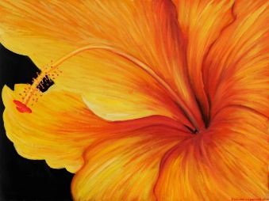 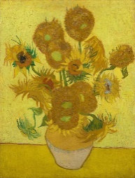

**Key Skills Coverage – DT**

**Prior Knowledge**

**Year 2 Children**

*During lockdown, home learning included recipes and making a healthy fruit snack.

*Learnt about the Eatwell Plate and the importance of the different sections.

**Key Vocabulary**

**Key Skills and Knowledge**

**vegetables and fruits** - lettuce, tomatoes, cucumber, carrots

**recipe** - a set of instructions for preparing a particular dish

**ingredients** – the food items needed to make a particular dish

**measurements** – the amount of food needed for the recipe

**hygiene** - the practice of keeping clean to stay healthy and prevent disease

**healthy snack** –food that is low in added fat and sugar and high in fibre and water

**5 a day** – the recommended number of portions of fruit and vegetables that should be eaten each day

**Design**

*Develop and communicate these ideas through talk, drawings and mock ups where relevant

**Make**

*Develop a food vocabulary using taste, smell, texture and feel.

*Grate, chop and peel a range of ingredients

*Measure and weigh food items.

*Work safely and hygienically

**Evaluate**

* Discuss how their finished product meets the criteria.

**Technical Knowledge**

* Understand the basic principles of a healthy and varied diet to prepare dishes.

