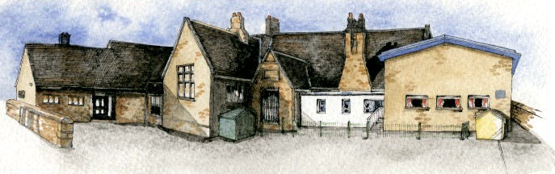

**Writing Opportunities**-

The children will write innovated stories based on the book ‘Zog’ and innovated poems about fire.

They will write setting and character descriptions based on The Snow Dragon

Diary entries about The Great Fire of London

**Key Learning Overview;-**

**Science –** The children will observe changes across the four seasons and will observe and describe weather associated with the seasons and how day length varies. (This will be ongoing throughout the year.)

**History-** The children will identify some similarities and differences between their way of life and the way of life during the Great Fire of London in 1666. They will ask and answer questions about the past, using a range of sources. They will also learn some of the important events from the Great Fire of London.

**Design Technology-** The children will design and make a picture with a moving part to reflect an event from the Great Fire of London. They will talk about their design as it develops and identify good and bad points, making modifications where necessary.

**Music-** The children will learn to use their voices expressively by singing songs and speaking chants and rhymes. They will also listen to music and songs inspired by the theme of fire and fireworks. They will work collaboratively to compose their own piece of ‘fire’ music.



Class: Elm Class Year 1/2 Term: Autumn 2

**Curriculum Unit – Fire! Fire!**

**Class Novel, key texts and extracts-**

The Snow Dragon by Vivian French

Zog by Julia Donaldson

London’s Burning Rhyme

London Bridge is Falling Down

* Where is London?
* What is it like today?
* How can we find out what London was like in 1666?
* Can we sequence the events of the Great Fire of London?
* How are moving parts in books made?
* How can we make a moving part for an image of the Great Fire of London?
* How have different musicians been inspired by the theme of fire?
* Can we work collaboratively to produce our own fire music using instruments?
* Be Curious: Show an interest in life in the past

*Use a range of sources to ask and answer questions

* Be Knowledgeable: Secure an understanding of life in the past in London 1666.
* Be Adventurous: Appreciate and perform songs from an eclectic range of styles and genres
* Be Ambitious: Strive for improvement
* Be Creative: Apply new skills to produce their own moving picture. *Create their own music.
* Be Collaborative: Work with others to sing songs and produce music.
* Be Reflective: Evaluate their own work to make improvements *Recognise positive points
* Be Positive: Develop their own opinions about their work *Listen to and respond to advice

**Curriculum Shapers**

**Key Questions**

**Key Skills Coverage – Science**

**Prior Knowledge**

**EYFS –**

*Children know about similarities and differences in relation to places, objects, materials and living things. They talk about the features of their own immediate environment and how environments might vary from one another. They make observations of animals and plants and explain why some things occur and talk about changes.

**Year 2 Children**

*Observed plants and trees in the school grounds.

**Key Skills and Knowledge Key Vocabulary**

**Working Scientifically**

* Making tables and charts about the weather

*Making displays of what happens in the world around them, including day length, as the seasons change.

**Plan:**

*\*Ask questions and plan enquiry:* Ask simple questions and recognise that they can be answered in different ways.

*Materials waterproof (Y2)

**Knowledge**

*Observe changes across the four seasons.

*Observe and describe weather associated with the seasons and how day length varies.

**Key Learning**

In the UK, the day length is longest at mid-summer (about 16 hours) and gets shorter each day until mid-winter (about 8 hours) before getting longer again.

The weather also changes with the seasons. In the UK, it is usually colder and rainier in winter, and hotter and dryer in the summer. The change in weather causes many other changes. Some examples are: numbers of minibeasts found outside; seed and plant growth; leaves on trees; and type of clothes worn by people.

**Common Misconceptions**

Some children may think:

• it always snows in winter

• it is always sunny in the summer

• there are only flowers in spring and summer

• it rains most in the winter.

**weather** - is the daily state of the atmosphere, or air, in any given place

**(sunny, rainy, windy, snowy)**

**climate** – is the average of **weather** conditions in an area over a long period

**seasons** - are four different times during the year with different types of weather. They are caused by the earth's orbit around the sun, its rotation on its axis, and its tilt.

**(winter, summer, spring, autumn)**

**day length** – the length of the day between sunrise and sunset

**sun** - the star at the centre of the **solar** system. It is a hot ball of gas that gives off great amounts of energy. Life on Earth depends on light and heat from the **sun**.

**sunrise** – the time at which the sun rises

**sunset** – the time at which the sun sets

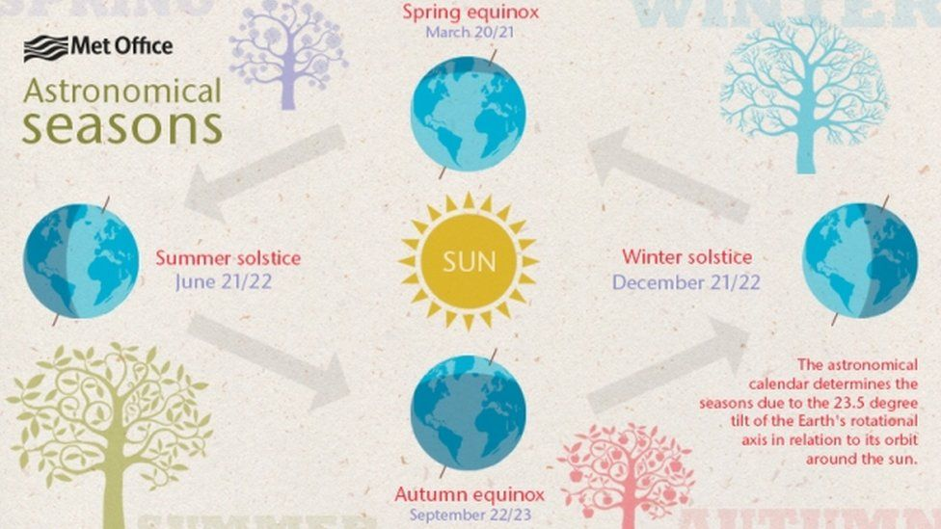

**Key Skills Coverage – History**

**Prior Knowledge**

**EYFS - Understanding the world: The world**

*Looks closely at similarities, differences, patterns and change.

*Children know about similarities and differences in relation to places, objects, materials and living things.

**KS1**

*Gained an understanding of timelines and chronology during Me, My Friends and My Family topic

*They used a range of sources to find out about the changes to their school and homelife

**Key Vocabulary**

**Key Skills and Knowledge**

**London** – capital city of England.

**firefighter** – a person who puts out fires

**fire brigade** – at the time consisted of a tub of water on wheels

**escape** – to get to safety away from the fire

**River Thames** – a famous London river that was used to escape the fire

**flammable** – easily set on fire

**monument** - a statue, building, or other structure built to commemorate an important person or event

**eyewitness** - a person who has seen something happen and can give a first-hand description of it

**thatched roof** – a house roof made from straw

**tudor houses** – Tudor houses were built of wood during the Tudor era in England between **1485 – 1603** and they had a very distinctive black-and-white style appearance.

**Samuel Pepys** – (23 February 1633 – 26 May 1703) was an administrator of the navy of England and Member of Parliament who is most famous for the diary he kept for a decade while still a relatively young man.

**Charles II** – the King at the time of the fire

**Thomas Farriner** – was a baker. His bakery in Pudding Lane was the source point for the Great Fire of London

**Chronology**

*Know where some people and events fit into a chronological framework

*Place set of events or objects in chronological order

**Events, People and Changes**

*To tell the difference between past and present in their own lives and others lives by making simple comparisons

*Use simple stories and sources to show they understand key features of events.

**Enquiry**

*Use a range of sources to find out about a period - artefacts, pictures

*To begin to understand the reasons why people acted as they did using sources

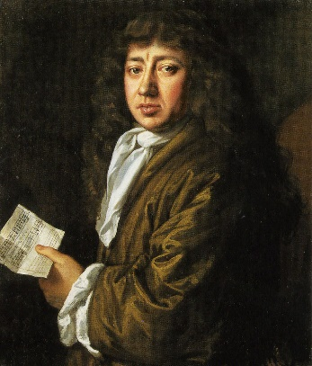 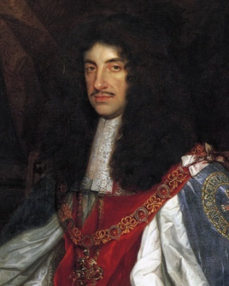

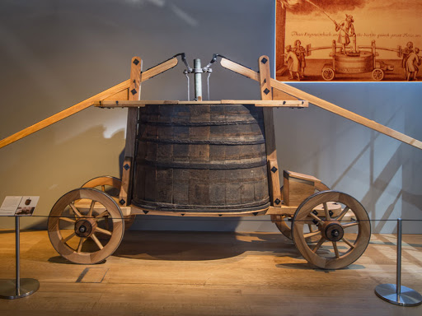

**Key Skills Coverage – DT**

**Prior Knowledge**

**EYFS – Expressive arts: Exploring and using media and materials**

*They safely use and explore a variety of materials, tools and techniques, experimenting with colour, design, texture, form and function.

**EYFS – Expressive arts: Exploring and using media and materials**

*Children use what they have learnt about media and materials in original ways, thinking about uses and purposes. They represent their own ideas, thoughts and feelings through design and technology.

**Year 2**

*Mechanisms – wheels and axles

*Structures – card structures of playground equipment

**Key Skills and Knowledge Key Vocabulary**

**Design**

*Generate initial ideas and design criteria through own experiences

*Name the tools they are going to use.

**Make**

*Experiment with sliders and levers.

*Understand that different mechanisms produce different types of movement.

*Cut along various lines.

*Use a range of materials to create models

**Evaluate**

*Evaluate their ideas throughout and using their finished products.

*Record any changes made during the process.

**Technical Knowledge**

*Explore and use mechanisms [for example, levers, sliders] in their products

**Mechanism**-a device used to create movement in a product.

**Lever**-a rigid bar which moves around a pivot. Levers are used in many everyday products. In this project children will use card strips for levers and paper fasteners for pivots.

**Slider**–a rigid bar which moves backwards and forwards along a straight line. Unlike a lever, a slider does not have a pivot point.

**Slot**-the hole through which a lever or slider is placed to enable part of a picture to move.

**Guide or bridge**-a short card strip used to keep sliders in place and control movement

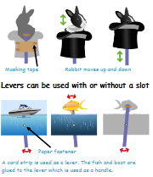

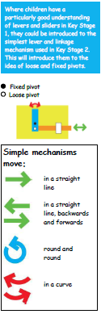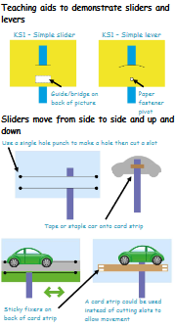

**Key Skills Coverage – Music**

**Prior Knowledge**

**EYFS – Expressive Arts: Exploring and using media and materials**

* Children sing songs, make music and dance, and experiment with ways of changing them. They safely use and explore a variety of materials, tools and techniques, experimenting with colour, design, texture, form and function.

**EYFS – Expressive Arts: Being imaginative**

*Children use what they have learnt about media and materials in original ways, thinking about uses and purposes. They represent their own ideas, thoughts and feelings through design and technology, art, music, dance, role play and stories.

**KS1**

*The children have sung a number of class songs during music lessons.

*They performed to an audience during the class showcases.

**Key Skills and Knowledge**  **Key Vocabulary**

**genre** – a style or type of music

**pulse –** the constant beat in a piece of music

**ensemble** – all instruments in an orchestra or all voices in a choir, playing at once.

**round/canon**- tune that is repeated at regular intervals by different performers, but with different starting times

**dynamics** – how loud or quiet a piece of music is

**tempo** – speed of a piece

**duration-** length of note

**pitch**- how high or low a sound is

**timbre-** the quality of sound

**texture**- layers of sound

**structure-** the order of a piece

*listen with concentration and understanding to a range of high-quality music

*use their voices expressively and creatively by singing songs and speaking chants and rhymes

