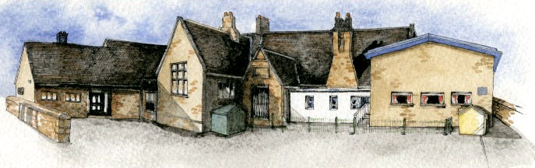

**BRABIN’S ENDOWED PRIMARY SCHOOL**

**Class: Sycamore Year 3/4 Term: Summer 1 Cycle A Curriculum Unit – Stone Age**

Class Novel, key texts and extracts-

Stig of the Dump, Skara Brae, Wolf Brother (extracts), The Secrets of the Stone Age and The History Detectives Investigate: Stone Age to Iron Age

In KS1: There has been no prior study on Lights and Shadows.

Working Scientifically:

▪ asking simple questions and recognising that they can be answered in different ways

▪ observing closely, using simple equipment  
▪ performing simple tests  
▪ identifying and classifying

▪ using their observations and ideas to suggest answers to questions

▪ gathering and recording data to help in answering questions.

**Prior Knowledge**

**Key Skills Coverage - Science**

**Key Vocabulary**

**Key Scientific Skills**

Knowledge:

* Recognise that they need light in order to see things and that dark is the absence of light.
* Notice that light is reflected from surfaces.
* Recognise that light from the sun can be dangerous and that there are ways to protect their eyes.
* Recognise that shadows are formed when the light from a light source is blocked by a solid object.
* Find patterns in the way that the size of shadows can change.

Working Scientifically:

* Look for patterns in what happens to shadows when the light source moves or the distance between the light source and the object changes.
* Gather record and present data to help answer scientific questions.
* Use graphs to represent data.
* Set up simple practical enquiries.

**Light source-** something that gives off or emits light.

**Opaque-** something you are unable to see through.

**Translucent-** something you are able to see through however with little detail.

**Transparent-** something you can clearly see through.

**Reflect-** bounce back something without absorbing it.

**Reflective-** an object that is able to provide a reflection e.g. a mirror

In KS1 children learnt:

* to use a range of materials creatively to design and make products
* to use drawing, painting and sculpture to develop and share their ideas, experiences and imagination
* to develop a wide range of art and design techniques in using colour, pattern, texture, line, shape, form and space
* about the work of a range of artists, craft makers and designers, describing the differences and similarities between different practices and disciplines, and making links to their own work.

**Prior Knowledge**

**Key Skills Coverage -Art**

**Key Skills**

* Explore and develop the roles of artists from different cultures and time periods such as the printmaker Eric Gill and drawings of fossils by early palaeontologists.

**Drawing and Painting**

* Experiment with ways in which surface detail can be added to drawings, *(e.g. use grades of pencil, biros, charcoal and chalk).*
* Use journals to collect and record visual information from different sources.
* Draw for a sustained period of time at an appropriate level.
* Make marks and lines with a wide range of drawing implements e.g. charcoal, pencil, crayon, chalk pastels, pens etc.
* Experiment with different grades of pencil and other implements to create lines and marks.
* Experiment with different grades of pencil and other implements to draw different forms and shapes.
* Begin to show an awareness of objects having a third dimension, *(e.g. achieved by shading).*
* Experiment with different grades of pencil and other implements to achieve variations in tone.
* Create textures with a wide range of drawing implements *(such as oil and chalk pastel).*
* Experiment with different effects and textures in paint.
* Work on a range of scales e.g. thin brush on small picture etc.
* Create different effects and textures with paint according to what they need for the task

**Printing**

* Create printing blocks using a relief or impressed method.
* Create repeating patterns.
* Print with two colour overlays.

**Evaluating**

* Annotate work in journal.
* Compare ideas, methods and approaches in their own and others' work and say what they think and feel about it.
* Adapt their work according to their views and describe how they might develop it further.