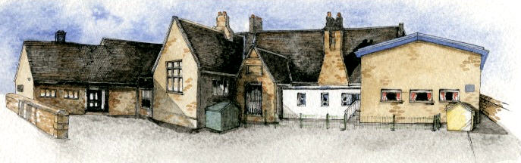 |  | Online Safety Long term plan – Education for a Connected world
  BRABIN’S ENDOWED PRIMARY SCHOOL

Cycle A | Autumn 1 | Autumn 2 | Spring 1 | Spring 2 | Summer 1 | Summer 2
EYFS | Self-image and Identity | Online Bullying  Anti-bullying week | Online Relationships  Safer internet focus | Health, Well-being and lifestyle | Privacy and Security/ Copyright and ownership | Managing information online/ reputations
Year 1/2 | Health, Well-being and lifestyle | Online Bullying  Anti-bullying week | Online Relationships  Safer internet focus | Self-image and Identity Online Bullying | Managing information online | Online Relationships
Year 3/4 | Privacy and Security  Online Relationships | Online Bullying  Anti-bullying week | Online Relationships  Safer internet focus | Health, Well-being and lifestyle | Online Bullying | Managing information online
Year 5/6 | Managing information online | Online Bullying  Anti-bullying week | Online Relationships  Safer internet focus | Privacy and Security | Online Relationships | Self-image and Identity  Online Bullying

Cycle B | Autumn 1 | Autumn 2 | Spring 1 | Spring 2 | Summer 1 | Summer 2
EYFS | Self-image and Identity | Online Bullying  Anti-bullying week | Online Relationships  Safer internet focus | Health, Well-being and lifestyle | Privacy and Security/ Copyright and ownership | Managing information online/ reputations
Year 1/2 | Online reputations | Online Bullying  Anti-bullying week | Online Relationships  Safer internet focus | Copyright and ownership | Online Relationships | Privacy and Security  Online Bullying
Year 3/4 | Copyright and ownership | Online Bullying  Anti-bullying week | Online Relationships  Safer internet focus | Online reputations | Self-image and Identity  Online Bullying | Online Relationships
Year 5/6 | Health, Well-being and lifestyle | Online Bullying  Anti-bullying week | Online Relationships  Safer internet focus | Copyright and ownership | Online reputations  Online Relationships | Online Bullying

