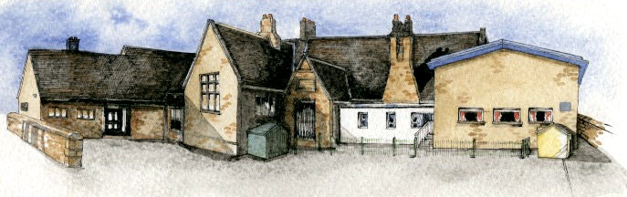

**Writing Opportunities**-

The children will write:

Spring 1 – innovated stories based on Katie Morag stories and non-chronological reports based on places we have studied.

Spring 2 - we will write persuasive posters about Chipping and create leaflets about John Brabin. We will also write stories based on the work of Beatrix Potter and poems based on ‘The Owl and the Pussycat’.

**Key Learning Overview;-**

**Science**- Children will explore the local environment and identify and name a variety of common plants and trees. They will describe the basic structure of plants, including trees.

**Geography-** Children will use simple fieldwork and observational skills to study the geography of their school and places in Chipping where they can play and have fun. They will use aerial photographs and plans to identify significant places in school and around Chipping and recognise how the places have changed.

**History**- Children will use a variety of sources to identify how the school and Chipping has changed over time. They will learn more about John Brabin and why he was/is important to the school and Chipping.

**Art-** Children will make observational drawings of the local area and use them to inspire their printmaking. They will then use a range of materials to create a print depicting the local area.

**DT-** Children will explore a range of wheels and axles and use them to make skateboards or scooters.



**Class:** Elm Class Year 1/2 **Term:** Spring

**Curriculum Unit –** Learning and Playing in Chipping

**BRABIN’S ENDOWED PRIMARY SCHOOL**

**Class Novel, key texts and extracts-**

The Twits by Roald Dahl

Katie Morag Stories

Peter Rabbit and other Beatrix Potter stories, including The Tale of Jeremy Fisher

Leaflets from local attractions

The Owl and the Pussycat by Edward Leah

The Further Adventures of the Owl and the Pussycat by Julia Donaldson

**Key Questions**

**Curriculum Shapers**

* What plants are growing around our school?
* How can I identify the plants arounds our school?
* What do you call the different parts of a plant?
* What does each part of a plant do?
* Where can I go to play and have fun in Chipping?
* Where is Brabin’s School on this aerial photograph?
* How has Chipping and our school changed?
* Why has the school changed?
* Who is John Brabin?
* How has John Brabin had an impact on the local area and our school?
* What features are important to include on my print of the local area?
* What is a chassis?
* How can I attach wheels and axles to a chassis?
* How can I improve my skateboard?
* Be Curious: about the world around them, invoking a sense of awe and wonder. Show an interest in the lives of significant people from the local area. Ask questions to find out how the school has changed.
* Be Knowledgeable: learn to identify and name plants in the local environment. Develop new subject specific vocabulary in all areas of the curriculum.
* Be Creative: use a range of materials to create drawings and prints of the local area. Design and make a product with wheels and axles.
* Be Adventurous: work practically in science and DT.
* Be Collaborative: work as a team, respecting the different opinions of others.
* Be Reflective: develop an understanding of their areas of strength and for development.
* Be Positive: consider one’s place in the world. Develop their own opinions about Chipping.

**Key Skills Coverage – Science**

**Prior Knowledge**

**EYFS – Understanding the world**

*Children know about similarities and differences in relation to places, objects, materials and living things. They talk about how features of their immediate environment and how environments might vary from one another. They make observations of animals and plants and explain why some things occur and talk about changes.

Year 2 Children

*Observed and collected information about the seasonal changes to the weather and daytime.

**Key Skills and Knowledge Key Vocabulary**

**Working Scientifically**

*By observing closely plants using magnifying glasses.

*By comparing and contrasting familiar plants.

*By describing how they were able to identify and group them.

*By drawing diagrams showing the parts of different plants including trees.

**Plants**

*Identify and name a variety of common wild and garden plants, including deciduous and evergreen trees.

*Identify and describe the basic structure of a variety of common flowering plants, including trees.

**Plants** - are living organisms that cover much of the land of planet Earth. They include grass, trees, flowers, bushes, ferns, mosses, and more.

**Blossom** - a flower or a mass of flowers, especially on a tree or bush

**Seed** - the part of a **seed** plant which can grow into a new plant.

**Bark** –the outer layer of the trunk of a tree.

**Stalk** – the main stem of a plant

**Bud** – a growth on a plant that develops into a leaf, flower, or shoot.

**Nutrients** – are minerals needed for plant growth – they are taken in by the plant’s root system

**Deciduous trees** – trees that lose their leaves

**Evergreen trees** - trees that retain green leaves throughout the year.

**Names of trees** in the local area.

**Names of garden and wild flowering plants** in the local area.

**Structure of a tree** **Structure of a Plant**

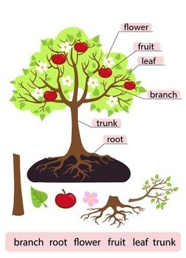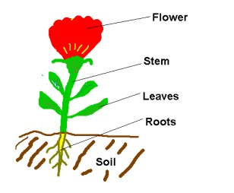

**Key Skills Coverage – History**

**Prior Knowledge**

**EYFS - Understanding the world: The world**

*Looks closely at similarities, differences, patterns and change.

*Children know about similarities and differences in relation to places, objects, materials and living things.

**KS1**

*Researched important Britons for the UK topic in autumn term

*Uses sources of evidence and created timelines in autumn term

**Year 2**

*Researched significant explorers

*Uses sources of evidence when finding out about old toys

*Learnt about significant events nationally – The Great Fire of London

**Key Skills and Knowledge Key Vocabulary**

**John Brabin** – established his business in 1668 when he set up a shop to trade cloth and a dye-house. He died in 1683 and through his will set up a trust to support education and help the poor of **Chipping**, Thornley and Leagram.

**Chronology** – the arrangement of events or dates in the order they happened.

**Local history** - is the study of history in a geographically local area and it often concentrates on the local community.

**Source** – a book, a person or document used to provide evidence in research.

**Village** - an area containing a small number of houses and other buildings such as a church and a school.

**Past** - Something that has already happened. This could have been a long time ago.

**Industry** - Companies involved in the process of producing goods for sale, especially in a factory.

**Rural** - The countryside – away from the town or city.

**Chronology**

Show their developing knowledge and understanding of the past by:

*Recognising the distinction between present and past in their own and other people's lives.

*Identifying some similarities and differences between Brabin’s Endowed School now and in the past

**Events, People and Changes**

*To tell the difference between past and present in their own and other people’s lives by using and making simple comparisons to *parts* of stories.

**Enquiry**

*Ask and answer questions about how the school has changed through observing and handling a range of different sources (including photographs and interviewing past pupils)

*Use sources to answer *simple* questions about the past.

*Learn about significant people (John Brabin) and places in their own locality.

**Organisation and communication**

*Understand and use simple concepts such as now/then and same and different

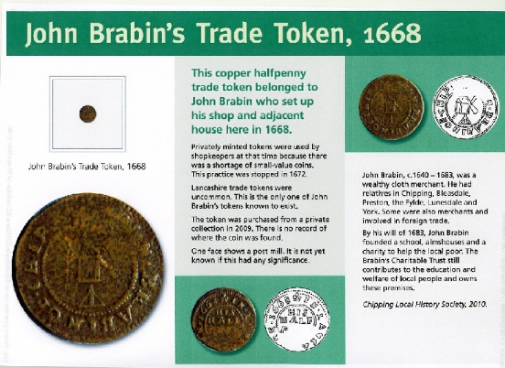

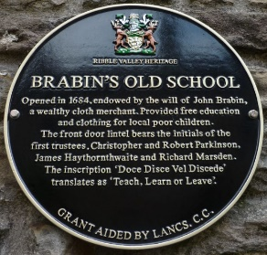

**Key Skills Coverage – Geography**

**Prior Knowledge**

**EYFS - Understanding the world: The world**

*Looks closely at similarities, differences, patterns and change during their Forest Schools work

*Children know about similarities and differences in relation to places and living things.

**KS1**

*Named and described the physical and human features of the different areas of the UK

**Year 2**

*Seven continents of the world

*Researched the Polar Regions and the Equator

*Place Knowledge - Small area of the United Kingdom (Blackpool)

*Place Knowledge - Study a small area in a contrasting non-European country Mugurameno in Zambia

**Key Skills and Knowledge Key Vocabulary**

**Aerial photograph** – is a photograph taken from above an area, possibly from a plane

**Compass directions** – North East South West

**Plan** – a drawing or diagram showing the layout of a building or one floor of a building

**Key** – an explanatory list of symbols used in a map, table

**Map Symbols** – A picture used on a map to represent different features of an area

**Directional language** - left/right, forwards and backwards.

**Place Knowledge**

Small area of the UK – Chipping (particular focus of the recreational areas)

**Mapping**

*Recognise landmarks and basic human features on aerial photos.

*Draw a simple map showing significant places in Chipping, including The Village Hall, Schools and Chipping Congregational Church.

*Use and construct basic symbols in a map key.

*Know that symbols mean something on maps.

*Begin to realise why maps need a key.

*Look down on objects and make a plan of the playground and field.

**Fieldwork**

*Use simple fieldwork techniques such as observation and identification to study the geography of the school.

*Use simple compass directions (NSEW).

*Use locational and directional language to describe feature and routes e.g. left/right, forwards and backwards.

*Use aerial photos and plan perspectives to recognise landmarks, including how the local area and school grounds have changed over time.

**Enquiry and Investigation**

Enquiry Question – Where can you go to have fun in Chipping?

*Ask simple geographical, ‘where?’, ‘what?’, and ‘who?’ questions about the world and their environment e.g. ‘What is it like to live in this place?’

*Investigate through observation and description.

**Key Skills Coverage – Art**

**Prior Knowledge**

**EYFS – The Year 1 Children**

*printed with food as part of their topic

*made leaf prints as part of their Forest Schools work

*they also printed with construction toys

**KS1**

*explored mark making with charcoal and chalk

**Key Vocabulary**

**Key Skills and Knowledge**

**Drawing Skills**

*Make observational drawings of the locality and school grounds; experiment with mark-making, charcoal and chalk, graphite sticks and pens on small/large-scale.

*Make drawings of local landmarks and experiment making shades and tones in greys using chalk and charcoal, encourage smudging contrasted with detail.

*Collect rubbings from surfaces then continue and extend into a drawing, or use as background to a drawing.

*Make observational drawings and include wet media such as watercolour.

**Printing**

*From drawings develop a simplified printing motif of school or local area etc.

*Plan and discuss ways this image could be translated or rotated and repeatedly printed.

*Plan and discuss colour choices for print or background; perhaps print on a textured rubbing of a building etc.

*Use rollers and printing ink to print image

*Develop drawings further by producing a print of the local area; start to collect and sort textures and shapes which can be used to print as seen in class clip with the City scape.

*Use printing rollers to ink up sides and edges of objects and textures from which to print and build up an image of ‘The Place Where I Play and Learn’.

**Evaluation**

*Give children time to evaluate their work and that of others, describe what they like or might change next time, what materials they preferred using, what advice they may give another artist.

*Know about craft makers and artists

**Landscape** – the visible features of an area of land

**Monotype** – a single print taken from a design created in oil paint or printing ink on a smooth surface of glass or metal.

**Printing** – to transfer a design or pattern to another surface

**Rubbing** - an impression of a design made by rubbing coloured wax or pencil over a textured surface,

**Texture** – the feel, appearance, or consistency of a surface

**Monotype**

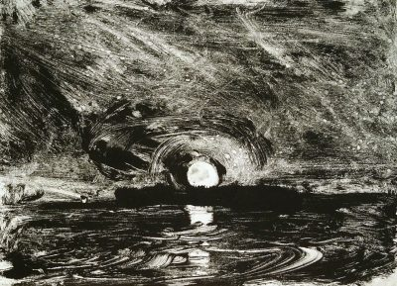

**City Scape** https://www.bbc.co.uk/programmes/p01149qw

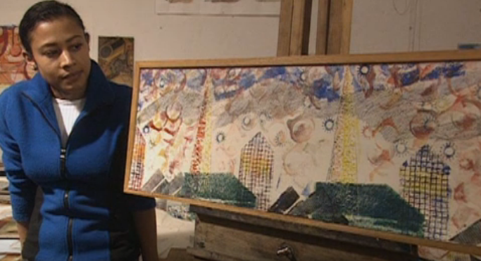

**Key Skills Coverage – DT**

**Prior Knowledge**

**EYFS** -

*used construction kits to explore wheels, axles and vehicles

**Year 2 Children**

*Created moving pictures using mechanisms (levers and sliders) in Y1

**Key Vocabulary**

**Key Skills and Knowledge**

**Design**

*Design purposeful, functional and appealing products for themselves based on a skateboard design criteria

**Make**

*Select from and use a range of tools and equipment to perform practical tasks (cutting, shaping, joining and finishing)

*Select from and use a wide range of materials and components for wheels and axles according to their characteristics

**Evaluate**

*Explore and evaluate a range of vehicles with wheels and axles

*Evaluate their ideas and products against design criteria

**Technical Knowledge**

*explore and use mechanisms (wheels and axles) in their products

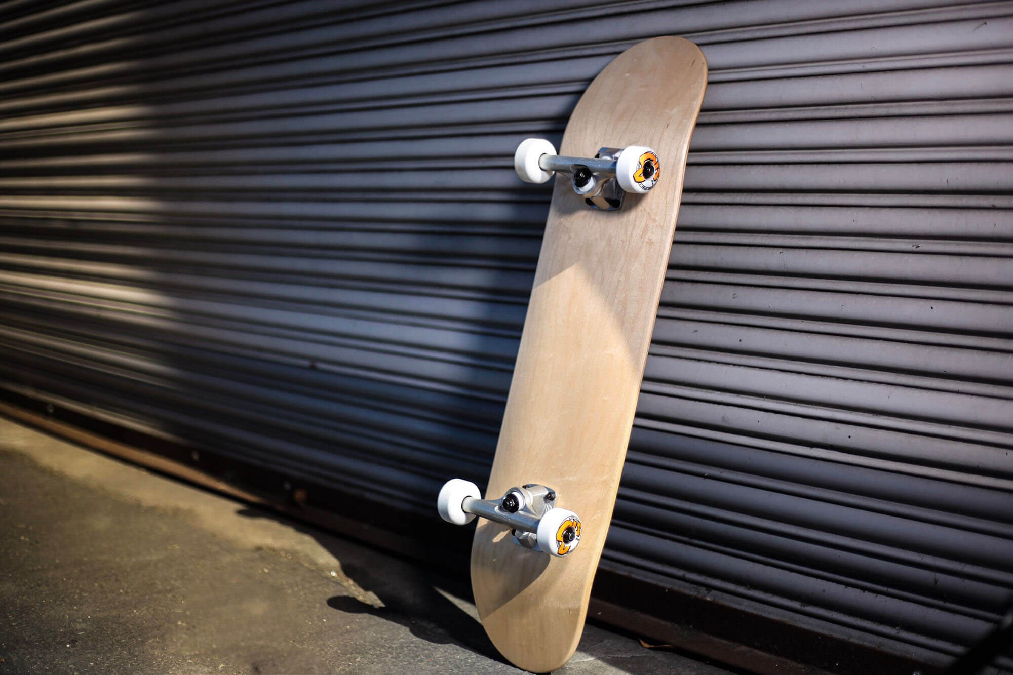

**Mechanism** - a system of parts working together in a machine; a piece of machinery.

**Axles** - a rod or spindle (either fixed or rotating) passing through the centre of a wheel or group of wheels.

**Chassis** - the base frame of a car, carriage, or other wheeled vehicle.

**Skateboard** - a short narrow board with two small wheels fixed to the bottom of either end, on which a person can ride in a standing or crouching position, propelling themselves by occasionally pushing one foot against the ground

**Wheels** - a circular object that revolves on an axle and is fixed below a vehicle or other object to enable it to move easily over the ground.

