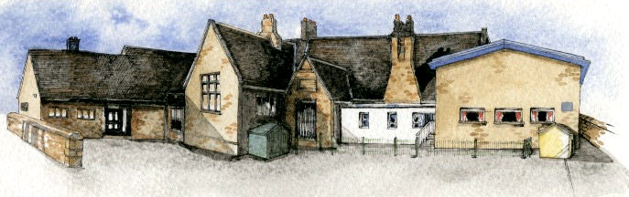

Key Learning Overview; -

Science- Children will be able to identify common appliances that run on electricity. They will construct a simple series circuit, identify faults in their circuit may not be working and name its basic parts including cells, wires, bulbs, switches and buzzers. They will be able to recognise common conductors and insulators.

Design and Technology- Children will be able to design and create a structure that includes electrical components.

History- The Roman Republic (including culture, founding mythology, Carthage and Hannibal)

Geography- The Rhine and the Mediterranean (including cities along the Rhine and how it changes through its course)

Authentic learning opportunities: the children are making a structure and circuitry that they will show to an electrician/ engineer who will comment and give options on how to improve them.

**Class: Sycamore Year 3/4 Term: Spring 1 Cycle A Curriculum Unit –Electricity**

Writing Opportunities- we will write: an explanation text, a fantasy story based on The Firework maker's Daughter, and short writing opportunities linked to our topic, such as an electricity fact file and a persuasive advert based around our DT work.

Class Novel, key texts and extracts-

Firework makers daughter, Scrooge, The Hobbit extracts, The Lion, the Witch and the Wardrobe extracts

**Curriculum Shapers**

**Key Questions**

* Where does electricity come from?
* What appliances run on electricity?
* How does a circuit work?
* What are electrical conductors and insulators?
* What materials let electricity flow through them?
* Why can electricity be dangerous?
* What if we had no electricity?
* Can you make a simple switch to turn a light on and off?
* Why should we try not to waste electricity?

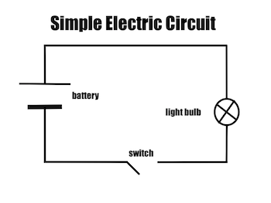

* Be Knowledgeable: develop information processing skills through programming.
* Be Adventurous: develop problem solving skills during DT when adapting a product.
* Be Ambitious and be Positive: develop relevant attributes of learning, resilience and independence.
* Be Creative: develop creative thinking skills to overcome problems in science and DT.
* Be Collaborative: Develop empathy and social skills
* Be Reflective: develop reasoning skills

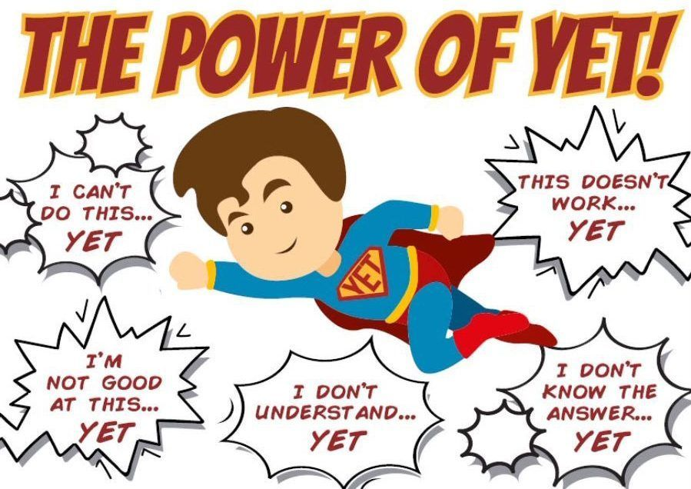

**BRABIN’S ENDOWED PRIMARY SCHOOL**

In KS1: Everyday Materials

* distinguish between an object and the material from which it is made
* identify and name a variety of everyday materials, including wood, plastic, glass, metal, water, and rock
* describe the simple physical properties of a variety of everyday materials
* compare and group together a variety of everyday materials on the basis of their simple physical properties.
* identify and compare the suitability of a variety of everyday materials, including wood, metal, plastic, glass, brick, rock, paper and cardboard for particular uses
* find out how the shapes of solid objects made from some materials can be changed by squashing, bending, twisting and stretching.

**Prior Knowledge**

**Key Skills Coverage - Science**

**Key Scientific Knowledge and Skills**

**Key Vocabulary**

**Appliances**- a device or machine in your home that you use to do a job such as cleaning or cooking. They are often electrical.

**Battery**-small devices that provide the power for electrical items such as torches.

**Bulb**- the glass part of an electric lamps.

Filament- a conducting wire or thread found inside a bulb that heats up to give out light.

**Buzzer**- an electrical device that is used to make a buzzing sound.

**Cell**- a synonym for battery.

**Circuit**- a complete route which an electric current can flow around.

**Conductor**- a substance that heat or electricity can pass through.

**Current**- a flow of electricity through a wire or circuit.

**Device**- an object that has been invented for a particular purpose.

**Electricity**- a form of energy that can be carried by wires and in used for heating and lighting and to provide power for devices.

**Switch**- a small control for an electrical device which you use to turn the device on or off.

**Wires**- a long thin piece of metal that is used to fasten things or to carry electric current.

Knowledge; -

* Identify common appliances that run on electricity
* Construct a simple series electrical circuit, identifying and naming its basic parts, including cells, wires, bulbs, switches and buzzers.
* Identify whether or not a lamp will light in a simple series circuit, based on whether or not the lamp is part of a complete loop with a battery.
* Recognise that a switch opens and closes a circuit and associate this with whether or not a lamp lights in a simple series circuit.
* Recognise some common conductors and insulators and associate metals with being good conductors.

Skills; -

* Observing patterns such as bulbs get brighter if more cells are added, metals tend to be conductors of electricity.
* Diagram











  Description automatically generated

**Key Skills Coverage - Science**

* design purposeful, functional, appealing products for themselves and other users based on design criteria
* generate, develop, model and communicate their ideas through talking, drawing, templates, mock-ups and, where appropriate, information and communication technology
* select from and use a range of tools and equipment to perform practical tasks [for example, cutting, shaping, joining and finishing]
* select from and use a wide range of materials and components, including construction materials, textiles and ingredients, according to their characteristics
* explore and evaluate a range of existing products
* evaluate their ideas and products against design criteria Technical knowledge
* build structures, exploring how they can be made stronger, stiffer and more stable
* explore and use mechanisms [for example, levers, sliders, wheels and axles], in their products.

**Prior Knowledge**

**Key Skills Coverage – Design and Technology**

**Key D&T Skills**

**Key Vocabulary**

**Battery**-small devices that provide the power for electrical items such as torches.

**Bulb**- the glass part of an electric lamps.

Filament- a conducting wire or thread found inside a bulb that heats up to give out light.

**Buzzer**- an electrical device that is used to make a buzzing sound.

**Cell**- a synonym for battery.

**Circuit**- a complete route which an electric current can flow around.

**Conductor**- a substance that heat or electricity can pass through.

**Current**- a flow of electricity through a wire or circuit.

**Device**- an object that has been invented for a particular purpose.

**Electricity**- a form of energy that can be carried by wires and in used for heating and lighting and to provide power for devices.

**Switch**- a small control for an electrical device which you use to turn the device on or off.

**Wires**- a long thin piece of metal that is used to fasten things or to carry electric current.

**Evaluate-** to judge the effectiveness of the product based on the brief.

**Product-** something that is manufactured for sale.

* Investigate similar products to give a starting point for a design.
* Investigate key events and individuals in design technology (Benjamin Franklin, Thomas Edison and Victorians who utilised it)
* Use electrical systems such as switches, bulbs and buzzers.
* Develop vocabulary related to the product.
* Develop more than one design or adaption of an initial design and research the needs of the user.
* Plan a sequence of actions to make a product.
* Decide which ideas to develop considering the capabilities and resources in the school.
* Select materials based on their functional properties.
* Consider and explain how the finished product could be improved.
* Discuss how the finished product meets the design criteria.

**Key Skills Coverage - Science**