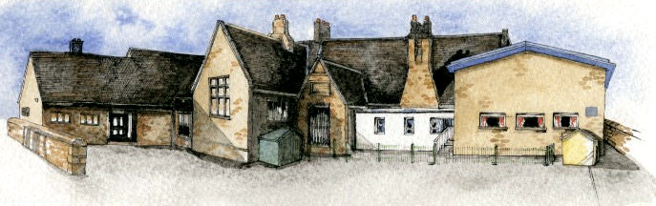

**Key Learning Overview;-**

**Science**- Children will explore the five senses. They will recognise which part of the body is associated with each sense. They will understand the importance of the senses for humans and other animals.

**Geography-** Children will be able to name and identify characteristics of the four countries and capital cities of the United Kingdom and its surrounding seas. They will use maps and atlases to locate them.

Computing – Children will programme floor robots to move along a route. They will learn how to debug programmes.

**Writing Opportunities**-

The children will write:

* character profiles for characters from traditional stories
* setting descriptions
* innovated traditional stories
* postcards from different places within the UK
* letters to characters



Class: Elm Class Year 1/2 Term: Autumn

**Curriculum Unit – The UK**

**BRABIN’S ENDOWED PRIMARY SCHOOL**

**Class Novel, key texts and extracts-**

Little Red

Different versions of Little Red Riding Hood

Other traditional tales

Information books and reports about the UK and London

Dear Dinosaur

* What countries make up the UK?
* What are the capital cities of the UK?
* What sea/oceans surround the UK?
* What are the five senses?
* Which parts of the body are associated with each sense?
* Why do we have senses?
* How can we programme a robot?
* What does debugging mean?

Be Curious: Find out about the features of the capital cities and important landmarks.

Be Knowledgeable: Develop specific geographical language to describe the countries of the UK.

Be Adventurous: Use their senses to explore different sounds, smells and textures.

Be Creative: Use new skills to programme different routes, write new versions of stories.

Be Collaborative: Work with others to produce presentations about the UK.

Be Reflective: Recognise positive points in their own work and in the work of others’.

Be Positive: Consider one’s place in the world.

**Curriculum Shapers**

**Key Questions**

**Key Coverage – Science**

**Prior Knowledge**

**EYFS - Understanding the world: The world**

*Looks closely at similarities, differences, patterns and change.

*Children know about similarities and differences in relation to places, objects, materials and living things.

**EYFS – Mathematics Shape, Space and Measure**

*Orders two or three items by length or height

**Year 2 children**

*What humans need for survival

*Humans are mammals

**Key Knowledge Key Vocabulary**

|  |  |
| --- | --- |
| **Key Vocabulary** | |
| **Stages of development** | baby, toddler, child, teenager, adult. |
| **Senses** | are a collection of **sensory** organs or cells in the body that respond to physical occurrences. **Senses** send information collected to various parts of the brain where the data is interpreted and an appropriate response signal returned. |
| **Vision/ sight** | the power of seeing |
| **Hearing** | the power to perceive with the ear the sound made by (someone or something) |
| **Smell** | the faculty or power of perceiving odours or scents by means of the organs in the nose. |
| **Taste** | the sensation of flavour perceived in the mouth and throat on contact with a substance. |
| **Touch** | the faculty of perception through physical contact, especially with the fingers. |
| **Textures** | the feel, appearance, or consistency of a surface or a substance. |
| **Sounds** | vibrations that travel through the air or another medium and can be heard when they reach a person's or animal's ear. |
| **Smells** | a quality in something that is perceived by the faculty of smell; an odour or scent. |

**Working Scientifically**

*asking simple questions and recognising that they can be answered in different ways

*observing closely, using simple equipment

*performing simple tests

*identifying and classifying

*using their observations and ideas to suggest answers to questions

*gathering and recording data to help in answering questions

**Knowledge**

*Humans have key parts in common, but these vary from person to person.

*Humans (and other animals) find out about the world using their senses.

*Humans have five senses – sight, touch, taste, hearing and smelling. These senses are linked to particular parts of the body.

**Common misconception**

*Humans are not animals

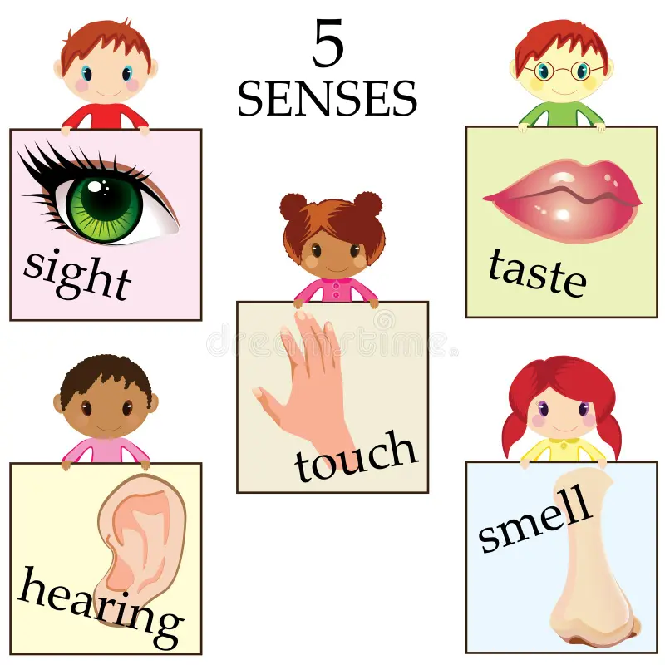

**Key Coverage – Geography**

**Prior Knowledge**

**EYFS - Understanding the world: The world**

*Look closely at similarities and differences

*Children know about similarities and differences in relation to places, objects, materials and living things.

**EYFS - Understanding the world: People and communities**

**\***Children talk about past and present events in their own lives and in the lives of family members.

**The Year 2 children**

*Learnt about the 7 continents of the world

*Place studies – Blackpool and Mugurameno in Zambia

**Key Knowledge Key Vocabulary**

**Aerial view** – a view from above

**Capital city** – the city where the government sits. **London** is the capital city of England and the UK.

**City** – a large town

**Country** – a nation with its own government, occupying a particular territory.

**England** – a country in the UK. Chipping is a village in England.

**Flag** – a piece of cloth which can be attached to a pole and which is used to represent a particular country

**Human Geography** – features of land that have been impacted by human activity

**Island** – a piece of land that is completely surrounded by water

**Great Britain** – An island that is made up of England, Scotland and Wales

**London** – the capital city of England

**Physical Geography** – natural features of a land

**Sea** – a large area of salty water that is part of an ocean

**Scotland** – a country that is north of England

**The United Kingdom** – includes England, Scotland, Wales and Northern Island.

**The Union Jack** - the national flag of the United Kingdom, formed by combining the red and white crosses of St George, St Andrew, and St Patrick and retaining the blue ground of the flag of St Andrew.

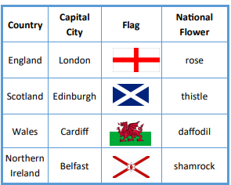

* use world maps, atlases and globes to identify the United Kingdom and its countries
* use simple compass directions (North, South, East and West) and locational and directional language [for example, near and far; left and right], to describe the location of features and routes on a map
* use aerial photographs and plan perspectives to recognise landmarks and basic human and physical features
* Name, locate and identify characteristics of the four countries and capital cities of the United Kingdom and its surrounding seas.
* use basic geographical vocabulary to refer to:

*key physical features, including: beach, cliff, coast, forest, hill, mountain, sea, ocean, river, soil, valley, vegetation, season and weather

*key human features, including: city, town, village, factory, farm, house, office, port, harbour and shop

