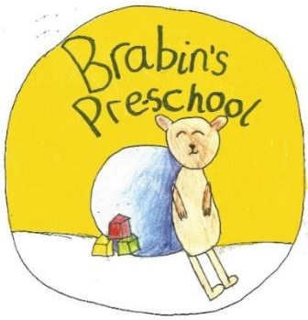
Brabin’s Pre-School
Newsletter
September 2023

Welcome to a new school year! We have enjoyed welcoming lots of new children and their families already and we are thrilled with how well the children are settling in. We have more friends who will be joining us soon!  We also welcome Miss Turner to the pre-school – I’m sure she will be a great asset to the team. Mrs Jackson, Mrs Pearson and Miss Whitehead will continue to work with the children this year.  There has been lots of activity over the summer holidays in the room and I thank Mrs Jackson and Mrs Pearson for giving up lots of their time to make sure the setting was ready for the new school year. They have been busy setting up lots of fantastic new resources – including an outdoor stage area!  We have also had a specially designed pre-school toilet block fitted so some really great changes have taken place.  Everyone is looking forward to another great year!  If you would like to discuss any matters regarding pre-school, please see Mrs Jackson or Mrs Wallace. We thank you for your continued support.  Mrs Wallace  Allergy Information  We have had to make the decision to ask  parents not to bring in birthday cakes  or treats due to a number of children in  school having severe allergies. Of course,  we know the children like to celebrate their birthday, so the school kitchen will ensure a birthday cake is provided for each child –  alongside a rendition of ‘happy birthday!’ |  | Primary School Admissions – September 2024  Apply online from Friday 1 September 2023 online at:  www.lancashire.gov.uk/schools  The statutory closing date is 15 January 2024  Water bottles  Please ensure that the children bring a water bottle into school each day. The  children are encouraged to drink water at various parts of the day.  Friday 13th October  1.30 p.m. to 6 pm  We invite prospective parents to  come and visit the school on this  date.  Alternatively, an appointment can be made to visit on a more convenient  day. Please contact the school office to arrange an appointment.  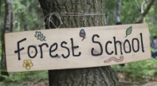  Forest School  Forest School will continue on  Wednesday afternoons. Please ensure your  Child has wellies and waterproof clothing in  school - we go out whatever the weather!

