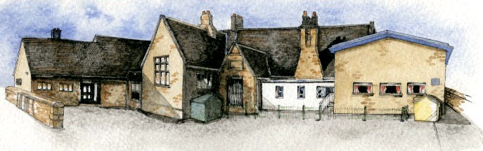

Class: Elm Class Year 1/2 Term: Autumn 1 Curriculum Unit – Me, My Family and Friends

Writing Opportunities-
The children will write:
- innovated stories based on The Owl Babies
- letters from one character to another
- poems on the theme of families

Class Novel, key texts and extracts-
Narrative  The Owl Babies  Rabbit and Bear - Rabbit’s Bad Habits  Rabbit and Bear – The Pest in the Nest | Poetry – Families

Key Learning Overview;-
Science- Children will be able to identify, name and label the basic parts of the human body. They will explore different stages of human growth, baby, toddler, child, teenager and adult.
Art- Children will be able to use their drawing and painting skills to create self-portraits. They will look at and comment on portraits by famous artists including Kathe Kollwitz, Pablo Picasso and Vincent Van Gogh.
History- Children will explore significant changes that have happened in their lives so far and the lives of their families. They will learn about the royal family now and in the past with Queen Victoria.

BRABIN’S ENDOWED PRIMARY SCHOOL

Curriculum Shapers
Key Questions
- Be Curious: Show an interest in life in the past. Use a range of sources to ask and answer questions

- Be Knowledgeable: develop subject specific language. Secure an understanding of childhood in the past
- Be Adventurous: experience exhilaration, challenge and achievement
- Be Ambitious: strive for improvement
- Be Creative: Use new skills to produce their own self portrait. Create their own family tree.

- Be Collaborative: respect the opinions and difference of others and value one’s own perceptions and others

- Be Reflective: Evaluate their own work to make improvements. Recognise positive points.

- Be Positive: Develop their own opinions about their work. Listen to and respond to advice.
- What are the names for the parts of the body?
- How have we changed?
- How are we the same/different to each other?
- What is a self-portrait?
- How do we mix colours to get the one we need?
- What is a family tree? Who is in my family tree?
- How are our lives today different to the lives of our parents and grandparents when they were children?

- Who are Queen Elizabeth II and Queen Victoria?

Prior Knowledge
Key Skills Coverage - Science

EYFS - Understanding the world: The world
*Looks closely at similarities, differences, patterns and change.
*Children know about similarities and differences in relation to places, objects, materials and living things.
EYFS – Mathematics Shape, Space and Measure
*Orders two or three items by length or height
Year 2 children
*What humans need for survival
*Humans are mammals

Key Science Skills
Key Vocabulary
Working scientifically
*Review: Evaluate: Use their observations and ideas to suggest answers to questions.
* Begin to use simple scientific language to talk about or record what they have noticed.

Knowledge – Humans
*Identify, name, draw and label the basic parts of the human body and say which part of the body is associated with each sense.
*Notice that animals, including humans, have offspring which grow into adults.

Key Learning
*Humans have key parts in common, but these vary from person to person.
*Recognise that humans are animals

parts of the body - head, neck, arms, elbows, legs, knees, face, ears, eyes, hair, mouth, teeth, vulva, penis, testicles
stages of development - baby, toddler, child, teenager, adult
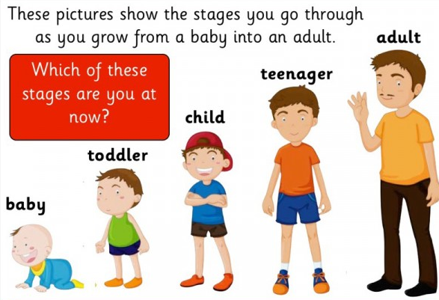
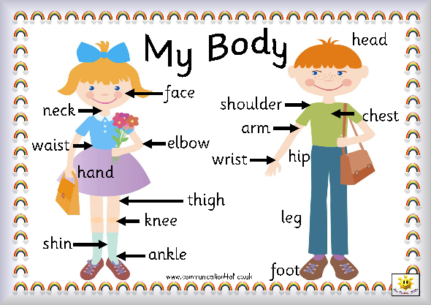

Key Skills Coverage - Art
Prior Knowledge
EYFS - Expressive arts and design: Exploring and using media and materials
*Explores what happens when they mix colours.
*Manipulates materials to achieve a planned effect
*Uses simple tools and techniques competently and appropriately.
*Selects appropriate resources and adapts work where necessary.
Year 2 children
*Observational drawings of penguins and leaves
*Completed paintings in the style of Serena Hall
*Colour matching using collage materials and textiles

Key Art Skills Key Vocabulary
Drawing
*Name, match and draw lines/marks from observations.
*Invent new lines.
*Observe and draw shapes from observations.
*Investigate tone by drawing light/dark lines,

Painting
Pupils should be taught to:
*Use a variety of tools and techniques including different brush sizes and types.
*Mix and match colours .
*Experiment with tools and techniques e.g. layering, mixing media, scrapping through.
*Name different types of paint and their properties.
Colour
*Identify primary and secondary colours by name.
*Mix primary shades and tints.
*Mix secondary colours.
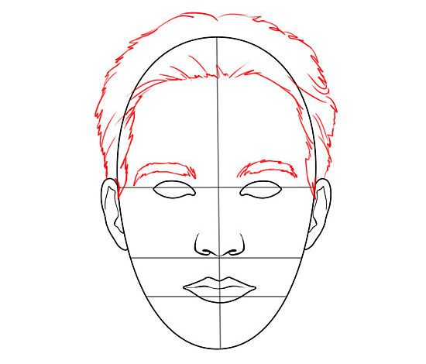
Exploring and Developing Ideas
*Record and explore ideas from first hand observations.
*Ask and answer questions about the starting points for their work.
*Explore the work of artists from different times and cultures for differences and similarities.
Portrait – a painting, drawing, photograph, or engraving of a person, especially one depicting only the face or head and shoulders.
Self-portrait- a portrait that an artist produces of themselves.
Colour mixing- to create a colour by mixing together two or more other colours.
Shade - to darken (an area of a drawing, painting) by drawing many parallel lines or by filling in with a dark or somewhat dark color.
Shades - mixtures of a colour with black
Tints - a pale or light color, often made by adding white to a paint
Tones – how light or dark something is
Primary colours - red, yellow and blue.
Secondary colours- orange, green and purple.
Pablo Picasso – Famous Spanish cubist painter 1881 – 1973
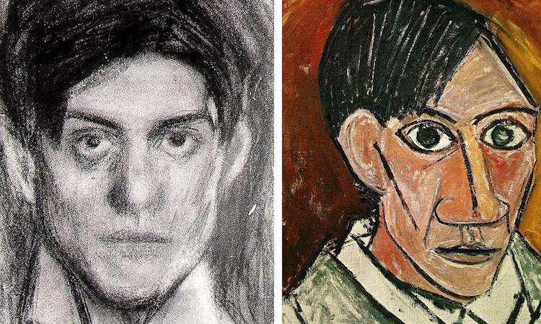
Kathe Kollwitz - Käthe Kollwitz, née Schmidt, was a German artist who worked with painting, printmaking and sculpture.
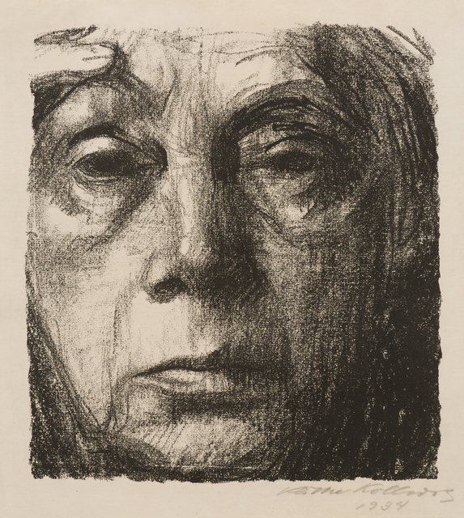

Key Skills Coverage – History
Prior Knowledge
EYFS - Understanding the world: The world
*Looks closely at similarities, differences, patterns and change.
*Children know about similarities and differences in relation to places, objects, materials and living things.
EYFS - Understanding the world: People and communities
*Children talk about past and present events in their own lives and in the lives of family members.
The Year 2 children
*Knowledge of timelines- Christopher Columbus timeline

Key History Skills Key Vocabulary
Chronology
*Identify some similarities and differences between ways of life in different periods
*Use set of events or objects and discuss chronological order

Events, People and Change
*Children will explore significant changes that have happened in their lives so far and the lives of their families

Historical Enquiry, Interpretation and Sources
*Ask and answer questions about the past through observing and using a variety of sources.

Organisation and Communication
*To show what they know and understand about the past in different ways

Timeline - a graphical representation of a period of time, on which important events are marked.
Family Tree - a diagram showing the relationship between people in several generations of a family.
Memory - Something remembered from the past.
Past - A moment of time that is gone or is now a memory.
Present - Something that is happening now.
Long ago - a time that has already happened in the distant past.
Baby - a very young child who needs to sleep and drink milk.
Toddler - a young child that is learning to walk and talk.
Teenager - a person of age thirteen through nineteen
Adult - a person who is fully grown or developed.
Modern - having to do with the present or current times
- using up to date ideas, clothes, toys and technology.
Old - something that was made or built a long time ago.
Before - during the period of time preceding (a particular event or time).
Yesterday - On the day preceding this day.
After - Later in time.
Royal Family - A royal family is the immediate family of Kings and Queen and sometimes his or her extended family.
Queen Elizabeth II – current Queen of the United Kingdom and the Commonwealth
Queen Victoria - was Queen of the United Kingdom of Great Britain and Ireland from 20 June 1837 until her death in 1901

Timeline
Victorian Times | Wartimes | When your Grandparents were born and their childhood | When your parents/carers were born and their childhood | When you were born and your childhood | When you started school

