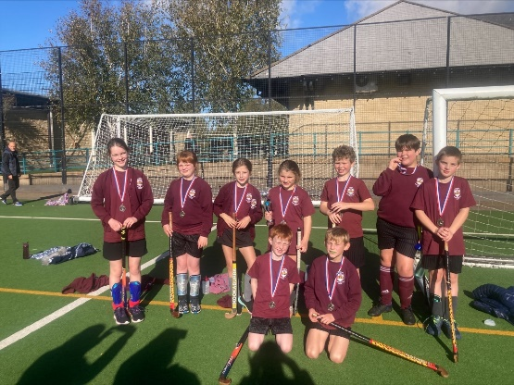
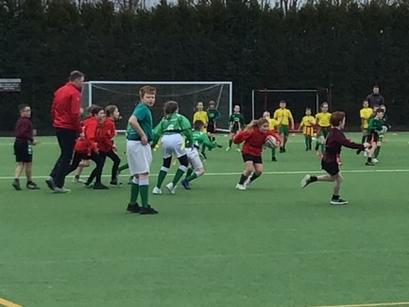
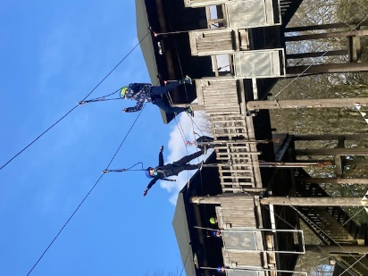
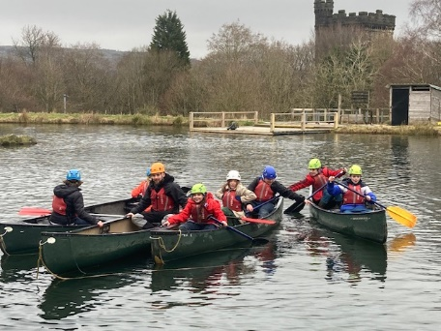
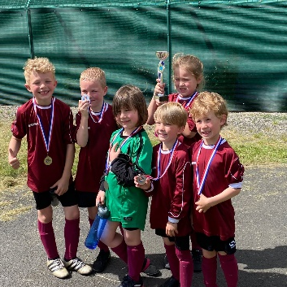
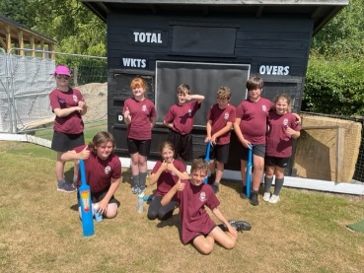
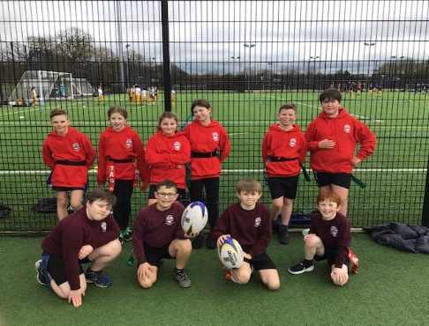
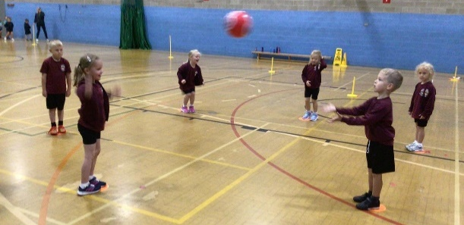
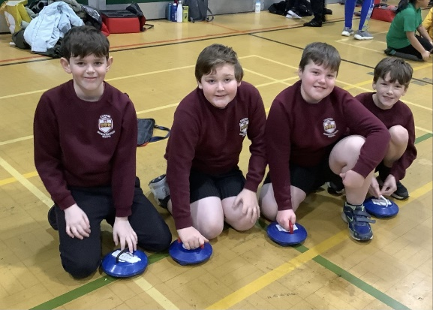
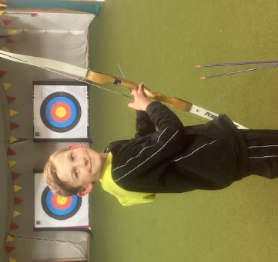
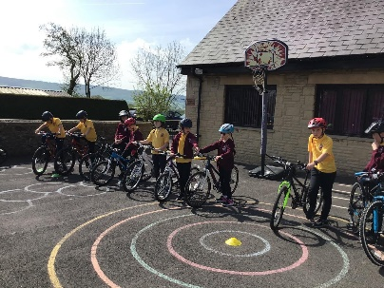
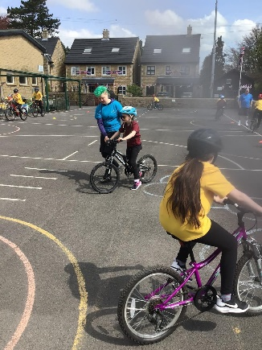

EVIDENCING THE IMPACT OF THE PRIMARY PE AND SPORT PREMIUM
AT BRABIN’S ENDOWED PRIMARY SCHOOL

JULY 2023

Details with regard to funding

Total amount carried over from 2021/22 | £0
Total amount allocated for 2021/22 | £16610
How much (if any) do you intend to carry over from this total fund into 2022/23? | £0
Total amount allocated for 2022/23 | £16820
Total amount of funding for 2022/23. To be spent and reported on by 31st July 2023. | £16820
Swimming Data

Meeting national curriculum requirements for swimming and water safety.
What percentage of your current Year 6 cohort swim competently, confidently and proficiently over a distance of at least 25 metres? | 87.5 %
What percentage of your current Year 6 cohort use a range of strokes effectively [for example, front crawl, backstroke and breaststroke]?  Please see note above | 87.5 %
What percentage of your current Year 6 cohort perform safe self-rescue in different water-based situations? | 100%
Schools can choose to use the Primary PE and sport premium to provide additional provision for swimming but this must be for activity over and above the national curriculum requirements. Have you used it in this way? | Yes. Y6 Top Up swimming for identified pupils and additional provision for EYFS pupils.

Action Plan and Budget Tracking
Capture your intended annual spend against the 5 key indicators. Clarify the success criteria and evidence of impact that you intend to measure to evaluate for pupils today and for the future.

Academic Year: 2022/23 | Total fund allocated: £16820 | Date Updated: 20th July 2023
Key indicator 1: The engagement of all pupils in regular physical activity – Chief Medical Officers guidelines recommend that primary school pupils undertake at least 30 minutes of physical activity a day in school |  |  |  | Percentage of total allocation:
 |  |  |  | £ 2300 13.7 %
Intent | Implementation |  | Impact
Your school focus should be clear what you want the pupils to know and be able to do and about what they need to learn and to consolidate through practice: | Make sure your actions to achieve are linked to your intentions: | Funding allocated: | Evidence of impact: what do pupils now know and what can they now do? What has changed?: | Sustainability and suggested next steps:
- To increase the physical activity of children after school by offering a variety of extra- curricular clubs (after school) | - Continue to affiliate with PNE Education Trust and Absolute Football to plan a timetable of after school sports for all year groups.  - School staff to deliver further clubs i.e. orienteering | £1400 | More children have engaged in extra-curricular clubs across all year groups.  Register of attendance is monitored to ensure all pupil groups have access to provision. | -Use PNE Education Trust coaches, Absolute Football coaches and school staff to deliver a wide range of sports/activities throughout the year.  -Continue to use pupil voice to identify popular sports/activities to encourage high levels of participation.
- To increase physical activity by offering a range of structured activities at break/lunch times.  Such emphasis will have a positive on health as well as providing social opportunities. | - Pro-active Sports Leaders to offer regular, varied and quality sessions e.g. activities linked to sports day  - Weekly lunchtime/break clubs including football, basketball and cross country | Staffing | Regular lunch time active sessions, led by sports leaders engage the majority of pupils across the school.  Sports leaders have acted as positive role models. They have led assemblies and awarded weekly incentives for pupils.  Register of pupils who participated in extra-curricular activities shows that engagement in extra-curricular increased.  New outdoor equipment/climbing frames were replaced last year; this promotes more active playtimes. | - It is evident that some children can only access activities within the day, therefore, offer a range of activities at breaks and lunchtimes to encourage higher levels of regular physical activity.  -Continue with Sports Leader Programme – new leaders to be recruited for 2023/24. Provide training. Purchase new badges/certificates.  -Replace/replenish outdoor equipment as appropriate.
- Increase the awareness of the benefits of a healthy lifestyle throughout school | - Opportunities to teach the importance of a healthy lifestyles i.e. Healthy Living Day- linked to PSHE curriculum /orienteering activities within the curriculum  - Seek enrichment projects/initiatives to promote healthy lifestyles. | Project costs | Through pupil voice, positive feedback was strong about how the school encourages both physical and mental health – May 2023.  Re-stocked library books that promote healthy lifestyles and different sports. | Ensure that teachers plan daily bursts of activity that are age-appropriate i.e. Wake Up, Shake Up.  Plan whole school themed ‘Healthy Living’ to raise awareness of the importance of regular exercise.  Once re-routing of public footpath has been passed, introduce ‘Walk to School’ initiative to encourage more local pupils to walk to school.
Key indicator 2: The profile of PESSPA being raised across the school as a tool for whole school improvement |  |  |  | Percentage of total allocation:
 |  |  |  | £700 6.5%
Intent | Implementation |  | Impact
Your school focus should be clear what you want the pupils to know and be able to do and about what they need to learn and to consolidate through practice: | Make sure your actions to achieve are linked to your intentions: | Funding allocated: | Evidence of impact: what do pupils now know and what can they now do? What has changed?: | Sustainability and suggested next steps:
High quality teaching and learning in PE. Progression of skills throughout the PE curriculum. Effective assessment and tracking so that early intervention and challenge can be implemented. | - Sign up to Lancashire PE Passport to receive updated scheme of work and App.  - Focus in staff meetings to introduce the app to share the benefits it brings to planning, assessing and collating evidence judgements.  - Additional CPD for PE Passport | £484 (PE passport App)  £400 CPD | Updated scheme of work in place.  All staff engage with app to ensure consistent high quality lessons are delivered to all pupils. All pupils have appropriate challenge. | Further CPD, as require, to ensure all staff have appropriate understanding of the app.  Subject Leader to monitor the use of the App, including the effectiveness and evidence.  Seek opportunities to work with cluster school and use as a moderation tool.
Maintain positive links with parents and the wider community about sport and physical activity. | - Post details of participation and success on school’s social media account and website | Staffing | The school has a positive reputation for sport, this is highly valued by parents.  Pupils are motivated and proud to represent the school.  Opportunities are given for pupils of all abilities, including SEN pupils and less engaged. An inclusion team won first place for a Kurling Competition in January 2023.  The school won the Preston Schools’ Small School Championship for 2022/2023 | Continue to update social media and website of sporting opportunities and celebrate with school community.
Whole school sport enrichment days/events to promote positive attitudes towards sport and physical education | - Whole school sports day – summer 2023  - Whole school Forest School Day and extra-curricular opportunities for all ages  - Enrichment days linked to cross-curricular themes | £200 | Such events promote inclusion as all pupils participate. It also provides an opportunity for pupils to work with specialist coaches to inspire and motivate e.g. Olympic Day, school dance festival. | Plan themed days linked to world sporting events and apply cross curricular links.  Further Forest School sessions to older to promote healthy lifestyles.
Gain recognition through the sport award ‘School Games’ to celebrate the schools’ commitment to sport and PE as well as its success.  To demonstrate that Brabin’s values are complemented by sporting values and contribute to their own overall development. | - Apply for school games award  - Assemblies linked to sporting values | Staffing time | The school achieved the silver award for 2021/2022. This success was shared with the school community through a recognised award.  The children feel proud of their achievements. | Continue to raise the profile of PE and school sport.  Apply for School Games Gold award for 2022/2023.

Key indicator 3: Increased confidence, knowledge and skills of all staff in teaching PE and sport |  |  |  | Percentage of total allocation:
 |  |  |  | £6000 35.7%
Intent | Implementation |  | Impact
Your school focus should be clear what you want the pupils to know and be able to do and about what they need to learn and to consolidate through practice: | Make sure your actions to achieve are linked to your  intentions: | Funding allocated: | Evidence of impact: what do pupils now know and what can they now do? What has changed?: | Sustainability and suggested next steps:
Continue to develop subject expertise in identified sports/areas including net & wall, cricket, rugby and dance. | - Continued rolling programme of CPD for staff from PNE Education Trust and Lancashire Cricket coaches to team-teach with Brabin’s teachers to deliver sessions and support training needs. | £4000 | Audits have indicated that staff have improved knowledge following CPD and working with coaches (Invasion Games and Gymnastics). Staff have increased confidence to deliver high quality lessons.  Increased quality extra-curricular programme. Following cricket CPD for Y3/4 teacher, extra-curricular clubs to KS1 & Y5/6 pupils were offered in the summer term 2023.  Y5/6 enjoyed the opportunity to participate in a cricket competition – June 2023. | Audit to be completed as to next year’s areas of support for CPD focus.  Continue to develop all teaching staff and HLTA through CPD to ensure all staff are upskilled and are confident in delivering high quality PE lessons.
All teachers have appropriate knowledge to deliver high quality lessons for all pupils. | - CPD for all staff  on the use of PE Passport App  - new member of team to attend training for Fundamental Movement skills for EYFS.  - Subject Leader to attend PE Network meetings. | £1000 | Knowledgeable teachers/staff ensure that learning can be appropriately moved forward or support provided.  EYFS teacher gained swimming qualification last year (Swim England) and has delivered session to EYFS and Y6 Top Up Swimming sessions this year.  Following a staffing change (PE Subject Specialist moved on) Training courses have been provided for new member of staff to ensure consistency and sustainability for high quality PE.  Other CPD attended: PE Passport, Lancashire PE Conference, Cricket. | The school will continue to invest in CPD for all staff delivering PE. The PE funding is used to address individual areas identified as areas that need to be developed. The aim is that this will lead to higher quality lessons for pupils which will lead to better outcomes.  Subject Leader will continue to monitor the impact of CPD.  Identify pupils for UKS2 Top Up swimming for 2023/2024 and timetable sessions.
Purchase of quality resources to support the teaching of high quality lessons | - Re-organise and update resources to support effective teaching  - Audit resources | £1000 | A focus for 2022-2023 was achieved by purchasing new, high quality equipment to ensure the revised curriculum could be taught effectively. | Well-resourced PE equipment – continue to replenish stock/purchase new resources as appropriate through audit.
Key indicator 4: Broader experience of a range of sports and activities offered to all pupils |  |  |  | Percentage of total allocation:
 |  |  |  | £4000 23.8%
Intent | Implementation |  | Impact
Your school focus should be clear what you want the pupils to know and be able to do and about what they need to learn and to consolidate through practice: | Make sure your actions to achieve are linked to your  intentions: | Funding allocated: | Evidence of impact: what do pupils now know and what can they now do? What has changed?: | Sustainability and suggested  next steps:
Continue to offer a wide range of extra-curricular activities, including a focus on less active pupils who are reluctant to engage in PE and sporting opportunities. | - Timetable of extra-curricular activities throughout the academic year  - Provide a range of activities during lunch/break times | Staffing | The vast majority of pupils attended an extra-curricular club and higher engagement by some of the more reluctant pupils. | Continue to provide activities at no cost or heavily subsidised for all pupils.  Engage pupils in new activities and sports by both external coaches and school staff i.e. archery  Continue to seek pupils’ views to ensure highest levels of engagement.  Keep an attendance register and monitor engagement.
Liaise with local clubs to engage the children with less traditional sports and encourage the children to participate in activities outside school and broaden their experiences. | - Make links with local clubs to plan sessions  - Continue with links with PNE Education Trust to provide additional experiences i.e. penalty shoot out, rugby league |  | Links with local clubs has encouraged pupils to participate in activities outside of school. For example, taster sessions of skateboarding last year was provided and many pupils have signed up and continued to engage with sessions. | Continue to liaise with local clubs/groups to provide enrichment opportunities and encourage participation i.e. golf
To provide off site Outdoor and Adventurous opportunities for all KS2 pupils to help develop resilience, confidence, co-operation and team building.  To introduce pupils to new experiences. | - Y5/6 pupils have the opportunity to attend a 3 day residential in May 2024  - Y3/4 pupils have the opportunity to attend a 2 day residential in March 2024 | £2000 | The Y5/6 residential experience (March 2023) helped build confidence and resilience for those pupils. This need has been more prevalent due to the impact of Covid 19.  The residential provided new experiences that cannot be offered on the school site i.e. water sports, abseiling . | Book future residential visits.  Subject Leader to monitor quality of provision – new centre for June 2024
To provide Bikeability training for Y5 pupils – allowing pupils to cycle safely on the roads – and potentially to school. | - Book 2 day course for all Y5 pupils in May 2024 | Staffing | All pupils in Y5 successfully completed Bikeability training in May 2023.  One pupil had never ridden a bike before and achieved Level 1 and was able to cycle by the end of the course (playground only.) | Continue to provide training so that all pupils attend course in Y5.
Continue to increase competency and confidence in swimming through additional swimming sessions for EYFS and catch up programme for KS2. | - Reception Class to attend weekly swimming lessons during summer term.  - Catch up sessions for UKS2 pupils during summer term | £2000 | 4 Y6 children achieved swimming 25metres after attending Top Up swimming in the summer term 2023.  All Y6 pupils left school being able to perform safe rescue in water situations.  one teacher, with qualified swimming qualification, delivered both the EYFS and Top Up swimming lessons. | Plan Top Up sessions for identified UKS2 pupils for 2024.

Key indicator 5: Increased participation in competitive sport |  |  |  | Percentage of total allocation:
 |  |  |  | £3420. 20.3 %
Intent | Implementation |  | Impact
Your school focus should be clear what you want the pupils to know and be able to do and about what they need to learn and to consolidate through practice: | Make sure your actions to achieve are linked to your  intentions: | Funding allocated: | Evidence of impact: what do pupils now know and what can they now do? What has changed?: | Sustainability and suggested next steps:
To affiliate to, and participate in a wide range of inter-school sporting competitions, through a range of providers.  More pupils engaging regularly in competitive sport. | - Continue to affiliate to Preston Schools’ Sport Partnership  - Attend Cluster sporting events  - Attend Preston School Games events  - Release staff members to provide training sessions to | £750  Staffing costs | Brabin’s School won the ‘Preston Super Mini League’– 2022/2023. See Appendix 1  Increased numbers of children representing the school at inter-school level in a wide range of sports.  All pupils have entered competitions including SEN events. | All pupils can access a wide variety of competitive sports/tournaments through affiliation with a range of providers.  Ensure opportunities continue to engage SEN/more reluctant pupils as well as providing challenge and competition .
Use of school minibus to enable all pupils to attend events. | - Fund the running costs of the minibus so that all pupils have the opportunity to attend competitions/tournaments.  - Additional staff to complete Midas Training | £2000 | By providing our own transport, all pupils have had the opportunity to attend events as we do not have to rely on parental support which could result in non-participation. This also supports appropriate safeguarding arrangements. | Due to the school being located in a rural area, it would prove difficult to transport pupils to events without a minibus so there is need to maintain this transport so all pupils can access additional swimming and competitions.  Current Midas trained staff to renew as appropriate and train additional staff as required.

Signed off by
Head Teacher and Subject Leader: | Rachel Wallace
Date: | 10th July 2023
Chair of Governors: | Mrs Judith Case
Date: | 10th July 2023

Appendix 1: Preston Small School Championship 2022- 23

SUPER MINI LEAGUE School Name | mini skills inclusion | kids cup | u9 mini skills | hockey | u7 mini skills | triathlon | u11 gym | kurling | sir tom finney trophy | u7 mini skills | u9 gym | u9 mini skills | tag rugby | x country | u7 footbal | u7 gymnastics | u5 mini skills | 0 | TOTAL ALL EVENTS
Brabins Endowed | 30 | 50 | 100 | 85 | 70 | 100 | 60 | 30 | 60 | 85 | 50 | 85 | 100 | 70 | 85 | 0 | 70 | 0 | 1130
 | 30 | 40 | 50 | 60 | 100 | 60 | 50 | 30 | 50 | 100 | 60 | 70 | 70 | 85 | 60 | 85 | 60 | 0 | 1060
 | 0 | 70 | 85 | 0 | 0 | 70 | 85 | 0 | 70 | 0 | 100 | 60 | 0 | 0 | 70 | 100 | 0 | 0 | 710
 | 30 | 40 | 70 | 70 | 85 | 85 | 0 | 0 | 85 | 0 | 0 | 0 | 0 | 0 | 100 | 0 | 50 | 0 | 615
 | 30 | 60 | 60 | 100 | 45 | 0 | 70 | 30 | 0 | 0 | 45 | 0 | 0 | 0 | 0 | 70 | 45 | 0 | 555
 | 0 | 45 | 0 | 0 | 50 | 0 | 0 | 0 | 100 | 0 | 70 | 0 | 85 | 100 | 0 | 0 | 85 | 0 | 535
 | 0 | 0 | 60 | 0 | 0 | 0 | 100 | 0 | 0 | 70 | 85 | 100 | 0 | 0 | 0 | 0 | 100 | 0 | 515
 | 0 | 0 | 0 | 0 | 0 | 50 | 0 | 30 | 50 | 0 | 0 | 0 | 60 | 0 | 60 | 0 | 40 | 0 | 290
 | 30 | 85 | 0 | 0 | 60 | 0 | 0 | 0 | 0 | 0 | 40 | 0 | 0 | 0 | 0 | 0 | 0 | 0 | 215
 | 0 | 100 | 0 | 0 | 0 | 0 | 0 | 0 | 0 | 0 | 0 | 0 | 0 | 0 | 0 | 0 | 0 | 0 | 100
 | 0 | 0 | 0 | 0 | 0 | 0 | 0 | 0 | 0 | 0 | 0 | 0 | 0 | 0 | 0 | 0 | 0 | 0 | 0
 | 0 | 0 | 0 | 0 | 0 | 0 | 0 | 0 | 0 | 0 | 0 | 0 | 0 | 0 | 0 | 0 | 0 | 0 | 0

