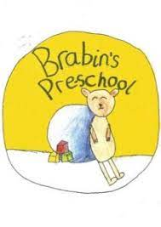
Brabin’s Pre-School
‘All About Me’

Insert Picture Here

My name is:

DOB:

Personal, social and emotional development

I like to play with/I am really interested in:

At the moment I like to play:
By myself/Alongside/With others (please circle)

I can put on my own coat and shoes:
Yes/No/Tries hard to (please circle)

I can use a knife and fork: Yes/No
I can drink from a cup: Yes/No
If your child is upset is there a particular way they like to be comforted?

Is there anything else you would like us to know about your child?

Physical development

I am/am not receiving treatment from the hospital /doctor? (please circle)
PLEASE GIVE DETAILS

I do/do not have allergies, asthma or eczema? (please circle)
PLEASE GIVE DETAILS

Have you had any concerns about your child’s health? Yes/No
PLEASE GIVE DETAILS

I am in a nappy/pull up: Yes/No

I still need help going to the toilet: Yes/No

I can go to the toilet by myself: Yes/No

I need a nap whilst at Pre-school: Yes/No
Please give details

Anything else we need to know?

HOME LIFE

I live with:

I have/do not have any pets (names/type of pet)

Parent’s/Carer’s signature:

Date:

Any additional information:

