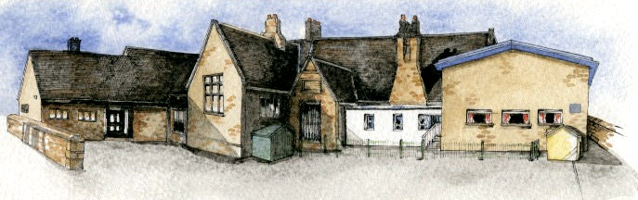

**Curriculum Shapers**

* Be Knowledgeable: develop information processing skills
* Be Adventurous: develop problem solving skills
* Be Ambitious: develop relevant attributes of learning
* Be Creative: develop creative thinking skills adapting our models and music
* Be Collaborative: develop empathy and social skills
* Be Reflective: develop reasoning skills, thinking about why something may have happened in a science experiment, how we could improve it and what we might do differently next time.
* Be Positive: Develop relevant attributes of learning, building focus and resilience.

**Key Questions**

* Why do we have teeth?
* What do the teeth do?
* How many teeth do we have? Is it the same for everyone?
* How can we care for our teeth and gums?
* What are the teeth like of other animals?
* How does this give us information about what they eat?
* How are the teeth of carnivores and herbivores similar or different? Why?
* What happens to our food once it enters our mouths?
* What happens in our bodies between eating our food and going to the toilet?
* How can music affect mood?
* Can music be used to convey mood?
* Should music be different depending on the setting?

Key Learning Overview;-

Science- Children will be able to describe the simple functions of the basic parts of the digestive system in humans and be able to identify the different types of teeth in humans and their function. They will be able to construct and interpret a variety of food chains, identifying producers, predators and prey. They will be able to describe how teeth and gums have to be cared for to keep them healthy.

History- The children will learn about the Victorians in relation to our British History. They will learn about the key people from the Victorian era and how major inventions and events changed out history.

Art- Children will be able to plan design and make 3D models from observation or imagination. They will then be able to evaluate and adapt their work according to their views and describe how they might develop it further.

Writing Opportunities- we will write: a story based on Bill’s New Frock, a persuasive advert or sales pitch, kenning poems and create non-fiction pieces on the digestive system, teeth and food chains.

Authentic Learning outcome: A instructional video about how the digestive system works for sharing on the school website and Facebook pages.

**BRABIN’S ENDOWED PRIMARY SCHOOL**

**Class: Sycamore Year 3/4 Term: Autumn 1 Cycle A Curriculum Unit –Chew to Poo**

* Identify that animals, including humans, need the right types and amount of nutrition, and that they cannot make their own food; they get nutrition from what they eat
* Identify that humans and some other animals have skeletons and muscles for support, protection and movement.
* Notice that animals, including humans, have offspring which grow into adults
* Find out about and describe the basic needs of animals, including humans, for survival (water, food and air)
* Describe the importance for humans of exercise, eating the right amounts of different types of food, and hygiene.

**Prior Knowledge**

**Key Skills Coverage - Science**

**Key Scientific Knowledge and Skills**

**Key Vocabulary**

**Digestive system**-the group of organs that work together to break down food to be used by the body.

**Saliva**- a fluid, containing enzymes, produced in the mouth to help digest food.

**Enzyme**- a natural catalyst produced by the body (it speeds up the reaction)

**Oesophagus**- a tube connecting the mouth to the stomach.

**Stomach**- an organ that breaks down food further using enzymes and muscles.

**Small intestine**- allows useful substances to be absorbed into the bloodstream for the body to use.

**Large intestine**- absorbs water from undigested food and gets rid of undigested food (faeces).

**Faeces**- waste matter removed from the body (poo).

**Gums**- the tissue that hold your teeth in place in your mouth.

**Incisor**- teeth that help you bite off and chew pieces of food.

**Molar**- teeth that allow you to crush and grind food.

**Canine**-teeth used for tearing and ripping food.

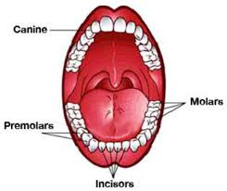

**Knowledge**

* Describe the simple functions of the basic parts of the digestive system in humans.
* Identify the different types of teeth in humans and their simple functions.
* Construct and interpret a variety of food chains, identifying producers, predators and prey

**Skills**

* Compare the teeth of carnivores and herbivores and suggest reasons for the differences.
* Investigate the effects of different substances on teeth, making predictions, setting up a simple scientific experiment, comparing results and findings then drawing a conclusion and reporting on findings.

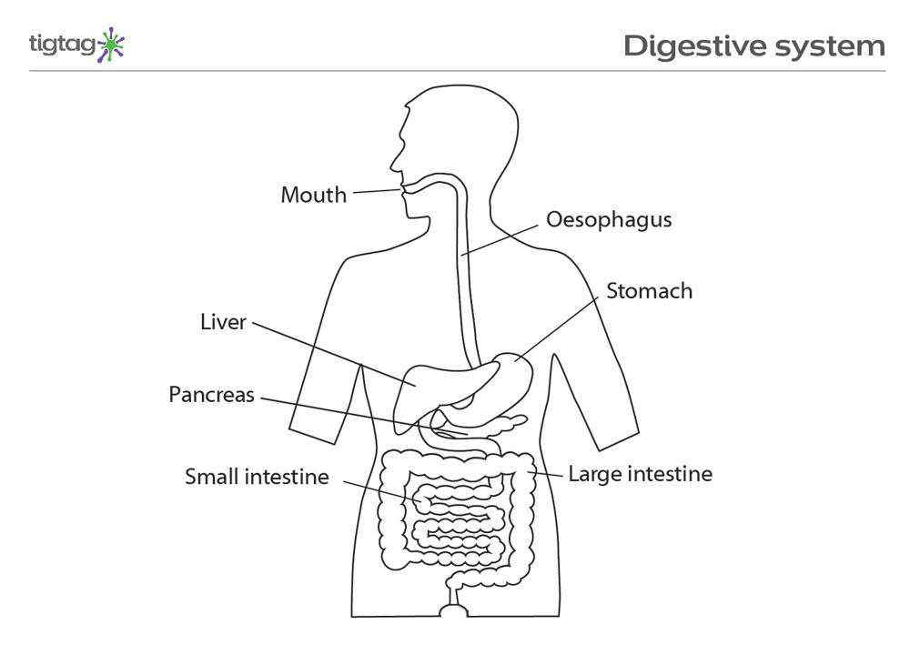

**Key Skills Coverage - Science**

**Key Skills Coverage - History**

British Empire - Lands that Britain controlled all over the world.

Coronation -The formal service of a making a person king/queen of a country.

Crime - Actions which break the law of a country. Many things were crimes in Victorian times with harsh punishments, even for children.

Disease - Illnesses, many of which were very dangerous (cholera, smallpox)

Government - People chosen by the country to pass laws and run the country.

Laws rules passed by government which people living in a country have to abide by.

Mines - Underground areas where people worked digging out coal and other minerals.

Parliament - The House of Lords and the House of Commons who meet to advise the Queen

Public health – The health of people living in a particular place, often looked after by the government.

Upper class - Wealthy people, often estate owners, who had a lot of money.

Workhouse - Places set up by the government where poor people with no money could go and be given a bed. Many had very harsh rules.

Working class - The bottom of the Victorian class system. Could be anyone from a skilled mechanic earning £90 a year to a servantearning £10 per year.

**Key Vocabulary**

***Victorians*****Curriculum enrichment**

*Focus on the changing power of the Monarch using studies such as Victoria*

Understand some of the ways in which people’s lives have shaped this nation.

Understand how our knowledge of the past is constructed from a range of different sources and that different versions of the past events may exist giving some reasons for this.

Organise relevant Historical information using appropriate dates and times.

**Key Historical Skills**

In KS1:

Changes within Living Memory

Great Fire of London

Famous British People and the changes they made - Tim Berners- Lee

World Explorers– Chris Columbus/Neil Armstrong

Local History Significant places and people in their locality - John Brabins

History of the Seaside

Old and New Toys

**Prior Knowledge**

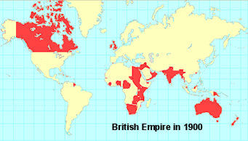

**Key Skills Coverage - Science**

* to use a range of materials creatively to design and make products
* to use drawing, painting and sculpture to develop and share their ideas, experiences and imagination
* to develop a wide range of art and design techniques in using colour, pattern, texture, line, shape, form and space
* about the work of a range of artists, craft makers and designers, describing the differences and similarities between different practices and disciplines, and making links to their own work.

**Prior Knowledge**

**Key Skills Coverage - Art**

**Key Vocabulary**

**Key Artistic Skills**

3D- an object with height, width and depth.

Tone- how light or dark something is.

Texture- how something feels when touched.

Tint- add white to a colour to create a lighter tint or tone.

Shade- add black to a colour to create a darker shade or tone.

Primary Colours- Red, Yellow and Blue. Three colours that cannot be made by mixing other colours.

Secondary Colours- colours created by mixing primary colours and other colours.

Still life- drawing or paintings that focus on still objects which are inanimate and never move.

* Explore the roles of different artists.
* Arrange objects in preparation for drawing still life.
* Children use a range of materials to make observational drawings (charcoal, pencils, crayons) and begin to experiment with texture.
* Experiment with drawing and painting still life for extended periods of time.
* Explore how to mould and join pieces of clay to create sculptures and use known skills to add detail.
* Mix colours and know what primary colours make secondary colours.
* Learn how brush size and pencil sharpness may affect paintings and drawings.

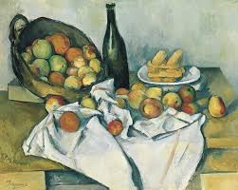

**Key Skills Coverage - Science**