
Online safety at Brabin’s
This poster will tell you everything about online safety.
Only talk to people you know and trust.
Never give personal information to strangers.
Learn to use computers before you play online and pay.
It is important to not to go on tabs you do not no.
Never pay for things unless your family or teacher tells you to do so.
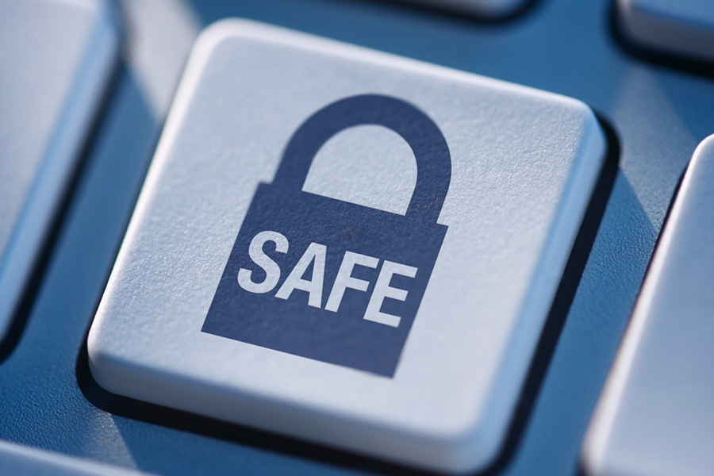
Each person needs to know about computing before they do anything.

For further information, use these websites.
- https://www.childnet.com/
- https://www.nspcc.org.uk/keeping-children-safe/online-safety/
- https://www.internetmatters.org/

By Fraser and Evie.

