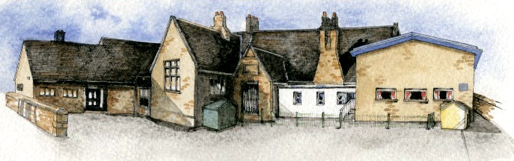

Writing Opportunities- we will write: a film playscript based on Gullivers Travels, poems about different countries around the world, and debates and reports.

Key Learning Overview;-

Geography- the children will be learning about a contrasting European country and a specific region within that country.

Art- the children will be using computers to create art using digital media/ photography

DT- the children will be designing and making simple savoury foods for a purpose using new cooking techniques.

Music- the children will be learning about the history of music and the music of some famous European composers.

Science- study of European scientists and their effects on the world.

Authentic learning opportunities: The children will create discussion and persuasion texts and send them into the local council (Ribble Valley or Preston).

**BRABIN’S ENDOWED PRIMARY SCHOOL**

**Class:Sycamore Year 3/4 Term:Summer 2 Cycle A Curriculum Unit–European Adventure**

* What do the children know already about this region? What would they like to know or find out?
* Where is the region located? How far away is this region? How might people travel there?
* What is the physical geography like e.g. climate, landscape, rivers, mountains etc? What distinctive features does the region have?
* What is the human geography like e.g. settlement size, transport, tourist attractions, economic activity and trade links?
* Why have towns and cities developed where they are?
* How does location, climate etc. have a bearing on economic activity in the region?
* What are the similarities and differences between this region and the region of the UK that has been explored previously?
* What are the lives of children in this region like? How are their lives similar to ours? What would it be like to live in this place?

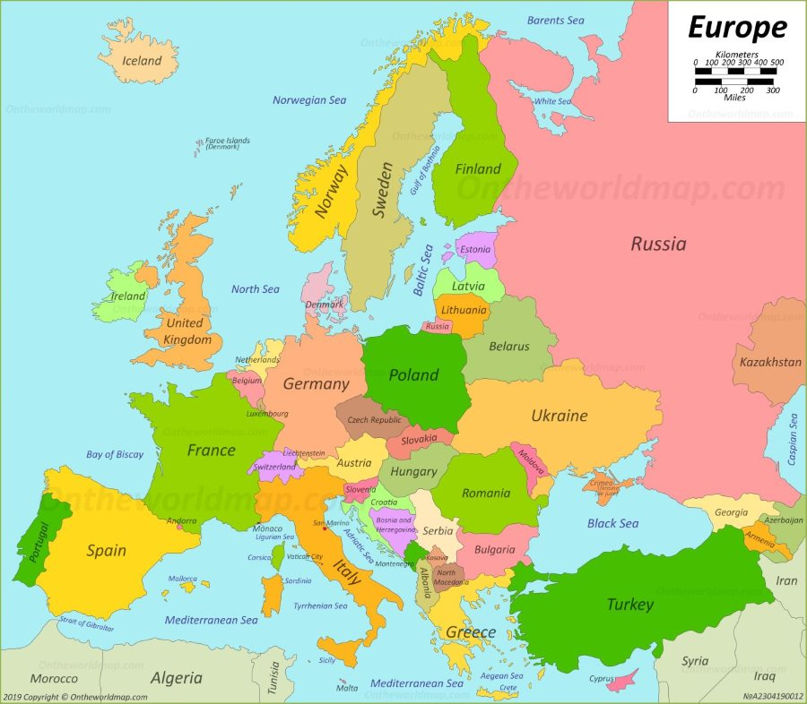

**Key Questions**

* Be Curious: engage in first-hand experiences and experience contrasts between different countries.
* Be Knowledgeable: nurture a thirst for knowledge and apply cross -curricular skills
* Be Adventurous: work outside of comfort zones when performing music and making a meal.
* Be Ambitious: link with experts.
* Be Creative: develop creative thinking skills and question why
* Be Collaborative: working as a team to make a savoury meal.
* Be Reflective: listen to and act on advice
* Be Positive: develop self-esteem
* 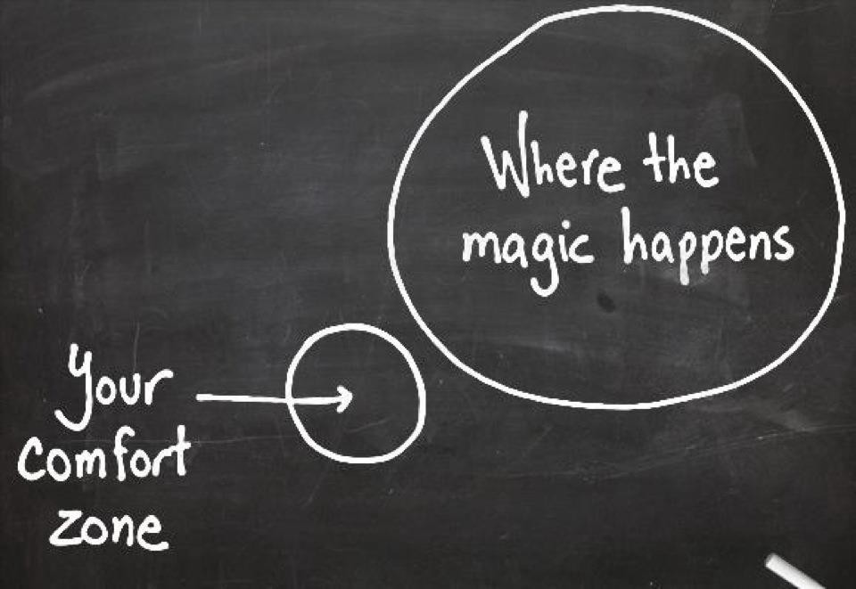

**Curriculum Shapers**

Class Novel, key texts and extracts-

Gulliver’s Travels, non- chronological reports about Europe and European countries, playscripts based on films and debates.