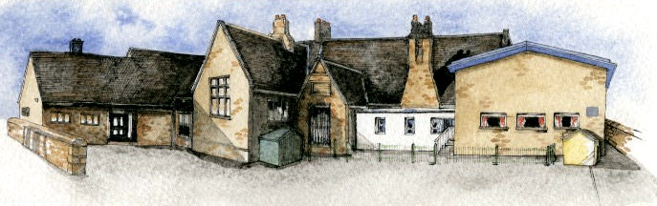

Writing Opportunities- we will write: stories with a flashback set during WW2, letters and a new chapter linked to our novel ‘Goodnight Mr Tom’ and information booklets linked to our Science Week.

Key Learning Overview;-

**History**- Children will analyse connections, trends and contrasts over time in relation to the social aspects of ‘the WW2 with a specific focus on local history.

**DT**- ‘Make do and mend’. Children will up-cycle old clothing by creating a new product using a range of sewing techniques.

**Science**- an enrichment week: investigating the works of famous scientists and their contributions to the wider world.

**Geography**- an enrichment week: children will be able to carry out fieldwork within the local area- with a focus on changes to the area since WW2.

**Class: Oak Year 5/6 Term: Summer 1 2022 Curriculum Unit – Chipping during World War II**

**BRABIN’S ENDOWED PRIMARY SCHOOL**

* Be Curious: engage in first-hand experiences and experience contrasts between periods of history and geographical locations.
* Be Knowledgeable: nurture a thirst for knowledge and apply cross -curricular skills
* Be Ambitious: link with experts (Chipping Historical Society)
* Be Creative: develop creative thinking skills and question why. Apply previously learnt skills to new situations.
* Be Collaborative: respect the opinions and differences of others
* Be Positive: develop self-esteem
* How was life different for people living in Chipping during WW2?
* Why were children evacuated to the area? Where did they live?
* How did the War affect people living in and around Chipping?
* What are the physical and human geography elements of Lancashire and the surrounding area?
* How has this changed since WW2?
* What do we mean by ‘Make Do and Mend’?

Class Novel, key texts and extracts- Novel: Goodnight Mr Tom.

Extracts of: My Uncle’s Dunkirk and Carrie’s War.

**Curriculum Shapers**

**Key Questions**

Chronology

* Sequence events and periods relating to the theatre
* Analyse connections, trends and contrasts over time
* Know and understand the history of these islands as a coherent, chronological narrative, from the earliest times to the present day
* In depth study of different periods, using appropriate vocabulary

Events, People and Changes

* Gain historical perspective by placing their growing knowledge into different contexts by studying aspects of cultural and social history*.*
* Establishing a narrative showing connections and trends within and across periods of study.
* Begin to recognise and describe the nature and extent of diversity, change and continuity and suggest relationships between causes

Communication

* frame historically-valid questions involving thoughtful selection and organisation of relevant historical information using appropriate dates and terms.

Enquiry, Interpretation and Sources

* Understand methods of historical enquiry, how evidence is used to make historical claims
* Use sources as a basis for research
* Understand how our knowledge of the past is constructed from a range of different sources and that different versions of past events often exist

**Air raid-** An attack by planes dropping bombs.

**Allies-** Countries (including Britain, France, the Soviet Union and the USA) who joined forces to fight the Axis Powers.

**Axis Powers-** Germany, Japan, Italy and other countries that were allies in World War 2.

**Blackout-**Wartime ban on street lights and other lights at night.

**Blitz-** German air raids, from a German word 'blitzkrieg' which means 'lightning war'.

**Commonwealth**- Group of friendly countries almost all of which were once part of the British Empire.

**D-Day-** 6 June 1944, the date Allied forces landed in Normandy, France.

**Evacuee-** Someone who was evacuated, moved from a danger area to a safer place.

**Forces-** The Army, Royal Air Force, Royal Navy and other services.

**Neville Chamberlain and Winston Churchill**- British Prime ministers

**Hitler,Adolf (1929-1945)-** Leader of Nazi Germany.

**Prisoners of war-** Soldiers captured enemies

**Rationing-** Controlling the supply of food, clothes, petrol and other things.

**Invaded-** Attacked and taken over by an enemy.

**Liberate**- To free from an enemy's control.

**Key Skills Coverage - History**

**Prior Knowledge**

**Key Historical Skills**

**Key Vocabulary**

* Year 1/2: A study of events beyond living memory- The Great Fire of London
* Year 1/2: A study of significant people including Christopher Columbus
* Year 1/2: Comparative study-The seaside then and now
* Year 3/4: A theme in British History- the Great Plague
* Year 3/4:A Study of Ancient Egypt
* Year 3/4:Roman Britain
* Year 3/4:Ancient Britain- the Stone Age

**Key Skills Coverage - DT**

Prototype-A model which is made to test whether a design will work.

Texture-Surface quality of being, for example, hard, soft,smooth or rough.

Binca-Textile with regular weave, useful for embroidery.

Calico-Coarse, heavyweight fabric usually used for producing prototype garments.

Mesh-The open space between woven threads.

Appliqué-Describes method of stitching/gluing patches onto fabric

back-stitch-Stitching where each stitch overlaps the previous one.

blanket stitch-Hemming stitch, particularly on the edge of blankets.

cross-stitch-Stitches which form a cross shape.

running stitch-Stitches which do not overlap.

|  |
| --- |
| **Textiles**   * Use the correct vocabulary appropriate to the project. * Create 3-D products using patterns pieces and seam allowance. * Understand pattern layout. * Decorate textiles appropriately (often before joining components). * Pin and tack fabric pieces together. * Join fabrics using over sewing, back stitch, blanket stitch or machine stitching (closer supervision). * Combine fabrics to create more useful properties. * Make quality products.   **Research**   * Use research to inform the design of the product   **Design**   * Ensure product is fit for purpose and audience * Draw and annotate sketches, diagrams and prototypes   **Make**  *Use a wide range of tools for sewing and textile materials  **Evaluate**   * Evaluate product against design criteria * Consider the views of others |
| **Design and Technology** | |
| **Key Learning (contd.)** | |
| **Evaluation (of their Finished Product)**   * Give a report using correct technical vocabulary. * Consider and explain how the finished product could be improved related to design criteria. * Discuss how well the finished product meets the design criteria of the user. Test on the user. | |

**Key Design Skills Key Vocabulary**

* Year 1/2: Sewing- making puppets

Year 3/4: Mechanical Systems- levers and linkages

* Year 3/4: Control- electrical systems
* Year 3/4:Textiles- seams, stiffening, strengthening, materials and fastenings

**Prior Knowledge**

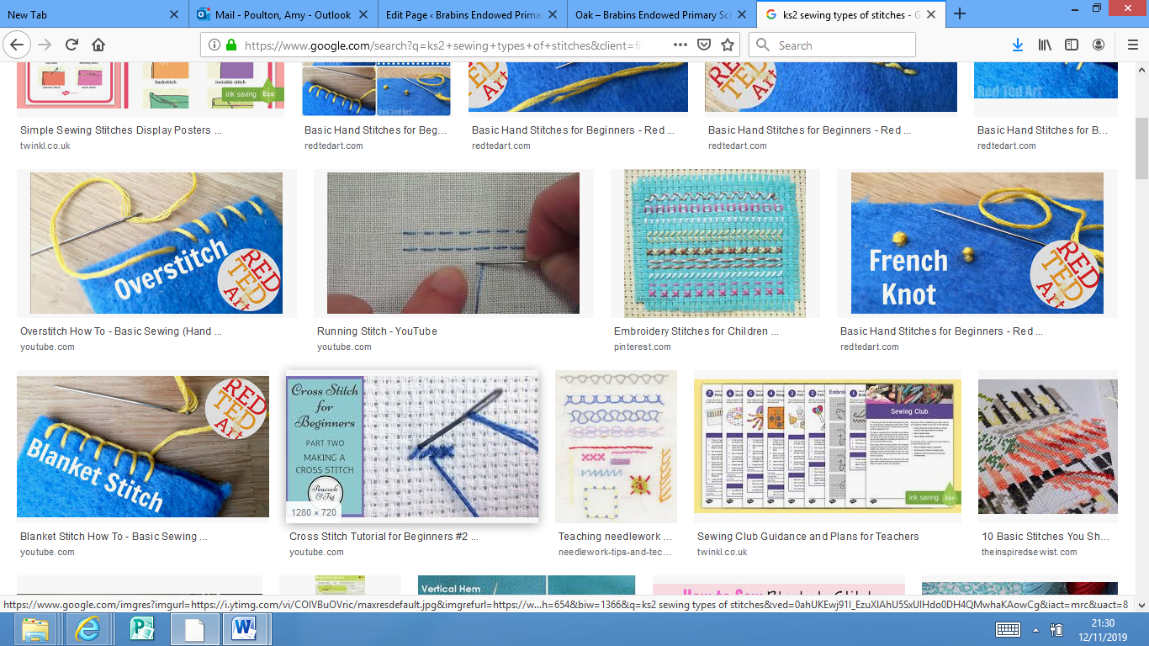

**

**Prior Knowledge**

Year 3/4: Science Investigation Week

Year 3/4: Famous European Scientists Week

**Key Skills Coverage – Science (Enrichment)**

**Key Skills**

Practical Investigations:

* planning different types of scientific enquiries to answer questions, including recognising and controlling variables where necessary
* taking measurements, using a range of scientific equipment, with increasing accuracy and precision, taking repeat readings when appropriate
* recording data and results of increasing complexity using scientific diagrams
* using test results to make predictions
* reporting and presenting findings from enquiries, including conclusions, causal relationships and explanations of and degree of trust in results, in oral and written forms
* identifying scientific evidence that has been used to support or refute ideas or arguments
* Use fieldwork to observe, measure and record the human and physical features in the local area using a range of methods, including sketch maps, plans and graphs, and digital technologies.
* Use the eight points of a compass, four-figure grid references, symbols and key (including the use of Ordnance Survey maps) to build their knowledge of the United Kingdom in the past and present.
* Extend to 6 figure grid references
* Linking with History, compare land use maps of UK from past with the present.

**Key Skills**

Year 1/2: Local Study of the School

Year 1/2: UK countries and capitals

Year 1/2: Study of Blackpool

Year 3/4: Local Study- Ribchester/Romans

**Prior Knowledge**

**Key Skills Coverage – Georgraphy (Enrichment)**