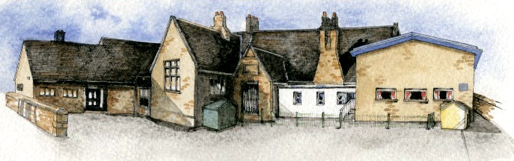

**Key Learning Overview**;-

**Science-** children will find out about and describe the basic needs for animal, including human, survival.

**Music-** children will listen to Latin music and work collaboratively to produce their own Latin music.

**Art-** children willdraw the human figure in action in various poses. They will use these drawings as inspiration to create a clay model of a human figure.

**DT-** children will learn about the different sections of the ‘Eatwell Plate’ and will design and make a fruit salad.

**PSHE-** children will gain a greater understanding about what it means to be healthy and why it is important.

**Geography-** the children will learn about the continents and oceans and where some of their food comes from.

**Writing Opportunities**-

The children will write:

* Character descriptions of Anansi from different stories
* Innovated stories based on the character of Anansi
* Guide to keeping healthy
* Recipes



Class: Elm Class Year 1/2 Term: Summer 1

**Curriculum Unit – The Active Human**

**Class Novel, key texts and extracts-**

Flat Stanley

Anansi Does the Impossible

How Anansi Got His Stories

Anansi the Spider: A Tale from the Ashanti

Anansi and the Turtle

A number of information books and non-chronological reports about keeping healthy

Recipes

* What do animals, including humans need to survive?
* Why do we need to eat a range of different foods?
* What is the Eatwell plate?
* How much sugar is in our cereal?
* Where does our food come from?
* What are seasonal fruit and vegetables?
* What happens to our bodies when we exercise?
* Why is hygiene important?
* What are germs?
* What are the characteristics of Latin music?
* Who is Keith Haring and what do I think about his work?
* How can we join clay together to create the human figure?

Be Curious: Engage in multi-sensory learning; tasting different fruits and vegetables; feeling the affect exercise has on the body.

Be Knowledgeable: Apply cross curricular knowledge, linking learning in science, PSHE, DT and geography. Manage, organize and record learning in an information book.

Be Adventurous: Work practically within and outside one’s own comfort zone.

Be Ambitious: Strive for improvement

Be Creative: Apply newly learnt skills to sculpt a clay figure. Explore alternatives when engaged in problem solving activities.

Be Collaborative: Work collaboratively to create a class information book. Challenge one’s own work and the work of others.

Be Reflective: Make lifestyle choices in response to thoughts. Move towards the understanding of a wide range of feelings (success/failure).

**Curriculum Shapers**

**Key Questions**