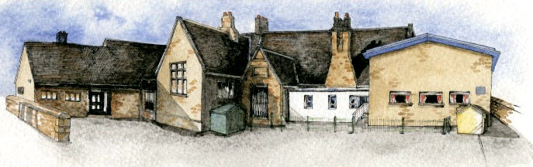

Key Learning Overview;-

Science- Children will be able to recognise how shadows are formed and how their sizes can change, recognise that light from the sun is dangerous and that light is needed to see.

History- Children will be able to understand the significance of Stonehenge, make links across time periods looking at similarities and differences and understand where the Stone Age fits on a timeline.

Art- Children will explore the work of printmakers such as Eric Gill and study drawings of fossils by early palaeontologists.

Authentic Learning Opportunities: The children will create information videos and writings based on the stone age for publishing in an ebook.

Writing Opportunities- we will write: a story based on Stig of the Dump, Non- chronological reports about the Stone Age, an advert for Stonehenge and other opportunities linked to our topic.

**BRABIN’S ENDOWED PRIMARY SCHOOL**

**Class: Sycamore Year 3/4 Term: Summer 1 Cycle A Curriculum Unit – Stone Age**

**Curriculum Shapers**

* Be Curious: engage in first-hand experiences and experience contrasts between periods of history.
* Be Knowledgeable: nurture a thirst for knowledge and apply cross -curricular skills
* Be Adventurous: develop problem solving skills
* Be Ambitious: develop a growth mindset.
* Be Creative: develop creative thinking skills
* Be Collaborative: develop empathy and social skills
* Be Reflective: listen to and act on advice
* Be Positive: consider ones place in the world by understanding where we fit in a timeline.

**Key Questions**

* What was life like after the dinosaurs became extinct but before modern man?
* What kind of animals lived in the Stone Age?
* What did Britain’s first farming settlements look like?
* When was Stonehenge built and where is it?
* What are shadows?
* How are shadows formed?
* How does light travel?
* Can shadows change?

Class Novel, key texts and extracts-

Stig of the Dump, Skara Brae, Wolf Brother (extracts), The Secrets of the Stone Age and The History Detectives Investigate: Stone Age to Iron Age