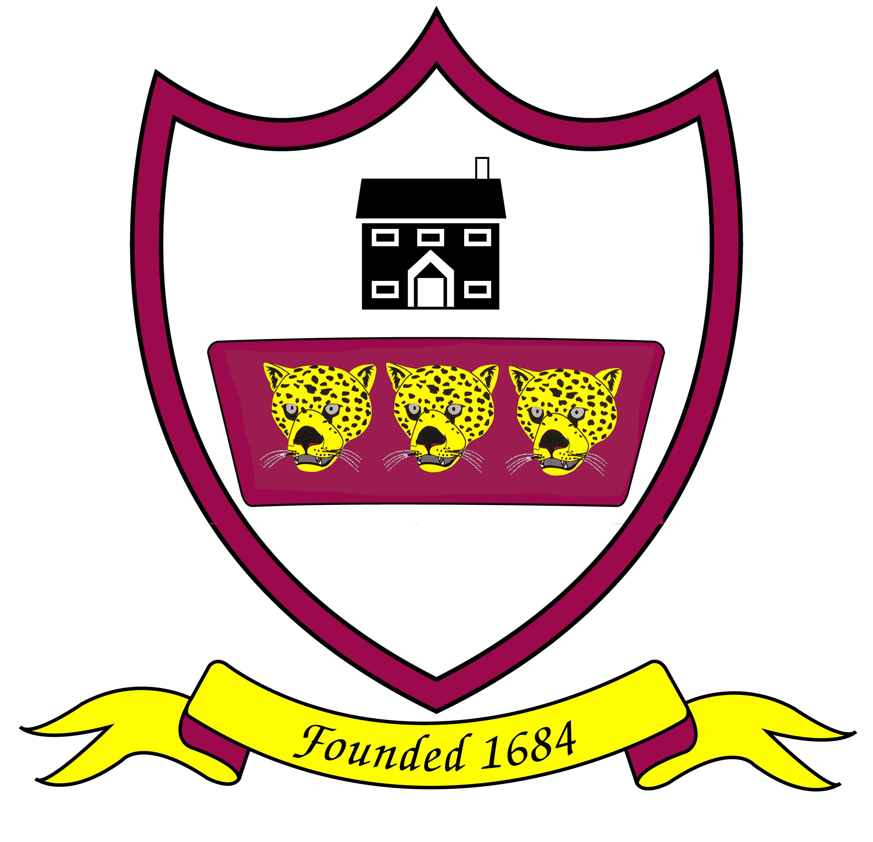 Brabin’s Endowed Primary School

SINGLE EQUALITIES POLICY 2022

Reviewed: March 2022
Review due: March 2023

INTRODUCTION
The policy outlines the commitment of the staff, pupils and governors of Brabin’s Endowed Primary School to ensure that equality of opportunity is available to all members of the school community. We will strive to eliminate all forms of discrimination, harassment and victimisations and foster good relations with all. For our school this means not simply treating everybody the same but understanding and tackling the different barriers which could lead to unequal outcomes for different groups of pupils in school, whilst celebrating and valuing the achievements and strengths of all members of the school community. These include:
- Pupils
- Staff
- Parents/carers
- The governing body
- Multi-agency staff linked to the school
- Visitors to school
- Students on placement

STATEMENT OF PRINCIPLES
We believe that equality at our school should permeate all aspects of school life and is the responsibility of every member of the school and wider community. Every member of the school community should feel safe, secure, valued and of equal worth.
At Brabin’s Endowed Primary School, equality is a key principle for treating all people fairly and creating a society in which everyone has the opportunity to fulfil their potential - irrespective of their gender, ethnicity, disability, religion or belief, sexual orientation, age or any other recognised area of discrimination. Our Christian ethos permeates all aspects of school life and we attempt to follow Jesus’ example in including everyone.

Our primary purpose is to serve the families within our ecclesiastical parish whose parents wish their children to be educated at our school. Our admissions arrangements are fair and transparent.
We are committed to providing a working environment free from discrimination, bullying, harassment and victimisation. We aim to recruit an appropriately qualified workforce and establish a governing body that is representative of all sections of the community in order to respect and respond to the diverse needs of our populations. As a Christian school we expect all staff to respect and promote the Christian ethos of our school.

Pupil’s view of equality here at Brabin’s School (March 2022)

“Treating people equally no matter their age, race, gender, religion beliefs or appearance.”
Emma.
“If everyone was treated equally, the world would be a better place. Some of our current problems in the world would be solved e.g the current troubles in Ukraine.” Finlay.
“Everyone should be treated fairly. Equality is making sure everyone gets the same opportunities.”
Bailey.

We aim to provide all our pupils with the opportunity to succeed, and to reach the highest level of achievement; academically, personally and spiritually.
The achievement of all pupils will be monitored, where appropriate in light of the protected characteristics outlined in the Equality Act 2010. We will use the analysis of this data to support pupils, raise standards and ensure inclusive teaching.
Brabin’s Endowed Primary School will ensure that we buy services from organisations that comply with equality legislation. This will be a significant factor in any tendering process.

STAUTORY REQUIREMENTS
The Equality Act 2010 has brought together all the current discrimination laws into one and sets out the “protected characteristics” that qualify for protection from discrimination as:
- Age (relevant in duties as an employer but not in relation to pupils)
- Disability
- Gender reassignment
- Pregnancy and maternity
- Race
- Religion or belief
- Sex
- Sexual orientation
- Marriage/Civil Partnership

The Act introduces a single Public Sector Equality Duty (PESD), sometimes referred to as the general duty. The combined duty has 3 main elements and in carrying out our functions we will have due regard to the need to:
- Eliminate all forms of discrimination, harassment and victimisation that are prohibited by the Act.
- Advance equality of opportunity between persons who share a protected characteristic and persons who do not share it.
- Foster good relations between persons who share a relevant protected characteristic and persons who do not share it.
- The specific duties, which will help us to fulfil our obligations under the general duty require us to:
  - Publish information to demonstrate how we are complying with the Public Sector Equality Duty.
  - Prepare and publish equality objectives.
- In light of the specific duties the school will publish and review annually appropriate information and equality objectives.

SCHOOL IN CONTEXT
The school currently has 71 children on roll. We are a small, rural primary school. The majority of our children live in the village of Chipping, but a growing number of family’s travel from local towns and villages to attend the school.

ETHOS AND ATMOSPHERE
At Brabin’s Endowed Primary school, the staff, governors, children and parents of the school are encouraged to demonstrate respect between all members of the school community, in line with our Christian ethos and mission statement. Any instances of discriminatory behaviour will be directly challenged and steps will be taken to address it.

POLICY DEVELOPMENT
This policy applies to the whole school community. It has been approved by the governing body and staff. The document has then been placed on the website where it is available for comment so that the process included all stakeholders.

MONITORING AND REVIEW
Brabin’s Endowed Primary school is an inclusive school, working towards greater equality in the community. We use the curriculum and teaching to enhance the self-esteem of all those it serves to provide a learning environment in which each individual is encouraged to achieve their full potential in in line with our mission statement. We make regular assessments of pupils’ learning and use this information to track pupils’ progress as they move through the school. As part of this process, we regularly monitor the performance of different groups to ensure that all groups of learners are making the best possible progress. We use this information to adjust future teaching and learning plans, as necessary.

School performance information is compared to national data and local authority data, to ensure that pupils are making appropriate progress when compared to all schools, and to schools in similar circumstances.

As well as monitoring pupil performance information, we also regularly monitor a range of other information. This relates to:
- Attendance
- Exclusions and truancy
- Racism, disability, sexism, homophobia and all forms of bullying

Our monitoring activities enable us to identify any differences in pupil performance and provide specific support as required, including pastoral support. This allows us to take appropriate action to meet the needs of specific groups in order to make necessary improvements.

DEVELOPING BEST PRACTICE

Teaching and Learning
We aim to provide all our pupils with the opportunity to achieve success and to reach the highest level of personal achievement. To do this, teaching and learning will:
- Provide equality of access for all pupils and prepare them for life in a diverse society
- Use materials that reflect a range of cultural backgrounds, disabilities and genders without stereotyping.
- Promote attitudes and values that will challenge discriminatory behaviour.
- Provide opportunities for pupils to appreciate their own culture and religions and celebrate the diversity of other cultures.
- Use a range of sensitive teaching strategies when teaching about different cultural and religious traditions
- Develop pupils’ advocacy skills so that they can detect bias, challenge discrimination, leading to justice and equality.
- Ensure that the whole curriculum covers issues of equality and diversity.
- All subject leaders' departments, where appropriate, promote and celebrate the contribution of different cultures to the subject matter.
- Seek to involve all parents in supporting their child’s education.
- Provide educational visits and extended learning opportunities that involve all pupil groups.
- Take account of the performance of all pupils when planning for future learning and setting challenging targets.
- Make best use of all available resources to support the learning of all groups of pupils.
- Identify resources and training that support staff development.

Learning Environment
There is a consistently high expectation of all pupils regardless of their gender, ethnicity, disability, religion or belief, sexual orientation, age or any other recognised area of discrimination. All pupils are encouraged to improve on their own achievements and not to measure themselves against others. Parents are also encouraged to view their own children’s achievements in this light.
- Teacher enthusiasm is a vital factor in achieving a high level of motivation and good results from all pupils
- Adults in the school will provide good, positive role models in their approach to all issues relating to equality of opportunity
- The school should place a very high priority on the provision for special educational needs and disability.
- We will meet all pupils’ learning needs including the more able by carefully assessed and administered programmes of work
- The school must provide an environment in which all pupils have equal access to all facilities and resources
- All pupils are encouraged to be actively involved in their own learning
- A range of teaching methods are to be used throughout the school to ensure that effective learning takes place at all stages for all pupils
- Consideration will be given to the physical learning environment – both internal and external, including displays and signage

Curriculum
- Planning reflects our commitment to equality in all subject areas and cross curricular themes promoting positive attitudes to equality and diversity
- Pupils will have opportunities to explore concepts and issues relating to identity and equality
- Steps are taken to ensure that all pupils have access to the mainstream curriculum by taking into account their cultural, backgrounds, linguistic needs and learning styles
- All pupils have access to qualifications which recognise attainment and achievement and promote progression

Resources and Materials
The provision of good quality resources and materials within Brabin’s Endowed Primary school is a high priority. These resources should:
- Reflect the reality of an ethnically, culturally and sexually diverse society
- Reflect a variety of viewpoints
- Show positive images of males and females in society
- Include non-stereotypical images of all groups in a global context
- Be accessible to all members of the school community

We recognise that it is important at Brabin’s Endowed Primary school that all members of the school community use appropriate language which:
- Does not transmit or confirm stereotypes
- Does not offend
- Creates and enhances positive images of particular groups identified at the beginning of this document
- Creates the conditions for all people to develop their self esteem
- Uses accurate language in referring to particular groups or individuals and challenges in instances where this is not the case

Provision for Bi-lingual children
We undertake at Brabin’s Endowed Primary school to make appropriate provision for all EAL/bilingual children/groups to ensure access to the whole curriculum. These groups may include:
- Pupils for whom English is an additional language
- Pupils who are new to the United Kingdom
- Gypsy, Roma and Traveller Children
- Advanced bi-lingual learners
Bilingual pupils are encouraged to use their first language effectively for learning.

Personal Development and Pastoral Guidance
Staff take account of gender, ethnicity, disability, religion or belief, sexual orientation, age or any other recognised area of discrimination and the experience and needs of particular groups such as Gypsy, Roma and Traveller, refugee and asylum seeker pupils
- All pupils are encouraged to consider the full range of career opportunities available to them with no discriminatory boundaries placed on them due to their disability, gender, race or sexual orientation (whilst acknowledging that a disability may impose some practical boundaries to some career aspirations)
- All pupils/staff/parents/carers are given support, as appropriate, when they experience discrimination
- We recognise that perpetrators may also be victims and require support.
- Positive role models are used throughout the school to ensure that different groups of pupils can see themselves reflected in the school community
- Emphasis is placed on the value that diversity brings to the school community rather than the challenges.

EQUAL OPPORTUNITIES FOR STAFF
We recognise the need for positive role models and distribution of responsibility among staff.
- This must include pupils' access to a balance of male and female staff at all key stages where possible. Where recruitment leads to a gender imbalance we promote positive male role models from the wider community e.g. Governors. We encourage the career development and aspirations of all school staff.
- It is our policy to provide staff with training and development, which will increase awareness of the needs of different groups of pupils
- Access to opportunities for professional development is monitored on equality grounds

Staff Recruitment
- All those involved in recruitment and selection are trained and aware of what they should do to avoid discrimination and ensure equality good practice through the recruitment and selection process
- Equalities policies and practices are covered in all staff inductions
- All temporary staff are made aware of policies and practices
- Employment policy and procedures are reviewed regularly to check conformity with legislation and impact

Partnerships with Parents/Carers/Families and the Wider Community
We will work with parents/carers to help all pupils to achieve their potential.
- All parents/carers are encouraged to participate in the full life of the school
- Members of the local community are encouraged to join in relevant and appropriate school activities.

ROLES AND RESPONSIBILITIES
- Our governing body will ensure that the school complies with statutory requirements in respect of this policy and action plan
- The headteacher is responsible for the implementation of this policy, and will ensure that staff are aware of their responsibilities, that they are given necessary training and support and report progress to the governing body
- The headteacher has day-to-day responsibility for co-ordinating the implementation of this policy
- Our staff will promote an inclusive and collaborative ethos in the school, challenge inappropriate language and behaviour, respond appropriately to incidents of discrimination and harassment, ensure appropriate support for children with additional needs and maintain a good level of awareness of equalities issues
- All members of the school community have a responsibility to treat each other with respect, to feel valued, and to speak out if they witness or are subject to any inappropriate language or behaviour
- We will take steps to ensure all visitors to the school adhere to our commitment to equality

COMMISSIONING AND PROCUREMENT
Brabin’s Endowed Primary school will ensure that we buy services from organisations that comply with equality legislation. This will be a significant factor in any tendering process.

MEASURING THE IMPACT OF THE POLICY
This policy will be evaluated for its impact on pupils, staff, parents and carers for the different groups that make up our school by the Headteacher and governors of Brabin’s Endowed Primary school.

PUBLICISING THE POLICY AND THE PLAN
This policy is a public document and is publicised on our school website and it is available for all new staff as part of their induction reading materials.

ANNUAL REVIEW OF PROGRESS
This policy will be reviewed and revised at least every three years. We will report annually on our progress and performance in respect of our policy covering ethnicity, disability and gender and on our progress to improve access to the curriculum for disabled pupils. Taking this single equality approach, we will incorporate all requirements into one annual report to the governing body, which meets the requirements of the new legislation, and which will formulate the basis for the annual action plan.

APPENDIX 1

RACE
The term race includes colour, ethnic origin, nationality, national origin and citizenship as well as race.

Reporting racist incidents in schools
Schools in Lancashire are required to have in place a procedure for dealing with and reporting racist incidents, which includes providing an annual summary of racist incidents to Lancashire County Council.

DISABILITY
What is a disability?
Disability is a physical or mental impairment which has an effect on a person’s ability to carry out normal day-to-day activities. That effect must be:
- substantial (more than minor or trivial)
- adverse
- long-term (it has lasted, or is likely to last, for at least a year or for the rest of the life of the person affected).
There is no need for a person to have a specific, medically-diagnosed cause for their impairment – what matters is the effect of the impairment, not the cause. Examples include hearing or sight impairments, a significant mobility difficulty, mental health conditions or learning difficulties. There are many other types of condition, illness or injury that can result in a person being disabled (eg diabetes, asthma, cancer, arthritis, epilepsy, multiple sclerosis, heart conditions, facial disfigurement).
G

GENDERENDER
The term gender includes boys, girls, men and women, and transgender/transsexual people. Sexual orientation is a distinct protected characteristic. (The term transgender refers to a range of people who do not feel comfortable with their birth gender).

What is the difference between sex and gender?
- Sex refers to biological status as male or female. It includes physical attributes such as sex chromosomes, gonads, sex hormones, internal reproductive structures, and external genitalia.
- Gender is a term that is often used to refer to ways that people act, interact, or feel about themselves, which are associated with boys/men and girls/women. While aspects of biological sex are the same across different cultures, aspects of gender may not be.

Sexual Orientation
Heterosexism is any prejudice and discrimination against individuals and groups who are lesbian, gay, bisexual (LGB) or are perceived to be so. It is based on the assumption that everyone is or should be heterosexual. Expressions of dislike, contempt or fear based on heterosexism are usually known as homophobia, although lesophobia and biphobia are also coming into use. Whether through institutional practice or personal behaviour, the prevalence of heterosexism is likely to mean that LGB people feel excluded and unsafe. This effect can be mitigated by an actively welcoming and supportive environment. Sexual orientation is defined as an individual's sexual orientation towards people of the same sex as her or him (gay or lesbian), people of the opposite sex (heterosexual) or people of both sexes (bisexual).

Transgenderism and gender re-assignment
Transgender is an umbrella term used to describe people whose gender identity or gender expression differs from that usually associated with their birth sex. Gender reassignment is the process a transgender person goes through to change sex.

