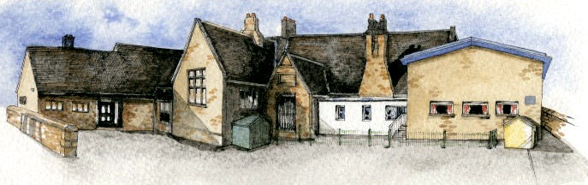

Writing Opportunities- we will write: an explanation text, a fantasy story based on The Firework maker's Daughter, and short writing opportunities linked to our topic, such as an electricity fact file and a persuasive advert based around our DT work.

Class Novel, key texts and extracts-

Firework makers daughter, Scrooge, The Hobbit extracts, The Lion, the Witch and the Wardrobe extracts, Oliver Twist

Key Learning Overview; -

Science- Children will be able to identify common appliances that run on electricity. They will construct a simple series circuit, identify faults in their circuit may not be working and name its basic parts including cells, wires, bulbs, switches and buzzers. They will be able to recognise common conductors and insulators.

Music- Children will be able to improvise and compose music for a specific purpose.

Design and Technology- Children will be able to design and create a structure that includes electrical components.

Authentic learning opportunities: the children are making a structure and circuitry that they will show to an electrician/ engineer who will comment and give options on how to improve them.

**Curriculum Shapers**

**Key Questions**

* Where does electricity come from?
* What appliances run on electricity?
* How does a circuit work?
* What are electrical conductors and insulators?
* What materials let electricity flow through them?
* Why can electricity be dangerous?
* What if we had no electricity?
* Can you make a simple switch to turn a light on and off?
* Why should we try not to waste electricity?

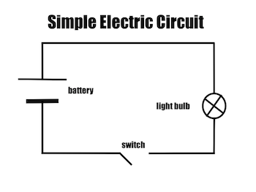

* Be Knowledgeable: develop information processing skills through programming.
* Be Adventurous: develop problem solving skills during DT when adapting a product.
* Be Ambitious and be Positive: develop relevant attributes of learning, resilience and independence.
* Be Creative: develop creative thinking skills to overcome problems in science and DT.
* Be Collaborative: Develop empathy and social skills
* Be Reflective: develop reasoning skills

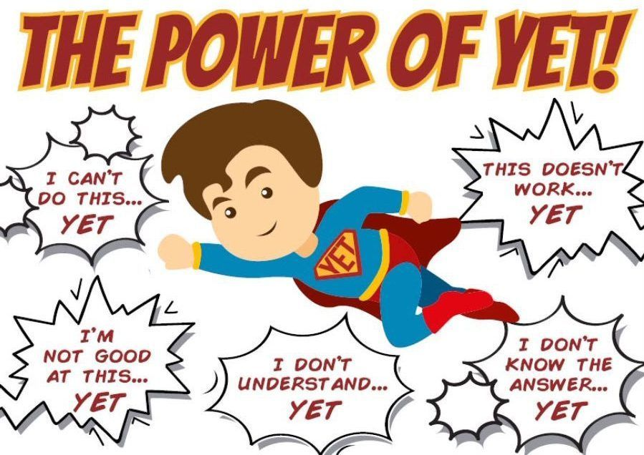

**BRABIN’S ENDOWED PRIMARY SCHOOL**

**Class: Sycamore Year 3/4 Term: Spring 1 Cycle A Curriculum Unit –Electricity**