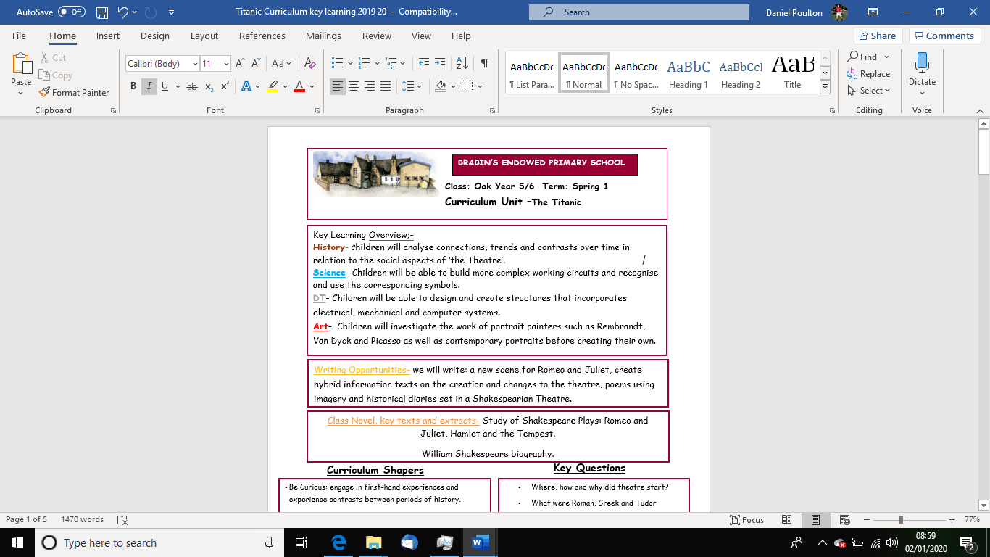

**2**2

Key Learning Overview;-

**Science**- By the end of this unit children should be able to categorise material changes into reversible or irreversible. E.g. Reversible changes: freezing, melting, boiling, evaporating, condensing and dissolving. Irreversible changes: cooking, reactions caused when some materials are mixed and new materials are created plus burning, rusting. **Art**- Children will investigate the work of abstract painters such as Pollock and Kandinsky as well as focussing on the use of texture in paintings. They will then create their own textured painting inspired by the sea. **Music**- Children will consider the use of music for a purpose with a particular focus on seaside songs. They will compose their own pieces of music based on poetry using graphic notation. **History**- Curriculum enrichment: study of the Titanic. Children will focus on the use of sources within historical enquiry.

Writing Opportunities- we will write: a series of autobiographical recounts as passengers onboard the Titanic; newspaper articles recounting the news of the Titanic sinking; a collection of poems on the theme of the sea as well as writing opportunities linked to our class novel e.g letters

* Be Curious: ask questions to challenge their learning and experience a sense of awe and wonder
* Be Knowledgeable: nurture a thirst for knowledge and apply cross -curricular skill, particularly during our ‘Titanic Theme Day’
* Be Adventurous: work practically and develop problem solving skills in Science
* Be Ambitious: see possibilities and strive for improvement
* Be Creative: question ‘what if’ and ‘why not’ and develop creative skills within our art unit
* Be Collaborative: working as a team during scientific investigations
* Be Reflective: develop reasoning skills
* Be Positive: be listened to and develop own opinions
* What is the difference between a reversible and irreversible change and what examples are there of each?
* What investigations can we plan to test materials?
* How do abstract artists create textured paintings? What materials do they use?
* How do the styles of different abstract artists compare to one another?
* What is graphic notation?
* How do composers create music to suit a mood or purpose?
* When and how did the Titanic sink?
* What are historical sources?
* Which types of sources are more reliable than others?

**Key Questions**

**Curriculum Shapers**

Class Novel, key texts and extracts- Class Novel: Tragedy at Sea; extracts from Kasper Prince of Cats; extracts from autobiographical writing e.g Roald Dahl and Bear Grylls and poems on the theme of the sea by a series of poets including: James Reeves, John Masefield and Henry Wadsworth Longfellow.

**Key Skills Coverage - Art**

**Prior Knowledge**

* Year 1/2: Self-portraits: drawing and painting in a range of medias, developing into digital art
* Year 1/2: Printmaking
* Year 1/2: Drawings and paintings of the local area
* Year 3/4: Still life- colour mixing
* Year 3/4: Printmaking: rotating and translated
* Year 3/4: Drawing and painting based on water- Monet

**Key Skills**

**Drawing**

**Lines, Marks, Tone, Form and Texture**

* Use dry media to make different marks, lines, patterns and shapes within a drawing.
* Experiment with wet media to make different marks, lines, patterns, textures and shapes.
* Explore colour mixing and blending techniques with coloured pencils.
* Use different techniques for different purposes i.e. shading, hatching within their own work.

Start to develop their own style using tonal contrast and mixed media.

**Painting**

* Develop a painting from a drawing.
* Carry out preliminary studies, trying out different media and materials and mixing appropriate colours.
* Create imaginative work from a variety of sources e.g. observational drawing, themes, poetry, music.

**Colour**

* Mix and match colours to create atmosphere and light effects.

Be able to identify and work with complementary and contrasting colours.

* Begin to use simple perspective in their work using a single focal point and horizon.
* Begin to develop an awareness of composition, scale and proportion in their paintings e.g. foreground, middle ground and background.

Show an awareness of how paintings are created i.e. Composition.

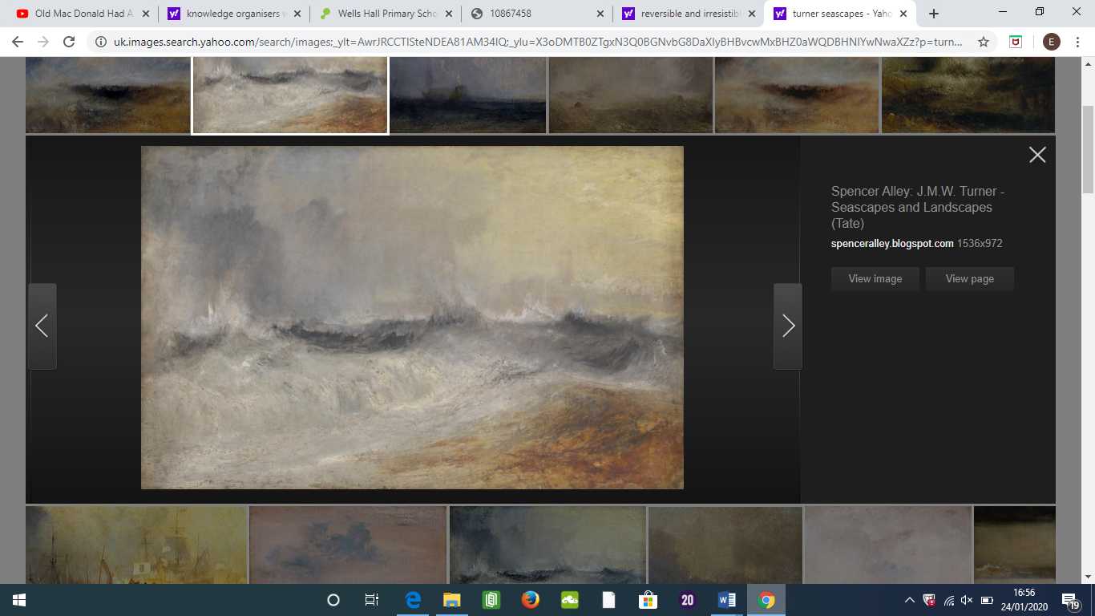

Paul Nash

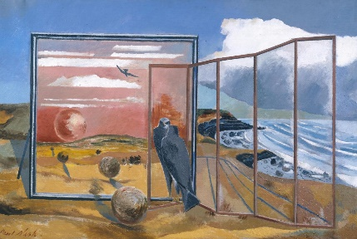

Turner and Paul Nash

**Key Skills Coverage - Science**

**Knowledge**

* Know that some materials will dissolve in liquid to form a solution, and describe how to recover a substance from a solution.
* Use knowledge of solids, liquids and gases to decide how mixtures might be separated, including through filtering, sieving and evaporating.
* Demonstrate that dissolving, mixing and changes of state are reversible change
* Recognise that dissolving is a reversible change and recognise situations where dissolving occurs.
* Explain that some changes result in the formation of new materials, and that this kind of change is not usually reversible, including changes associated with burning, and the action of acid on bicarbonate of sod

**Working Scientifically**

* By observing and comparing the changes that take place, for example, when burning different materials or baking bread or cakes.
* By researching and discussing how chemical changes have an impact on our lives, for example cooking.
* By discussing [researching] the creative use of new materials such as polymers, super-sticky and super-thin materials. 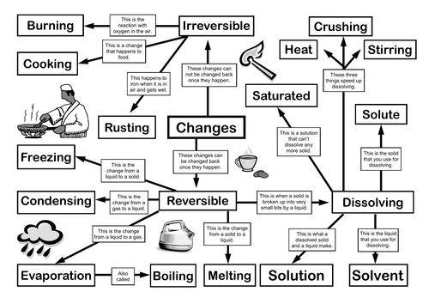

**Reversible -**possible to reverse, change back or turn back

**Irreversible -**Impossible to reverse, change back or turn back.

**Properties-** the ways in which an object behaves

**Solid**- having a firm shape or form that can be measured in length, width, and height; not like a liquid or a gas

**Liquid-** in a form that flows easily and is neither a solid nor a gas.

**Gas**- a form of matter that is neither liquid nor solid. A gas rapidly spreads out when it is warmed and contracts when it is cooled.

**Dissolve**– when a substance is mixed with a liquid and then dissolves

**Variable**- something that can change or that has no fixed value

**Insoluble**- impossible to dissolve, esp. in a given liquid.

**Melting-** to change from a solid to a liquid state through pressure or heat

**Evaporation**- to turn from liquid into gas; pass away in the form of vapour.

**Filtering-** a device used to remove dirt or other solids from liquids or gases **State**- the structure or condition of something **Solution-** a mixture that contains two or more substances combined evenly **Particles-** a tiny amount or small piece **Permeable-** of a substance, being such that gas or liquid can pass through it

**Key Scientific Skills**

**Key Vocabulary**

**Prior Knowledge**

* Year 1/2: Uses of everyday materials: properties and suitability
* Year 3/4: States of matter
* Year 3/4: Rocks and soil
* Compare and group materials together, according to whether they are solids, liquids or gases.
* Observe that some materials change state when they are heated or cooled, and measure or research the temperature at which this happens in degrees Celsius (°C).
* Identify the part played by evaporation and condensation in the water cycle and associate the rate of evaporation with temperature.

**Key Skills Coverage - Music**

**Prior Knowledge**

* Year 1/2: Self-portraits: chants and rhymes
* Year 1/2: Listening: music for a purpose
* Year 1/2: Musical patterns
* Year 1/2: Exploring how sounds can be made in different ways
* Year 3/4: Performance skills
* Year 3/4: Musical patterns for dance
* Year 3/4: Music using electronics
* Year 3/4: Music from other cultures
* Practise, rehearse and present performances with an awareness of the audience.
* Listen with attention to a range of high quality live and recorded music, to detail and to internalise and recall sounds with increasing aural memory.
* Experience how the combined musical elements of pitch, duration, dynamics, tempo, timbre, texture and silence can be organised within musical structures (for example, ostinato) and used to communicate different moods and effects.
* Improvise and develop rhythmic and melodic material when performing.
* Explore, choose, combine and organise musical ideas within musical structures
* Analyse and compare sounds.
* Explore and explain their own ideas and feelings about music using movement, dance, expressive language and musical vocabulary.
* Use and understand staff and other musical notations.

**Musical Elements**

* Pitch: Identify short phrases and long phrases, prominent melody patterns in a piece of music, Improvise a melodic patterns and melodies.
* Duration: Perform rhythmic patterns and ostinato, identify a silence in a rhythmic pattern with a gesture, indicate strong and weak beats through movements and recognise a metre.
* Dynamics: Recognise crescendo, diminuendo *a*ssess the appropriateness of dynamic.
* Tempo: Identify the differences between fast and slow tempos and identify the tempo of music as fast, moderate, slow, getting faster or getting slower.
* Timbre: Identify groupings of instruments and recognise the instruments heard in a piece of music.
* Texture: Understand how the texture might vary in a song.

**Key Vocabulary**

**Key Musical Skills**

**bar** – a regular section on a staff, separated by vertical lines. Contains the beats **beat**- unit of rhythm **clef** – a symbol on written music, defining what pitch to play the note **crescendo** – getting louder **decrescendo** – getting quieter **dynamics** – how loud or quiet a piece of music is **forte** – loud **pulse –** the constant beat in a piece of music **rest** – moment when a note is not played for a defined length of time **rhythm –** structuredgroups of accented and unaccented beats **staff** – five horizontal lines on which notes are written **tempo** – speed of a piece

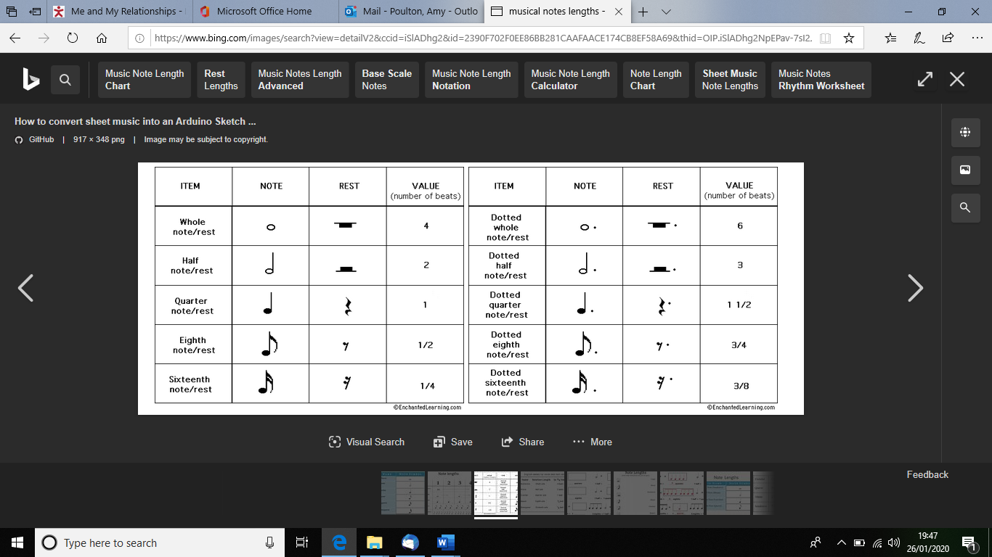

**Key Skills Coverage - History**

**Prior Knowledge**

* Year 1/2: A study of events beyond living memory- The Great Fire of London
* Year 1/2: A study of significant people including Christopher Columbus
* Year 1/2: Comparative study-The seaside then and now
* Year 3/4: A theme in British History- the Great Plague
* Year 3/4:A Study of Ancient Egypt
* Year 3/4:Roman Britain
* Year 3/4:Ancient Britain- the Stone Age

**Key Skills**

Chronology

* Identifying where periods studied fit into a chronological framework by noting connections, trends and contrasts over time.
* Study of different periods, using appropriate vocabulary when describing the passing of time and historical concepts

Events, People and Changes

* Establishing a narrative showing connections and trends within and across periods of study.

Enquiry, Interpretation and Sources

* Understand how our knowledge of the past is constructed from a range of different sources and that different versions of past events often exist, giving some reasons for this.
* Begin to recognise why some events, people and changes might be judged as more historically significant than others.

