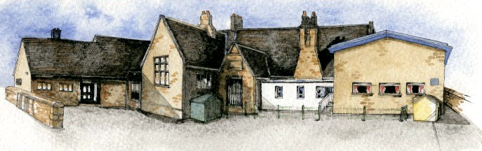

Writing Opportunities- we will write: a folk tale based on one from the region, write a biography and write an information booklet about the local area that we live in.

Key Learning Overview;-

Science: the children will study plants in depth looking at their parts and their functions, what plants need to grow as well as running experiments to help answer questions.

Geography: the children will learn about Chipping and it’s surrounding areas (Ribchester) looking at human features from the past (Romans in Ribchester) and present, as well as physical features.

History: the children will learn about the history of Chipping and its surrounding areas by comparing photographs, maps and other sources from different time periods.

Authentic Learning opportunity: The children will create presentations on our local area and present them to the local historical society.

**BRABIN’S ENDOWED PRIMARY SCHOOL**

**Class: Sycamore Year 3/4 Term: Spring 2 Cycle A Curriculum Unit – Local Study**

* Be Knowledgeable: Develop information processing skills.
* Be Adventurous: develop problem solving skills.
* Be Ambitious: Develop relevant attributes of learning.
* Be Creative: Develop creative thinking skills.
* Be Collaborative: develop empathy and social skills.
* Be Reflective: develop reasoning skills.
* Be Positive: consider one’s place in the world.

* Where do I live?
* Where is our local area and what is in it?
* Which are natural features and what has been built by people?
* What did our local area look like in the past at different times?
* What makes a plant a plant? (Considering the features of plants).
* What does each feature do to help the plant survive, grow and reproduce?
* What do plants need to grow healthily?
* Do seeds need soil to grow?
* Do plants need soil to grow healthily?
* How much water should we give plants? How long can they last without water?
* Where is the best location to keep our plants? Does a greenhouse help?
* Why do plants need leaves? What happens if we remove all the leaves from a plant?
* Why are plants important?
* What if all plants died out?
* How do plants produce new plants?
* How do plants help their seeds to spread?
* What are pollinators and how do they help plants?
* How do plants change as they grow?

Class Novel, key texts and extracts-

A collection of Lancashire Folk tales, Folk tales from around the world e.g. Romulus and Remus, and a collection of biographies. We will also read an old dialect Lancashire poem.

**Curriculum Shapers**

**Key Questions**