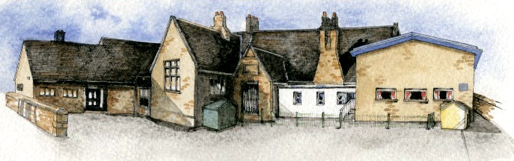

**Class: Oak Year 5/6 Term: Spring 1 2022 Curriculum Unit –Theatre through the Ages**

Class Novel, key texts and extracts- Study of Shakespeare Plays: Macbeth and extracts from others. Extracts of Great Expectations and Treasure Island. Selection of poetry by Edward Leer, Pam Ayres and Michael Rosen. William Shakespeare biography.

Writing Opportunities- we will write: a new scene for Macbeth, write formal persuasive reviews of our Shakespeare production, poems with a structure and historical diaries set in a Shakespearian Theatre.

Key Learning Overview;-

**History**- Children will analyse connections, trends and contrasts over time in relation to the social aspects of ‘the Theatre’.

**Science**- Children will be able to build more complex working circuits and recognise and use the corresponding symbols.

**DT**- Children will be able to design and create structures that incorporates electrical, mechanical and computer systems.

**BRABIN’S ENDOWED PRIMARY SCHOOL**

* Be Curious: engage in first-hand experiences and experience contrasts between periods of history.
* Be Knowledgeable: nurture a thirst for knowledge and apply cross -curricular skills
* Be Adventurous: experience exhilaration, challenge and achievement and work outside our comfort zones by performing in a professional theatre to an audience
* Be Ambitious: link with experts (Shakespeare Schools’ Festival)
* Be Creative: develop creative thinking skills and question why
* Be Collaborative: working as a team to perform Romeo and Juliet
* Be Reflective: listen to and act on advice
* Be Positive: develop self-esteem
* Where, how and why did theatre start?
* What were Roman, Greek and Tudor theatres like?
* How have theatres changed over time?
* How have theatres been important socially?
* How do key portrait artists styles compare to one another?
* Which materials/media can be used to create portraits?
* What is an electrical circuit and which symbols correspond with each part?
* How can I create a theatre which incorporates electricity?

**Key Questions**

**Curriculum Shapers**

**Prior Knowledge**

* Year 1/2: A study of events beyond living memory- The Great Fire of London
* Year 1/2: A study of significant people including Christopher Columbus
* Year 1/2: Comparative study-The seaside then and now
* Year 3/4: A theme in British History- the Great Plague
* Year 3/4:A Study of Ancient Egypt
* Year 3/4:Roman Britain
* Year 3/4:Ancient Britain- the Stone Age

**Key Skills Coverage - History**

**Key Vocabulary**

**Key Historical Skills**

**Theatre** – a building or outdoor area in which plays and other dramatic performances are given

**Greeks-** theatrical culture began from 700 BC

**Romans-** theatrical culture began from 364 BC

**Elizabethan**- the Tudor period of history during which Shakespeare’s plays were popular- 1500 and 1600’s AD

**William Shakespeare-**born 1564 and widely regarded as the greatest writer in the English language,

**The Globe Theatre**- built in London in 1599

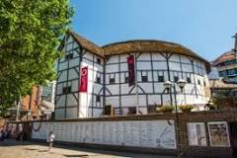[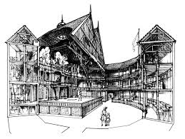](https://www.google.com/imgres?imgurl=https://www.folger.edu/sites/default/files/TM1%20-%20Globe%20image.jpg&imgrefurl=https://www.folger.edu/shakespeare-the-player-illustrating-elizabethan-theater-through-midsummer-nights-dream&docid=AKenwuLZiuzOUM&tbnid=UT7HgFkdpwZppM:&vet=10ahUKEwjV2o3c4KrkAhXByKQKHYmjBkgQMwh9KAIwAg..i&w=1536&h=1156&bih=457&biw=1024&q=elizabethan%20theatre&ved=0ahUKEwjV2o3c4KrkAhXByKQKHYmjBkgQMwh9KAIwAg&iact=mrc&uact=8) [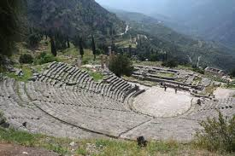](https://www.google.com/imgres?imgurl=https://www.ancient.eu/img/r/p/500x600/415.jpg?v%3D1485681491&imgrefurl=https://www.ancient.eu/article/895/greek-theatre-architecture/&docid=Lm0Ad8l3_KoaxM&tbnid=Bf7xfNu29krYfM:&vet=10ahUKEwjkwM7o4KrkAhXWThUIHfaeCYgQMwh8KAAwAA..i&w=500&h=333&bih=457&biw=1024&q=greek%20theatre&ved=0ahUKEwjkwM7o4KrkAhXWThUIHfaeCYgQMwh8KAAwAA&iact=mrc&uact=8)

Chronology

* Sequence events and periods relating to the theatre
* Analyse connections, trends and contrasts over time
* Know and understand the history of these islands as a coherent, chronological narrative, from the earliest times to the present day
* In depth study of different periods, using appropriate vocabulary

Events, People and Changes

* Gain historical perspective by placing their growing knowledge into different contexts by studying aspects of cultural and social history*.*
* Establishing a narrative showing connections and trends within and across periods of study.
* Begin to recognise and describe the nature and extent of diversity, change and continuity and suggest relationships between causes

Communication

* frame historically-valid questions involving thoughtful selection and organisation of relevant historical information using appropriate dates and terms.

Enquiry, Interpretation and Sources

* Understand methods of historical enquiry, how evidence is used to make historical claims
* Use sources as a basis for research
* Understand how our knowledge of the past is constructed from a range of different sources and that different versions of past events often exist

* Year 1/2: Uses of everyday materials
* Year 3/4: Forces and magnets
* Year 3/4: Light
* Year 3/4: Electricity:
* identify common appliances that run on electricity
* construct a simple series electrical circuit, identifying and naming its basic parts, including cells, wires, bulbs, switches and buzzers
* identify whether or not a lamp will light in a simple series circuit
* recognise that a switch opens and closes a circuit
* recognise some common conductors and insulators, and associate metals with being good conductors.

**Prior Knowledge**

**Key Skills Coverage - Science**

**Key Vocabulary**

**Key Scientific Skills**

**Knowledge**

* Associate the brightness of a lamp or the volume of a buzzer with the number and voltage of cells used in the circuit.
* Compare and give reasons for variations in how components function, including the brightness of bulbs, the loudness of buzzers and the on/off position of switches.
* Use recognised symbols (at least: cells, wires, switches, bulbs, buzzers and motors) when representing a simple circuit in a diagram.
* Use and interpret circuit diagrams to construct a variety of more complex circuits predicting whether they will ‘work’.

**Working Scientifically**

* By systematically identifying **[testing]** the effect of changing one component at a time in a circuit.
* By designing and making an item that includes an electrical component

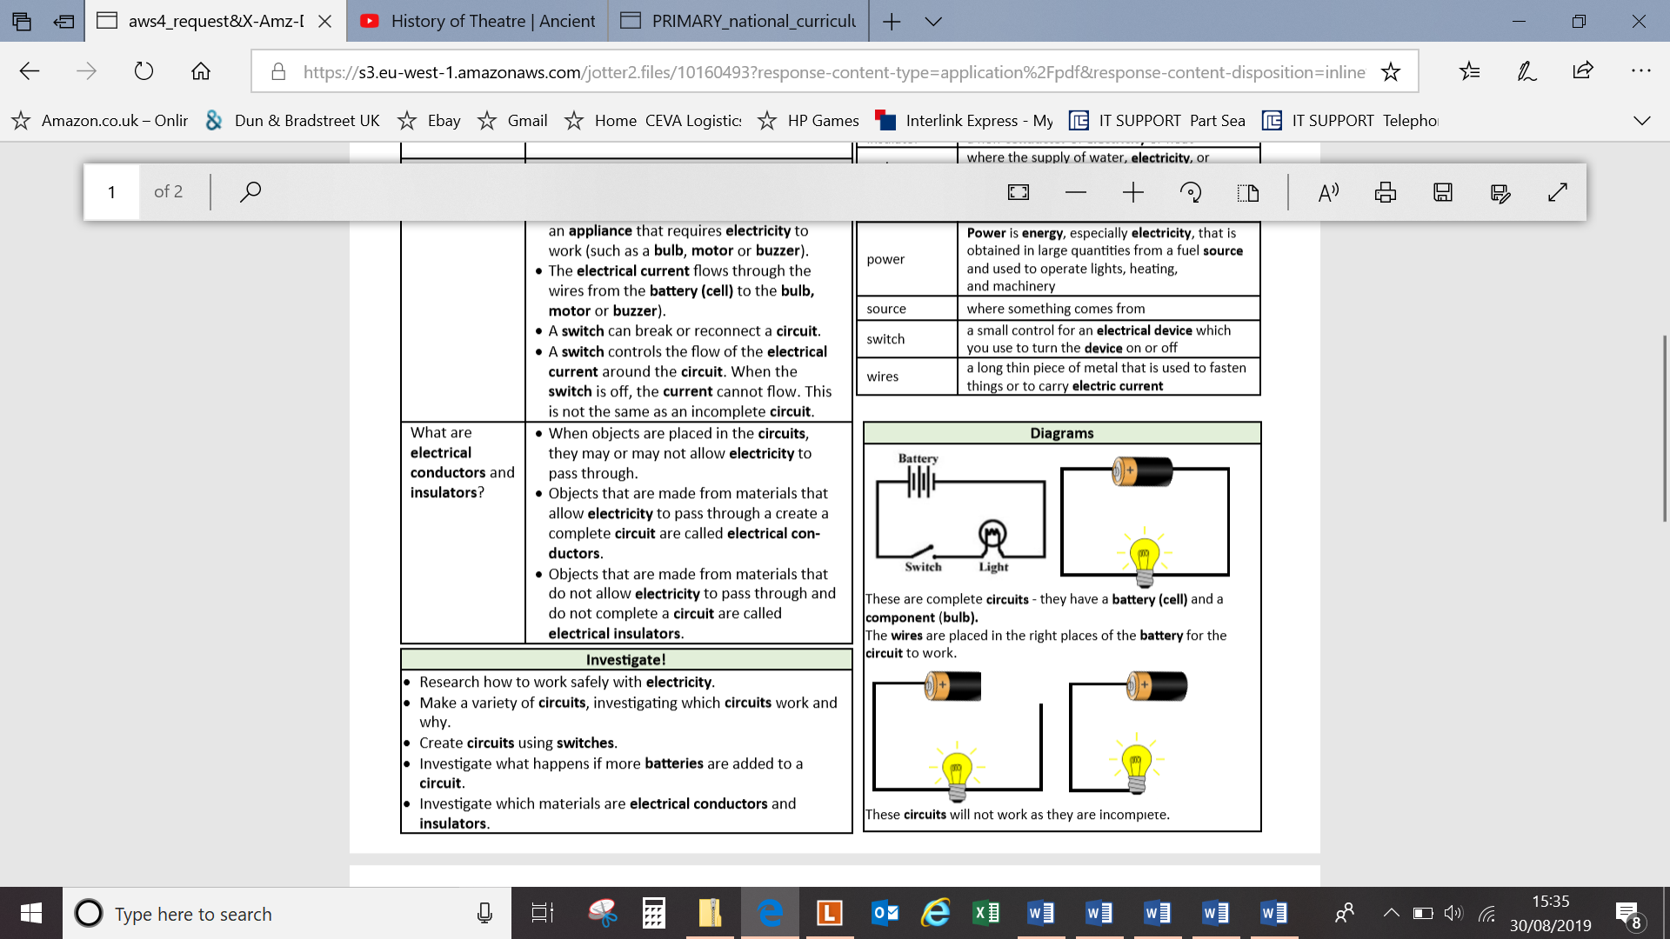

**Electricity** – a form of energy that can be carried by wires and is used for heating and lighting, and to provide power for devices

**Energy**- the power from sources such as electricity that makes machines work or provides heat

**Conductor-** a substance that heat or electricity can pass through or along

**Insulator**- a non-conductor of electricity or heat

**Current**- a flow of electricity through a wire or circuit

**Battery/cell-** small devices that provide the power for electrical items such as torches

**Bulb-** the glass part of an electric lamp, which gives out light when electricity passes through it.

**Motor-** a device that uses electricity or fuel to produce movement

**Switch-** a small control for an electrical device which you use to turn the device on or off

**Wires-** a long thin piece of metal that is used to fasten things or to carry electric current

**Buzzer-** an electrical device that is used to make a buzzing sound

**Key Skills Coverage – Design Technology**

**Prior Knowledge**

**Key Skills Coverage - DT**

* Year 1/2: Mechanisms-pop ups and simple card levers
* Year 1/2: Mechanisms- axles and wheels
* Year 1/2: Structures- stability and strength
* Year 3/4: Mechanical Systems- levers and linkages
* Year 3/4: Control- electrical systems
* Year 3/4: Structures shell and frame- strengthening

**Key Vocabulary**

**Key Design Skills**

**Axle**- Rod on which one or more wheels can turn.

**Cam**-Specially shaped wheel, or one with a hole off-centre; when it rotates, anything resting on its edge will bob up and down, as in a pull-along toy.

**Dowel**-Wood cut to a cylindrical shape, available in various widths.

**Pulley**-A grooved wheel over which a rope can run.

**Shaft**-A rod which transmits motion

**Wheel**-Circular frame or disc which rotates about a centre, enabling linear (straight-line) movement from circular motion.

**Control**-Process of making an action take place; computer control involves programming the computer so it will instruct a device to carry out an action

**Framework**-A structure made by joining together a number of pieces of wood, metal, card or plastic.

**Linkage**-A means of connecting components together usually so they can move.

**Focused Tasks: Structures**

* Use the correct terminology for tools, materials and processes.
* Use bradawl to mark hole positions.
* Use hand drill to drill tight and loose fit holes.
* Cut strip wood, dowel, square section wood accurately to 1mm.
* Join materials using appropriate methods.
* Build frameworks to support mechanisms.
* Stiffen and reinforce complex structures.

**Mechanical and Electrical Systems and ICT**

* Develop a technical vocabulary appropriate to the project.
* Use mechanical systems such as cams, pulleys and gears.
* Use electrical systems such as motors.
* Program, monitor and control using ICT.

**Design, Make and Evaluation Process**

**Key Skills Coverage – Art (Enrichment)**