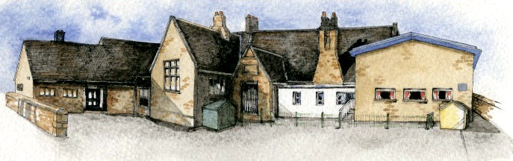

**Writing Opportunities**-

The children will write:

* postcards from different places within the UK
* character profiles for characters from traditional stories
* setting descriptions
* innovated traditional stories

**Key Learning Overview;-**

**Science**- (Ongoing) Children will observe the changes to the natural environment throughout the year. They will investigate the changing plants and animals that can be found around the school grounds.

**Geography-** Children will be able to name and identify characteristics of the four countries and capital cities of the United Kingdom and its surrounding seas. They will use maps and atlases to locate them.

**Additional Subjects – Curriculum Enrichment**

**History**- Children will explore the lives of significant individuals from the UK who have contributed to national and international achievements, including Tim Berners-Lee.

**Art-** Children willlook at the work of significant UK artists, including LS Lowry and J M W Turner.



Class: Elm Class Year 1/2 Term: Autumn

**Curriculum Unit – The UK**

**Class Novel, key texts and extracts-**

Little Red Riding Hood

Little Red by Bethan Woollvin

Little Red by Lynn Roberts Maloney

Information books and reports about the UK and London

* What countries make up the UK?
* What are the capital cities of the UK?
* What sea/oceans surround the UK?
* What are the four seasons?
* What impact do the changing seasons have on our environment?
* What plants and animals can be found around the school?
* How is the natural environment changing?
* Why has the environment changed?
* Who is Tim Berners-Lee?
* What impact has Tim Berners-Lee had on our lives?
* Who are L S Lowry and J M W Turner?
* How would you describe their work?

Be Curious: Show an interest in the lives of significant people from the UK. Find out about the features of the capital cities and important landmarks

Be Knowledgeable: develop specific geographical language to describe the countries of the UK.

Be Adventurous: use their senses to explore different sounds, smells and textures

Be Creative: Use new skills to produce work inspired by L S Lowry

Be Collaborative: work with others to produce presentations about the UK and dance sequences

Be Reflective: Recognise positive points in their own work and in the work of others’.

Be Positive: Consider one’s place in the world

**Curriculum Shapers**

**Key Questions**