Brabin’s Endowed School
Longridge Road
Chipping, Preston
Lancashire
PR3 2QD
Tel:01995 61596
Fax: 01995 61828 Headteacher: Mrs RA Wallace BA Hons NPQH
Email: head@brabins.lancs.sch.uk

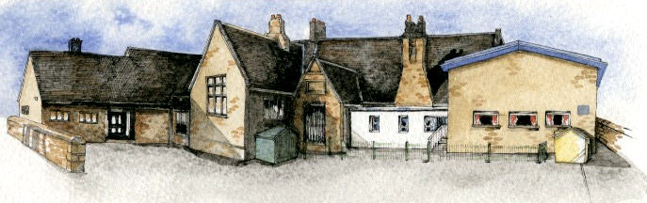

Serving its Community
For over 320 years

__________________________________________________________________________________

Dear Year 4 Parents/Carers,

In June this year, Y4 pupils across England will undertake a Multiplication check in school. It is an on-screen check consisting of 25 times table questions. Your child will be able to answer 3 practice questions before taking the actual check. They will then have 6 seconds to answer each question. On average, the check should take no longer than 5 minutes to complete.
Schools will have unlimited access to a try it out area from March. They can use this to make sure pupils have the necessary support required to access the check. This includes opportunities for pupils to familiarise themselves with the check application and try out any access arrangements that may be required.
Schools will have access to all their pupils’ results, allowing those pupils who need additional support to be identified.
Your child’s teacher will share your child’s score with you, as they would with all national curriculum assessments. There is no pass mark for the check.
To prepare for this check we have been practicing times tables in the classroom and asking for children to complete Timestables Rockstars at home as this is a similar format to the multiplication check. Although we are preparing the children for the check in school, additional preparation at home would be beneficial.
We will be undertaking the check between 6th June 2022 and 24th June 2022.

If you would like any more information, please do not hesitate to contact me at school.

Kind Regards,

Mr Pearse

