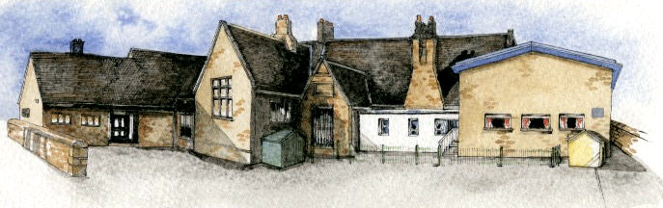

**Writing Opportunities**-

The children will write:

Spring 1 – stories based on familiar settings, non-chronological reports and postcards based on places we have studied.

Spring 2 - we will write persuasive posters about Chipping and create leaflets about John Brabin. We will also write stories based on the work of Beatrix Potter and poems based on ‘The Owl and the Pussycat’.

**Key Learning Overview;-**

**Science**- Children will explore the local environment and identify and name a variety of common plants and trees. They will describe the basic structure of plants, including trees. They will note how the plants and animals change throughout the seasons.

**Geography-** Children will use simple fieldwork and observational skills to study the geography of their school and places in Chipping where they can play and have fun. They will use aerial photographs and plans to identify significant places in school and around Chipping and recognise how the places have changed.

**History**- Children will use a variety of sources to identify how the school and Chipping has changed over time. They will learn more about John Brabin and why he was/is important to the school and Chipping.

**Art-** Children will make observational drawings of the local area and use them to inspire their printmaking. They will then use a range of materials to create a print depicting the local area.

**DT-** Children will explore a range of wheels and axles and use them to make skateboards or scooters.



Class: Elm Class Year 1/2 Term: Spring Term

**Curriculum Unit – Learning and Playing in Chipping**

**Class Novel, key texts and extracts-**

The Twits by Roald Dahl

Postcards from different places

Peter Rabbit and other Beatrix Potter stories, including The Tale of Jeremy Fisher

Leaflets from local attractions

The Owl and the Pussycat by Edward Leah

The Further Adventures of the Owl and the Pussycat by Julia Donaldson

**Key Questions**

**Curriculum Shapers**

* What plants are growing around our school?
* How can I identify the plants arounds our school?
* What do you call the different parts of a plant?
* What does each part of a plant do?
* Where can I go to play and have fun in Chipping?
* Where is Brabin’s School on this aerial photograph?
* How has Chipping and our school changed?
* Why has the school changed?
* Who is John Brabin?
* How has John Brabin had an impact on the local area and our school?
* What features are important to include on my print of the local area?
* What is a chassis?
* How can I attach wheels and axles to a chassis?
* How can I improve my skateboard?
* Be Curious: about the world around them, invoking a sense of awe and wonder. Show an interest in the lives of significant people from the local area. Ask questions to find out how the school has changed.
* Be Knowledgeable: learn to identify and name plants in the local environment. Develop new subject specific vocabulary in all areas of the curriculum.
* Be Creative: use a range of materials to create drawings and prints of the local area. Design and make a product with wheels and axles.
* Be Adventurous: work practically in science and DT.
* Be Collaborative: work as a team, respecting the different opinions of others.
* Be Reflective: develop an understanding of their areas of strength and for development.
* Be Positive: consider one’s place in the world. Develop their own opinions about Chipping.