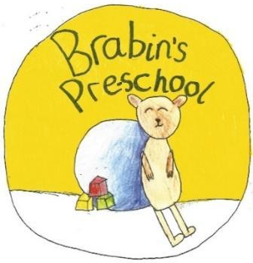
Brabin’s Pre-School
Newsletter
November 2021

Watch our new ‘Welcome to Brabin’s’ film on the school website (front page). You might spot someone you recognise!    School Admissions September 2022  The deadline to apply for a primary school place for September 2022 is 15 January 2022. Apply for a place via this link:  https://www.lancashire.gov.uk/children-education-families/schools/apply-for-a-school-place/    As the weather is becoming cold and wet, please ensure that children who attend forest school have full waterproofs and wellies in school.  The Little Lancashire Village  On Tuesday 7th December we will be visiting The Little Lancashire Village in Burnley where the children will be able to role play different job roles and experience a variety of role play areas.  The cost of the trip will be £10 per child, we will be leaving pre-school at 12.00pm and return at 3.30pm. If you would like your child to attend, please pay via parent pay and complete the permission slip on the letter attached.  Odd sock day  On Monday 15th November, we are asking the children to wear odd socks to school to  help raise awareness around anti-bullying. Odd Socks Day is designed to be fun! It’s an  opportunity for children to express themselves and celebrate their individuality  and what makes us all unique. |  |   Non Uniform Day – Friday 26th November Chocolate donation  Non Uniform Day – we are asking for chocolate donations for our chocolate tombola at the village Christmas Fair which will take place on Sunday 5th December.    Christmas Jumper day  Friday 10th December  We invite children to wear their Christmas jumpers to raise money for the charity Save the Children.  £2 donation please.  Pre-School Nativity  Thursday 9th December  We invite parents to attend our pre-school nativity at 2.30pm. We ask that parents/ Grandparents are limited to 2 adults per child. A film of the nativity will be available for those unable to attend.  Refreshments will be served afterwards by the pre-school children!    Christmas Party  Our Christmas party will take place on Friday 17th December. Children are welcome to wear non uniform/party clothes.  Christmas Holiday: Monday 20th December 2021- 3rd January 2022.  Pupils return to Pre - school on Tuesday 4th January 2022.
Current Topics - light and dark
Here are some of the things we are covering in this topic:
- Diwali the festival of light
- Bonfire night/Fireworks
- Shadows
- Safety in the dark
- The difference between day and night.


