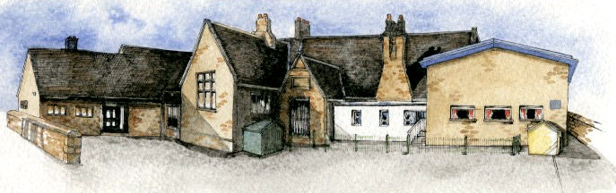

**Class: Sycamore Year 3/4 Term: Autumn 2 Cycle A Curriculum Unit – Natural Disasters**

Class Novel, key texts and extracts-

A Child’s Garden of Verses, The Spider and the Fly, National Geographic Everything: Volcanoes and Earthquakes, Destination Planet Earth (extracts), Escape from Pompeii, The Pebble in my Pocket, Varjak Paw

Writing Opportunities- we will write: a mystery story, a classic poetry performance based on group work as well as reviews of poems.

Key Learning Overview;-

Science- children will learn about how different rocks and fossils are formed.

Geography- children will learn about the key aspects of Volcanoes and Earthquakes around the world.

Music- children will learn about the history of different types of music and how it has evolved over time.

DT- Textiles, seams, stiffening and strengthening, materials and fastenings.

Authentic learning outcomes: The children will write stories based on Varjak Paw and send them to the author.

**BRABIN’S ENDOWED PRIMARY SCHOOL**

* Be Curious: engage in first-hand experiences and experience contrasts between areas of living.
* Be Knowledgeable: nurture a thirst for knowledge and apply cross -curricular skills
* Be Adventurous: develop problem solving skills when facing problems with designs in DT.
* Be Ambitious: develop relevant attributes of learning.
* Be Creative: develop creative thinking skills and question why e.g. why did music change? Why would people live near volcanoes?
* Be Collaborative: develop empathy towards people who have suffered during a natural disaster.
* Be Reflective: listen to and act on advice on designs in DT.
* Be Positive: considers one’s place in the world.
* A view of a snow covered mountain

  Description automatically generated
* What are fossils?
* How are fossils formed?
* What can fossils tell us about the past?
* What is rock?
* How can rocks be different?
* What are rocks used for?
* How can we test rocks/compare rocks?
* What is a volcano? Are they all the same? How are they different?
* What is an earthquake?
* Where in the world do earthquakes/volcanoes happen?
* How/why do earthquakes and volcanic eruptions occur?
* Can earthquakes be predicted?
* What effects do earthquakes/volcanoes have on people? Are they always disastrous?
* Why do people live near volcanoes or where earthquakes are likely to happen? Do they have a choice?
* Can people prepare for earthquakes or volcanic eruptions? Are buildings different in earthquake zones?
* What do you think it feels like to live near a volcano?
* Do people visit volcanoes? Which ones? Why? What would it be like to visit a volcano?

**Curriculum Shapers**

**Key Questions**