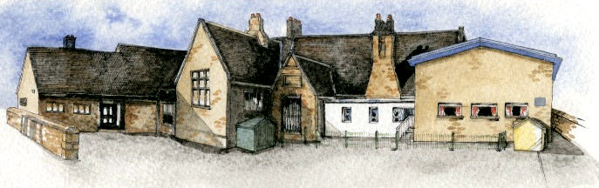

Key Learning Overview;-

**Geography**- children will be able to locate countries in North and South America, describe both physical and human geography of the Amazon rainforest, use maps and suggest a line of enquiry.

**Science**- Children will be able to describe the differences in the life cycles of a mammal, an amphibian, an insect and a bird as well as the life process of reproduction in some plants and animals. They will also observe animals and plants in our local environment.

**Art**- Children will learn printing techniques and create abstract pieces based on the Solar System inspired by a range of abstract and pop artists (linked to previous half term)

**BRABIN’S ENDOWED PRIMARY SCHOOL**

**Class: Oak Year 5/6 Term: Autumn 2 2021 Curriculum Unit –The Amazon**

Class Novel, key texts and extracts- Novel: The Explorer Extracts: The Vanishing Rainforest, The Great Kapok Tree, Kenske’s Kingdom and Deforestation reports

Writing Opportunities- we will write: a story based on another culture (South American), a persuasive speech/discussion and create non-fiction pieces.

* Be Curious: develop an appreciation of and responsibility for the environment and experience contrasts with the Amazon
* Be Knowledgeable: develop subject specific language, manage, receive, record and apply information, nurture a thirst for knowledge and apply cross -curricular skills
* Be Adventurous: experience exhilaration, challenge and achievement
* Be Ambitious: see possibilities
* Be Creative: develop creative thinking skills and question why
* Be Collaborative: respect the opinions and difference of others and value one’s own perceptions and others
* Be Reflective: make lifestyle choices in relation to learning and identify new aptitudes
* Be Positive: value pupil voice and consider one’s place in the world

**Key Questions**

**Curriculum Shapers**

* Where in the world is the Amazon Basin and in which countries is it located?
* How is the rainforest in the Amazon Basin changing? Why is the rainforest changing?
* How does this region of South America compare and contrast with regions we have studied before?
* What is a life cycle?
* How do plants and animals change over time?

•The seven continents and five oceans

.•The names of some key rivers around the world including the Thames and the Nile

.•The main biomes and climate zones around the world, including rainforests (hold and cold desert).

•That the climate of places is affected by their location (e.g. the equator, Tropics).

•The effects of climate change and pollution on the Earth.

* In-depth study of various locations: polar regions, an African village, Egypt and a European country.

**Prior Knowledge**

**Key Skills Coverage - Geography**

**Key Geographical Skills**

**Key Vocabulary**

**Equator** – an imaginary line around the middle of the Earth at an equal distance from the North Pole and the South Pole **Tropics-** parts of the world that lie between two lines of latitude, the Tropic of Cancer, 23½° north of the equator, and the Tropic of Capricorn, 23½° south of the equator. The tropics have a humid climate, where the weather is hot and damp **Biomes-**a natural area of vegetation and animals **Vegetation-** plants, trees and flowers Forest **floor** – the ground of the rainforest, with soil and fallen trees and leaves **Understory** – a layer just below the canopy that includes ferns and vines that start growing above the ground, on trees; this gives them an advantage over plants that start growing on the ground because they have that little bit more sunlight **Canopy / forest roof**– the top layer of the rainforest where most of the trees have stopped growing, and where 80% of life in rainforest habitats can be found; it can be as high as 100 metres above the ground **Emergent** – describes anything that grows above the canopy

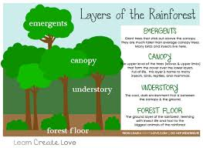

•Use atlases, maps and aerial photographs to find rainforests and explain what the climate is like there. Explain why rainforests cannot be found in the UK.

•Label maps to show where rainforests can be located.

•Explain how the vegetation and animal life changes in the different layers of the rainforest

•Compare the average rainfall in different climate zones, including the rainforest, and draw a graph to represent this.

•Investigate the effects of climate change and pollution on rainforests and explain how deforestation can impact the Earth

•Investigate the natural resources, such as palm oil that can be found in the rainforest

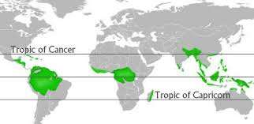

•Year 1/2: Animal and plants structure Year 1/2: Living things in their habitats

* Year 1/2: Plant Growth
* Year 3/4: The skeleton
* Year 3/4: Habitats- grouping and classifying
* Year 3/4: Plants- function and growth
* Year 3:Explore the part that flowers play in the life cycle of flowering plants, including pollination, seed formation and seed dispersal.
* Flowers attract insects to aid pollination.
* Pollination is when pollen is transferred between plants by insects, birds, other animals and the wind.
* Fertilisation occurs in the ovary of the flower.
* Seeds are formed as a result of fertilisation
* Recognise that animals are alive; they move, feed, grow, use their senses and reproduce.

**Prior Knowledge**

**Key Skills Coverage - Science**

**Key Scientific Skills Key Vocabulary**

**Life Cycle** – the series of changes that an animal or plant goes through from life to death **Reproduction-** when an animal or plant produces one or more offspring similar to itself **Embryo-** an unborn animal or human in the early stages of development **Cell**- the smallest part of an animal or plant that is able to function independently **Fertilisation-** male and female gametes meet to form an embryo or seed **Gamete-** the name for the two types of male and female that join together during reproduction **Stamen-** the pollen producing part of the plant **Anther-** the part of the stamen that produces pollen **Flower-** part of the plant at the end of the stem which is often brightly coloured **Ovary-** a female organ which produces an egg **Stigma-** the top of the plant that receives the pollen **Pollen-** fine dust produced by plants

**Pollination-** to fertilise with pollen

* Animals are alive; they move, feed, grow, use their senses, reproduce, breathe/respire and excrete.
* Describe the life process of reproduction in some plants and animals.
* Describe the difference in the life cycle of a mammal, amphibian and a bird.
* Know the different types of reproduction: sexual and asexual.
* Observe and compare the life cycles of plants and animals in the local environment and around the world.
* Grow new plants from different parts of the parent plant.
* Observe changes in an animal over time.
* Compare how different animals reproduce and grow.

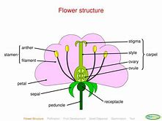 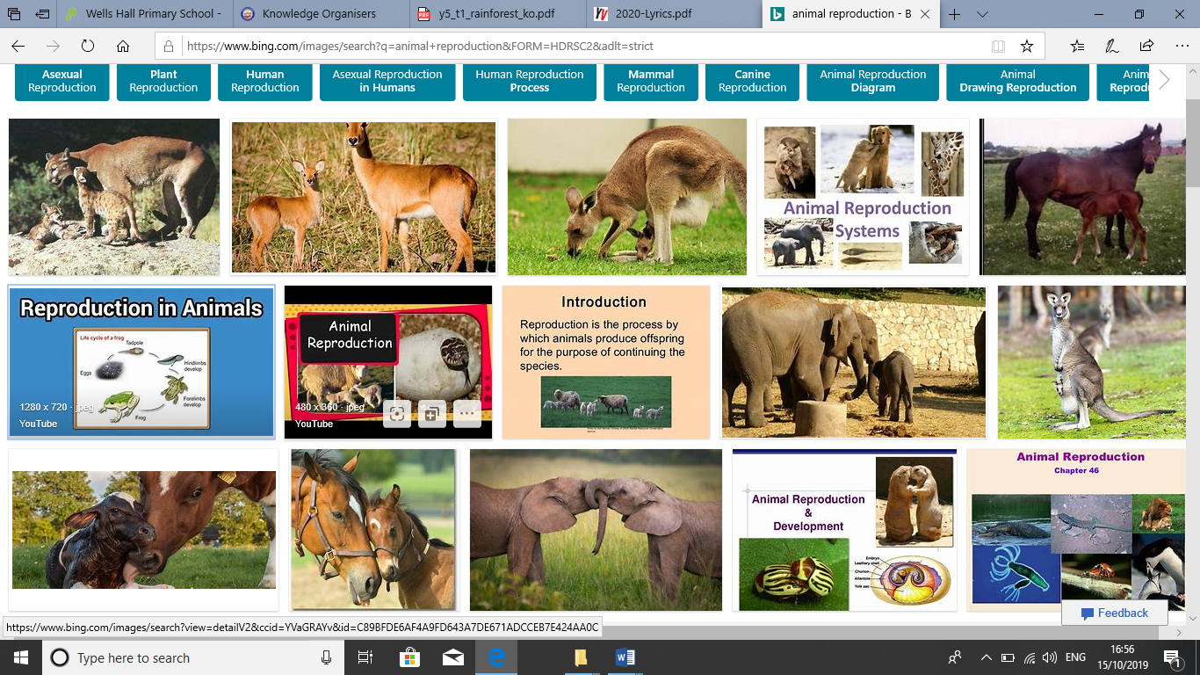

**Prior Knowledge**

* Year 1/2: 3D Sculpure- clay based on the human figure
* Year 3/4: 3D Sculpture- junk models and nature based

**Key Skills Coverage - Art**

**Key Skills**

**Printing:**

* Create printing blocks by simplifying an initial journal idea.
* Use relief or impressed method.
* Create prints with three overlays.
* Work into prints with a range of media e.g. pens, colour pens and paints.

**Drawing:**

* Work from a variety of sources including photographs and digital images.
* Develop close observation skills using a variety of view finders.
* Identify artists who have worked in a similar way to their own

**Lines, Marks, Tone, Form and Texture:**

* Use dry media to make different marks, lines, patterns and shapes within a drawing.
* Experiment with wet media to make different marks, lines, patterns, textures and shapes.
* Use different techniques for different purposes i.e. shading, hatching within their own work.

**Perspective and Composition***:*

* Begin to use simple perspective in their work using a single focal point and horizon.
* Begin to develop an awareness of composition, scale and proportion in their paintings e.g. foreground, middle ground and background

**Key Artists**: Albrecht Dürer*,* Lucien Rudaux ,Andy Warhol and Robert Raushenberg

