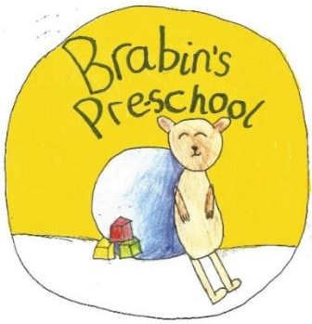
Brabin’s Pre-School
Newsletter
October 2021

  School Admissions September 2022  The deadline to apply for a primary school place for September 2022 is 15 January 2022 . Apply for a place via this link:  https://www.lancashire.gov.uk/children-education-families/schools/apply-for-a-school-place/    Individual and Family Photographs  Individual/family photographs will take place during the morning of Friday 22nd October 2021. Please contact the school office if you would like to arrange a family photo with a younger sibling. (Photographs with siblings in school will also take place).  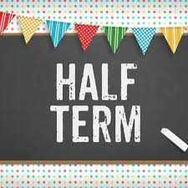  Half Term  25th October – 29th October  Monday 1st November is an Inset day  School Reopens Tuesday 2nd November  Term Dates for 2021-22  These dates have been amended in line with government information following the decision to give an extra bank holiday next year as we celebrate the Platinum Anniversary of the Queen’s accession to the throne. We now break up for the summer on Wednesday 20th July, with Thursday 21st being our extra day off.  Pre-school opens at 8.55am and closes at 3.15pm. If you are running late in the morning please can you let us know by 9.10am so we can order lunches. |  | Access to Pre-School  Thankyou to the familes using the alternative entrance to pre-school. We are ask that all Pre-School parents to use the walled pathway that runs alongside the school kitchen. The drive should be used for vehicle access only. Please ask Miss Strickland for further information.  Current topics  After half term we will be continuing our autumn topic. We will be looking at what animals do as it begins to get colder and observing changes in the environment.  Here are some picture of what we have recently been doing…  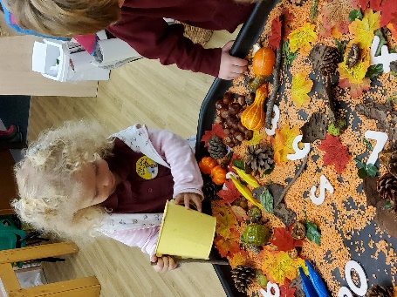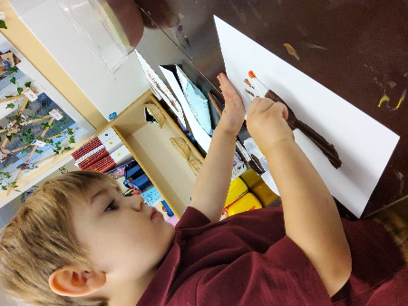  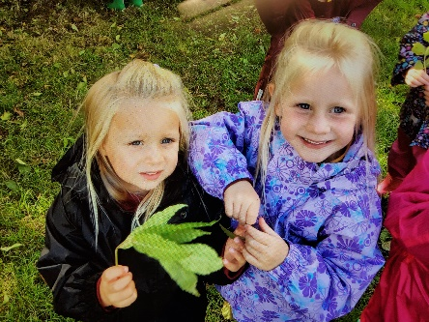  As the weather is becoming cold and wet, please ensure that children who attend forest school have full waterproofs and wellies in school.
Pre school Halloween day
On Friday 22nd October we are having a Halloween day. Children are welcome to bring in costumes to change into (after school photos) and there will be lots of fun Halloween activites.

Black History Month
Alma Woodsey Thomas
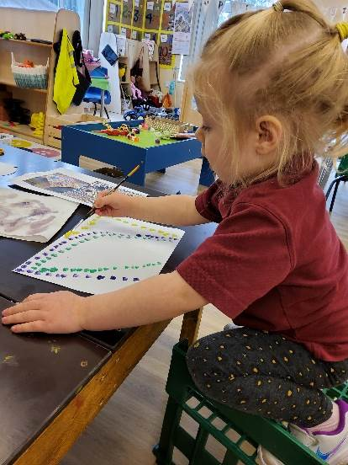
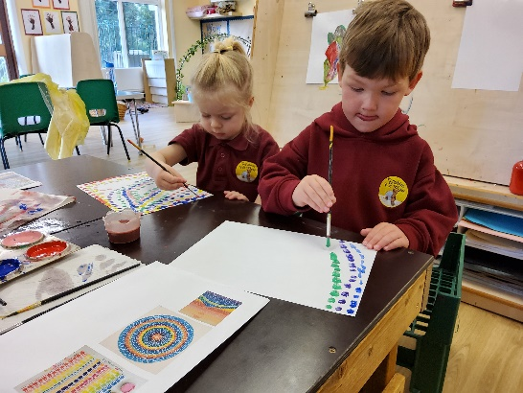
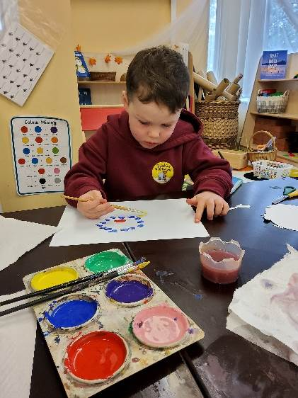
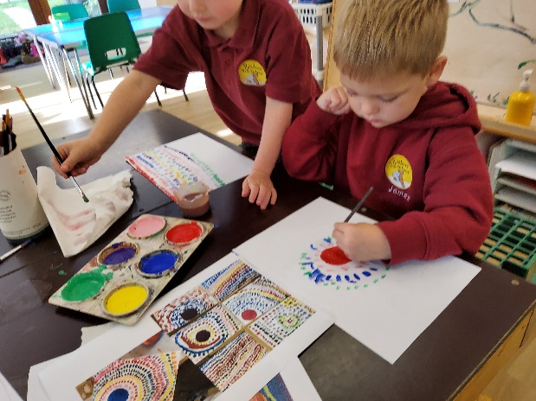
This week we have been looking at the Artist Alma Woodsey Thomas. The children have enjoyed painting in her unique style and recreating some of her most famous work.


