Storytelling Day with Sue Allonby
6th September 2021
Y5/6 enjoyed their session with Sue, experiencing listening to stories as well as retelling them to each other. They particularly enjoyed hearing the story of Gawain, King Arthur and the Crone. Sue also taught them about the history of fairy tales, folk tales and legends as well as giving them strategies on how to remember key facts to enable them to re-tell stories themselves. All pupils thoroughly enjoyed their session and showed a great deal of enthusiasm and engagement.
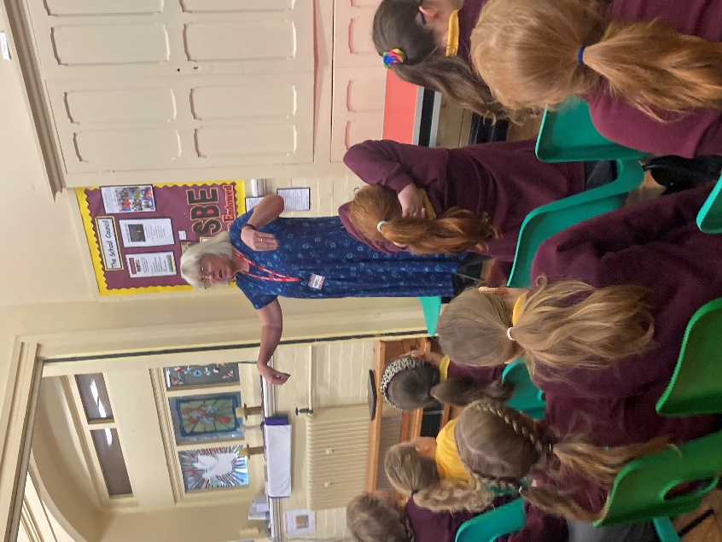
Y3/4 loved their session with Sue. They were engaged with the stories and learnt different ways of memorising stories. When they got chance to retell their story, the children were encouraged to use actions, expression and add their own elements to the retelling. We were taught the history of traditional tales. The children were very enthusiastic through the session and asked many questions at the end eager to learn more about the tales.
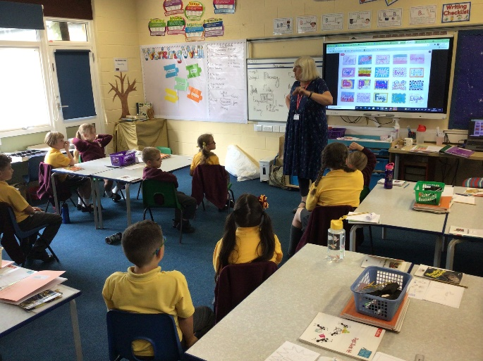
Y1/2 really enjoyed listening to Sue tell stories and talk about the history of traditional tales. She told them three stories and talked about where in the world the stories originated. The children were engaged with the storytelling and joined in with repetitive lines, songs and actions. They even contributed ideas that Sue incorporated into the stories. The children were keen to answer Sue’s questions and demonstrated a good understanding of what they had heard.
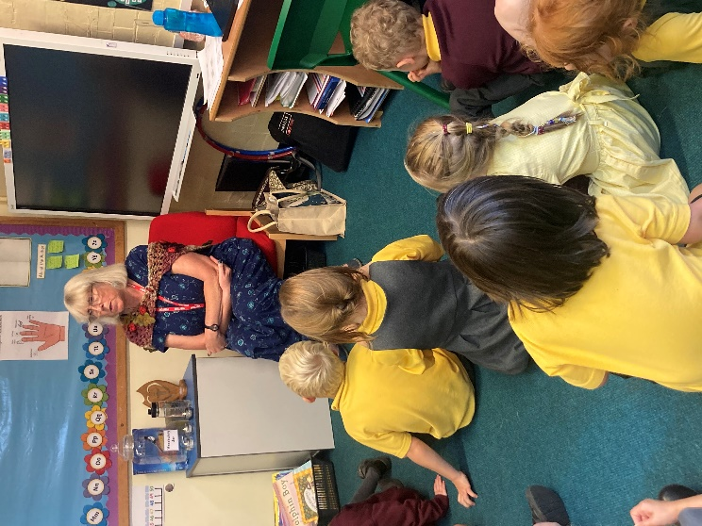
Reception class thoroughly enjoyed their story telling session with Sue. They eagerly listened to a story about a duckling called Quackling. The children were able to make predictions about what might happen next and enjoyed saying a line in the story alongside Sue. They were able to remember key parts of the story. The children loved the session and demonstrated a keen interest in the story.

