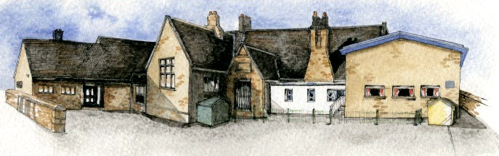

Class: Elm Class Year 1/2 Term: Autumn 1-2021 **Curriculum Unit – Me, My Family and Friends**

**Writing Opportunities**-

The children will write:

* innovated stories based on The Owl Babies
* letters from one character to another
* recounts of our lives, including important events
* friendship poems

**Class Novel, key texts and extracts-**

|  |  |
| --- | --- |
| **Narrative**  The Owl Babies  Rabbit and Bear - Rabbit’s Bad Habits  Rabbit and Bear – The Pest in the Nest | **Poetry –** I Can Be a Pal  Laughter Time |

**Key Learning Overview**;-

**Science**- Children will be able to identify, name and label the basic parts of the human body. They will learn the 5 senses and say which part of the body is associated with each sense. They will explore different stages of human growth, baby, toddler, child, teenager and adult.

**Art-** Children will be able to use their drawing and painting skills to create self-portraits. They will look at and comment on portraits by famous artists including Kathe Kollwitz, Pablo Picasso and Vincent Van Gogh.

**History**- Children will explore significant changes that have happened in their lives so far and the lives of their families. They will learn about the royal family now and in the past with Queen Victoria.

**BRABIN’S ENDOWED PRIMARY SCHOOL**

**Curriculum Shapers**

**Key Questions**

* Be Curious: Show an interest in life in the past. Use a range of sources to ask and answer questions
* Be Knowledgeable: develop subject specific language. Secure an understanding of childhood in the past
* Be Adventurous: experience exhilaration, challenge and achievement
* Be Ambitious: strive for improvement
* Be Creative: Use new skills to produce their own self portrait. Create their own family tree.
* Be Collaborative: respect the opinions and difference of others and value one’s own perceptions and others
* Be Reflective: Evaluate their own work to make improvements. Recognise positive points.
* Be Positive: Develop their own opinions about their work. Listen to and respond to advice.
* What are the names for the parts of the body?
* What are the 5 senses?
* How have we changed?
* How are we the same/different to each other?
* What is a self-portrait?
* How do we mix colours to get the one we need?
* What is a family tree? Who is in my family tree?
* How are our lives today different to the lives of our parents and grandparents when they were children?

* Who are the royal family? Who is in their family tree?
* Who are Queen Elizabeth II and Queen Victoria?