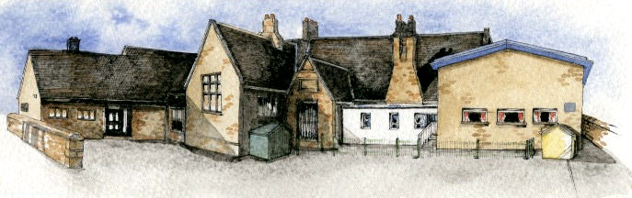

Key Learning Overview;-

**Science**- Children will be able to identify and name the planets in our galaxy and understand how they relate to the Sun. They will also learn how the rotation of the planets causes night and day. Finally they will learn about the Earth’s moon.

**Geography**- children will be able to locate a range of the world’s mountains as well as developing their understanding of the physical features of mountain ranges.

**Music**- Children will listen to and appraise a range of musical scores, in particular the work of John Williams, focussing on musical components (e.g. tempo). They will then create their own musical score.

**Art**- Children will investigate the work of portrait painters such as Rembrandt, Van Dyck and Picasso as well as contemporary portraits before creating their own. Children will learn printing techniques and create abstract pieces based on the Solar System inspired by a range of abstract and pop artists.

Writing Opportunities- we will write: a selection of fiction-based pieces leading to a new sci-fi story, explanations and reports on the Solar System and a poems with imagery.

**Class: Oak Year 5/6 Term: Autumn 1 2021 Curriculum Unit –Earth, Moon and Space**

**BRABIN’S ENDOWED PRIMARY SCHOOL**

Class Novel, key texts and extracts- Novel: Harry Potter and the Philosopher’s Stone Extracts of: Sci-Fi novels (War of the Worlds and Cosmic) and a Selection of poetry by Ted Hughes.

* Be Curious: invoke a sense of awe and wonder of the Universe
* Be Knowledgeable: develop subject specific language
* Be Adventurous: work outside of your comfort zone
* Be Creative: develop creative thinking skills and question ‘why’ and ‘what if’.
* Be Collaborative: work with each other as a team
* Be Positive: develop self- esteem
* How do the Sun, the planets, including Earth and the moon move?
* How are night and day caused and how did people in the past know what time it was?
* What is a mountain range and where in the world are they located?
* Who was John Williams?
* How does music add to the effect of films?
* What is ‘Pop Art’?

**Curriculum Shapers**

**Key Questions**

* Year 1/2: Seasonal Changes
* Year 1/2: Explorers
* Year 3/4: Light and Shadows
* Year 3/4: Forces
* Year 3/4 :Famous European Scientists

**Key Skills Coverage - Science**

**Prior Knowledge**

**Key Vocabulary**

**Key Scientific Skills**

**Knowledge**

* describe the movement of the Earth, and other planets, relative to the Sun in the solar system
* describe the movement of the Moon relative to the Earth
* describe the Sun, Earth and Moon as approximately spherical bodies
* use the idea of the Earth’s rotation to explain day and night and the apparent movement of the sun across the sky.

**Working Scientifically**

* By comparing the time of day at different places on the Earth through internet links and direct communication.
* By creating and constructing simple models
* By finding out why some people think that structures such as Stonehenge might have been used as astronomical clocks

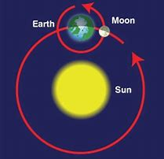

**Universe**- the whole of space and all the stars, planets, and other forms of matter and energy in it

**The Solar System**- includes the Sun and the planets that orbit it

**Planets**- a large spherical object in space which orbits a star- the Earth is a planet

**Star**-a large spherical object of burning gas- the Sun is a star

**Moon**- the natural satellite of the Earth, visible by reflected light from the Sun. Other planets also have moons

**Spherical** –an object round in shape like a ball

**Orbits**- the curved path in space that is followed by an object going round and round a planet, moon, or star

**Axis**- an imaginary line through the middle of something

**Rotates**- move or cause to move in a circle round an axis or centre.

**Gravity-** he force which causes things to drop to the ground

**Leap year**- a year which has 366 days. The extra day is the 29th February. There is a leap year every four years

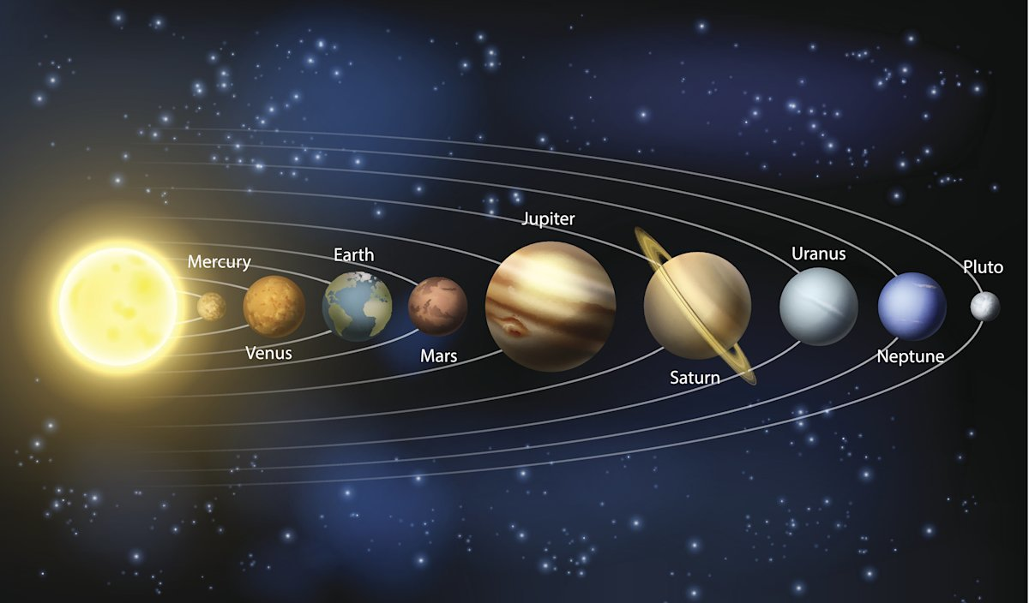

Year 1/2: Local Study (small aspect includes hills) Year 1/2: Mugumareno Village (study of local physical geography) Year 3/4: Volcanoes and Earthquakes linked to North America Year 3/4: European study (study of local physical geography) Volcano unit: physical geography study including volcanoes and earthquakes Volcano unit: human geography study including types of settlement and land use.

**Key Skills Coverage - Geography**

**Prior Knowledge**

**Key Vocabulary**

**Key Geographical Skills**

Locational Knowledge

* Name and locate Pyrenees, Carpathians, balks Apennines and Ural mountain ranges of Europe.
* Locate the world’s countries, using maps to focus on North and South America.
* Identify the position and significance of latitude, longitude, Equator, Northern Hemisphere, Southern Hemisphere, the Tropics of Cancer and Capricorn, Arctic and Antarctic Circle.

Physical Geography

* Name and label the features of a mountain landscape
* Understand that fold mountains are formed when tectonic plates collide
* The difficulties associated of living on/next to mountainous landscapes

Mapping

* Use models and maps to discuss land shape i.e. contours and slopes.
* Use contour lines to understand how height is shown on a map and interpret legends and heights

Enquiry

* Ask and answer questions that are more causal
* Make predictions and test simple hypotheses about people and places.

**Equator** – an imaginary line around the middle of the Earth at an equal distance from the North Pole and the South Pole **Hemisphere-** a half of the earth, usually as divided into northern and southern halves by the equator, or into western and eastern halves by an imaginary line passing through the poles. **Tropics-** parts of the world that lie between two lines of latitude, the Tropic of Cancer, 23½° north of the equator, and the Tropic of Capricorn, 23½° south of the equator. The tropics have a humid climate, where the weather is hot and damp **Peak/Summit**- the highest part/point **Altitude**- height measured above sea level **Fold mountains**- Mountains that form mainly by the effects of layers of the earth’s crust folding on top of each other **Dome mountains**-formed when sedimentary rock is bent upwards **Fault-block mountains**- A mountain formed by the natural faults in the earth’s crust

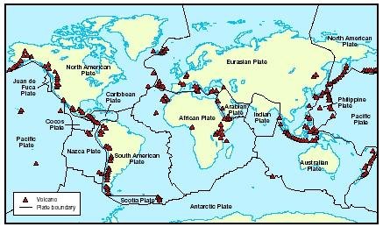

Year 1/2: Friendly Robots (singing and musical patterns/elements)

Year 1/2: Latin Music (performing and listening) Year 1/2: Fire! Fire! (performing and listening) Year 3/4: Rock and Roll (performing and listening) Year 3/4: European Composers (listening and composing) Year 3/4: Iron Man- Marvel Trailers (listening and composing)

**Key Skills Coverage - Music**

**Prior Knowledge**

**Key Vocabulary**

**Key Musical Skills**

**bar** – a regular section on a staff, separated by vertical lines. Contains the beats

**beat**- unit of rhythm

**downbeat** – first beat in a bar

**pulse –** the constant beat in a piece of music

**rest** – moment when a note is not played for a defined length of time

**rhythm –** structuredgroups of accented and unaccented beats

**dynamics** – how loud or quiet a piece of music is

**tempo** – speed of a piece

**duration-** length of note

**pitch**- how high or low a sound is

**timbre-** the quality of sound

**texture**- layers of sound

**structure-** the order of a piece

**crescendo** – getting louder

**decrescendo** – getting quieter

**staccato** – short, sharp notes

**Ostinato**- A short repeated   rhythmic or melodic pattern.

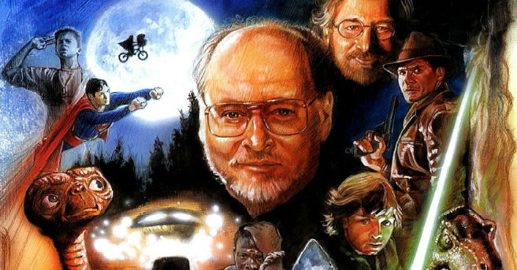

**Listening**

* listen with attention to detail and recall sounds with increasing aural memory
* appreciate and understand a wide range of high-quality live and recorded music drawn from different traditions and from great composers and musicians

**Composing**

* Improvise and develop rhythmic and melodic patterns when performing.
* Explore, choose, combine and organise musical ideas within musical structures with increasing effect and confidence

**Musical Elements (Revise all briefly through listening process)**

1. Pitch: Identify short phrases and long phrases, prominent melody patterns in a piece of music, Improvise a melodic patterns and melodies.
2. Duration: Perform rhythmic patterns and ostinato, identify a silence in a rhythmic pattern with a gesture, indicate strong and weak beats through movements and recognise a metre.
3. Dynamics: Recognise crescendo, diminuendo *a*ssess the appropriateness of dynamic.
4. Tempo: Identify the differences between fast and slow tempos and identify the tempo of music as fast, moderate, slow, getting faster or getting slower.
5. Timbre: Identify groupings of instruments and recognise the instruments heard in a piece of music.
6. Texture: Understand how the texture might vary in a song.

**Drawing**

* Work from a variety of sources including observation.
* Work in a sustained and independent way to create a detailed drawing.
* Use a journal to collect and develop ideas.
* Identify artists who have worked in a similar way to their own work.
* Use dry media to make different marks, lines, patterns and shapes within a drawing.
* Experiment with wet media to make different marks, lines, patterns, textures and shapes.
* Explore colour mixing and blending techniques with coloured pencils.
* Use different techniques for different purposes i.e. shading, hatching within their own work.
* Start to develop their own style using tonal contrast and mixed media.

**Painting**

* Develop a painting from a drawing.
* Carry out preliminary studies, trying out different media and materials and mixing appropriate colours.
* Mix and match colours to create atmosphere and light effects.
* Be able to identify and work with complementary and contrasting colours.

**Key Skills**

* Year 1/2: Self-portraits: drawing and painting in a range of medias, developing into digital art
* Year 1/2: Figure drawing
* Year 3/4:still life drawing
* Year 3/4: observational drawings

**Prior Knowledge**

**Key Skills Coverage – Art (Enrichment)**

**Key Skills Coverage - Art**

**Prior Knowledge**

* Year 1/2: 3D Sculpure- clay based on the human figure
* Year 3/4: 3D Sculpture- junk models and nature based

**Key Skills**

**Printing:**

* Create printing blocks by simplifying an initial journal idea.
* Use relief or impressed method.
* Create prints with three overlays.
* Work into prints with a range of media e.g. pens, colour pens and paints.

**Drawing:**

* Work from a variety of sources including photographs and digital images.
* Develop close observation skills using a variety of view finders.
* Identify artists who have worked in a similar way to their own

**Lines, Marks, Tone, Form and Texture:**

* Use dry media to make different marks, lines, patterns and shapes within a drawing.
* Experiment with wet media to make different marks, lines, patterns, textures and shapes.
* Use different techniques for different purposes i.e. shading, hatching within their own work.

**Perspective and Composition***:*

* Begin to use simple perspective in their work using a single focal point and horizon.
* Begin to develop an awareness of composition, scale and proportion in their paintings e.g. foreground, middle ground and background

**Key Artists**: Albrecht Dürer*,* Lucien Rudaux ,Andy Warhol and Robert Raushenberg

