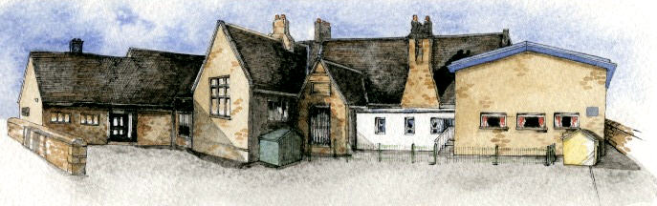
Brabin’s
Newsletter
2nd September 2021
BRABIN’S ENDOWED PRIMARY SCHOOL

  Welcome to the new school year – we hope that you all had an enjoyable summer!  We offer a special welcome to our 12 new Reception pupils. We also welcome Francesca, who has joined Y3, and Harry who has joined the Y4 class. We are sure that the pupils will settle quickly and we offer them our full support as they start their school life at Brabin’s.    Health and Safety  Please ensure that children are not left unsupervised on the playground before 8.45am. This is a safeguarding policy to ensure the children’s safety at all times.  Please also note that it is L.C.C. policy that dogs are not allowed on school grounds.  We do appreciate your support and understanding with these matters.    Covid 19  Any future changes in response to Government guidelines will continue to be reviewed and communicated to parents. School life is looking a little more ‘normal’ but we are continuing to ensure we keep our school community safe with additional ventilation and hygiene measures in place. |  |   Extra-Curricular Clubs  This half term, Mr Pearse will be delivering Basketball sessions for pupils in Y5/6 (Maximum 14 pupils). This club will take place on Mondays 3.15-4.15pm starting on 20th September until 18th October.  Please email the school office - admin@brabins.lancs.sch.uk if you would like a place. Please note that places are limited.  Absolute Futbol Sports Coaches will deliver a Yoga Club to pupils in Reception/Y1/2 on Tuesdays from 14th September – 19th October. Please book a place and pay via their website: www.absolute-futbol.org.  Future sport clubs have been planned for the academic year – these can be viewed on the link and can be booked in advance.  Please note that if your child has been booked into ASC, they will be signed in following the session.    Newsletters will continue to be available on alternate Mondays from Monday 13th September. These will be available to view on the school website and will also be emailed via Parentpay. head@brabins.lancs.sch.uk.  Please amend your account if you change your email address to ensure that you continue to receive appropriate school information. |  | 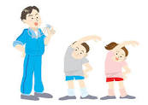  PE Days  The children will need to bring their full PE kit into school and these will be sent home regularly for washing.  Please ensure that the children wear the correct kit. Plain and simple kit without any branding.  Y5/6 Tower Wood  This visit has book booked for 9th-11th March 2022. An email and letter with further information will be sent in due course.    KS2 Swimming  Swimming lessons start on Friday 10th September.  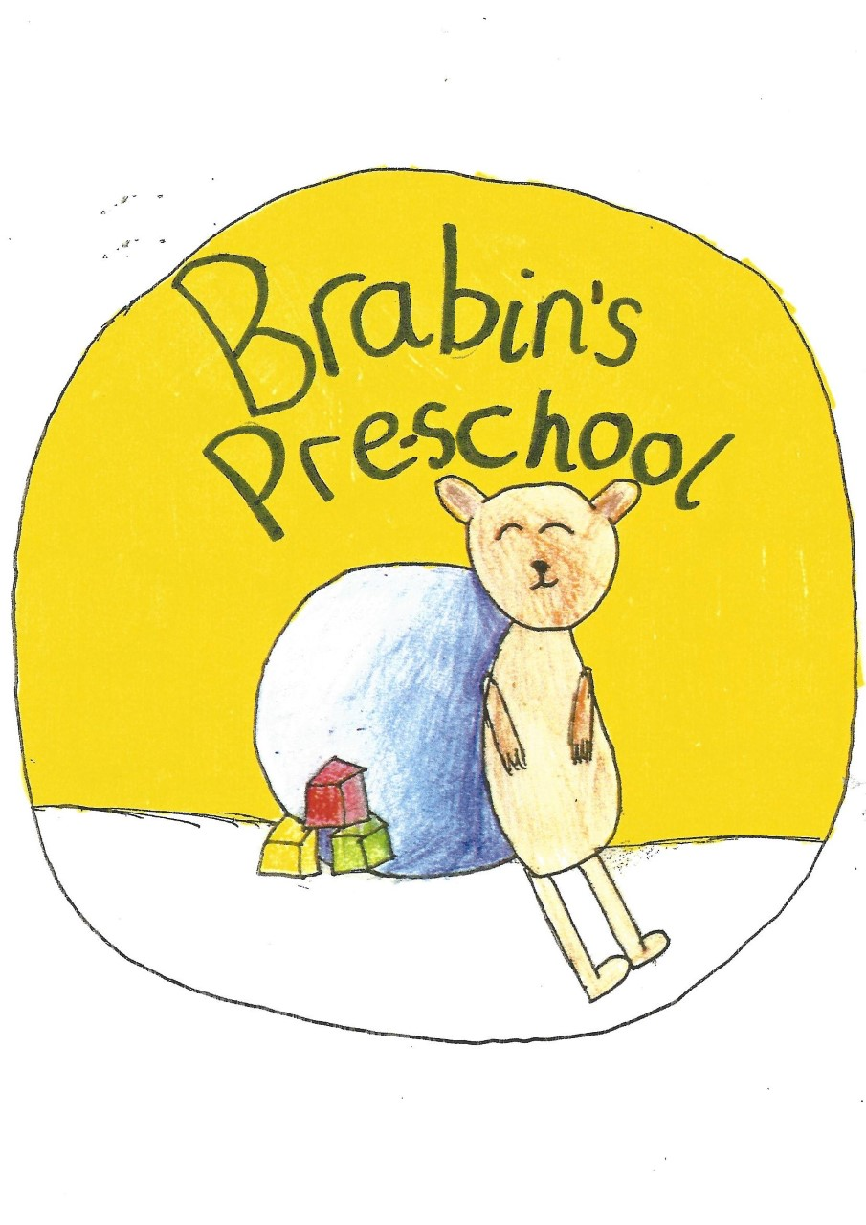  Pre-School  We have welcomed 7 pupils to our new pre-school.  I am sure they will settle quickly into their new environment and will enjoy playing in our play areas with lots of new resources.  Please contact Mrs Wallace to enquire about places as these are limited.  Office  Dinner payments for this half term are due:  37 days: £85.10  The dinner menu is available to view on the school website.

Message from The Palace Theatre Group
The Palace Theatre Group is starting again on Monday 6th September in Longridge and would love to offer your child a free trial session. The classes are for children aged between 5 to 16 years and run every Monday evening at Stonebridge Studios. It is the perfect opportunity for your child to join a friendly group of young people to work creatively in a safe space, build their confidence, develop crucial life skills and most importantly have fun. (No previous experience required). Places are limited so will be offered on a first come first serve basis. Please contact Claire for more information and to secure your space by messaging thepalacetheatregroup@hotmail.com or 07776843940 or https://www.facebook.com/palacetheatregroup

