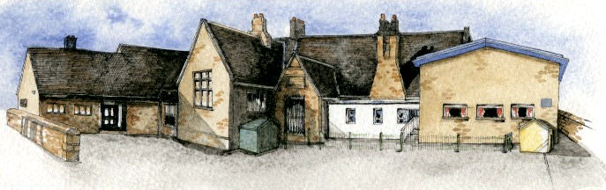

**Curriculum Shapers**

* Be Knowledgeable: develop information processing skills
* Be Adventurous: develop problem solving skills
* Be Ambitious: develop relevant attributes of learning
* Be Creative: develop creative thinking skills adapting our models and music
* Be Collaborative: develop empathy and social skills
* Be Reflective: develop reasoning skills, thinking about why something may have happened in a science experiment, how we could improve it and what we might do differently next time.
* Be Positive: Develop relevant attributes of learning, building focus and resilience.

**Key Questions**

* Why do we have teeth?
* What do the teeth do?
* How many teeth do we have? Is it the same for everyone?
* How can we care for our teeth and gums?
* What are the teeth like of other animals?
* How does this give us information about what they eat?
* How are the teeth of carnivores and herbivores similar or different? Why?
* What happens to our food once it enters our mouths?
* What happens in our bodies between eating our food and going to the toilet?
* How can music affect mood?
* Can music be used to convey mood?
* Should music be different depending on the setting?

Key Learning Overview;-

Science- Children will be able to describe the simple functions of the basic parts of the digestive system in humans and be able to identify the different types of teeth in humans and their function. They will be able to construct and interpret a variety of food chains, identifying producers, predators and prey. They will be able to describe how teeth and gums have to be cared for to keep them healthy.

Music- Children will create, practice, rehearse and present performances to an audience. They will experience how music can communicate mood using pitch, duration, tempo, textures and structure.

Art- Children will be able to plan design and make 3D models from observation or imagination. They will then be able to evaluate and adapt their work according to their views and describe how they might develop it further.

Writing Opportunities- we will write: a story based on Bill’s New Frock, a persuasive advert or sales pitch, kenning poems and create non-fiction pieces on the digestive system, teeth and food chains.

Authentic Learning outcome: A instructional video about how the digestive system works for sharing on the school website and facebook pages.

**BRABIN’S ENDOWED PRIMARY SCHOOL**

**Class: Sycamore Year 3/4 Term: Autumn 1 Cycle A Curriculum Unit –Chew to Poo**