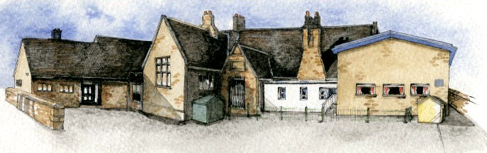

**Key Learning Overview**;-

**Science -** The children will observe and describe how seeds and bulbs grow into mature plants. They will investigate what plants need to grow and stay healthy.

**Art-** The children will observe plants and flowers and explore the detailed work of botanical artists. The children’s drawings will be developed into prints and collages.

**DT –** The children will design and make their own healthy snack using vegetables.

**Writing Opportunities**-

The children will write:

* explanation texts showing the life cycle of plants
* innovated traditional tales with a twist
* character descriptions comparing a character from a traditional tale and a twisted version of the same tale
* the recipe for their healthy snack



Class: Elm Class Year 1/2 Term: Summer

**Curriculum Unit – The World of Plants**

**Class Novel, key texts and extracts-**

Don’t Read This Book by Jill Lewis

Maximus and the Beanstalk

The Three Little Wolves and the Big Bad Pig

The True Story of the Three Little Pigs

The Wolf’s Story

Other traditional tales with a twist

Reports and information texts about plants

Explanation texts of life cycles

What do plants need to stay healthy?

What happens if a plant is grown in the dark?

What artists were inspired by plants?

What shape are leaves?

How do I make a poly print?

What is a collage? How can I create my own?

What is a healthy snack?

* Be Curious: Development a responsibility and appreciation of the environment. *Engage in first hand experiences of growing plants.
* Be Knowledgeable: Nurture a thirst for knowledge
* Be Adventurous: Experience exhilaration, challenge and achievement when growing a healthy plant
* Be Ambitious: Develop an open outlook
* Be Creative: Developing hobbies and interests (cooking/collage) *Apply skills to new situations when using collage materials
* Be Collaborative: Work with others in an interactive learning process
* Be Reflective: Make lifestyle choices in response to thoughts
* Be Positive: Manage one's own behaviour *Develop own opinions

**Curriculum Shapers**

**Key Questions**