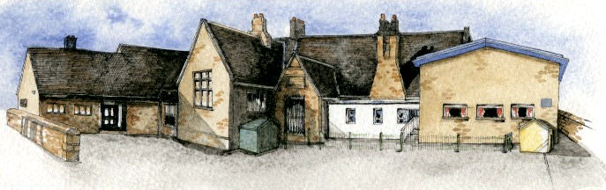

Key Learning Overview;-

**Science -** The children will identify and compare the suitability of a variety of everyday materials. They will find out how the shapes of solid objects made from some materials can be changed by squashing, bending, twisting and stretching.

**Geography-** The children will use atlases and maps to locate seaside resorts around the world and describe coastal features. They will learn about the history of Blackpool as a seaside destination and Blackpool today.

**History -** The children will look at the history of seaside holidays. They will develop an awareness of how these have changed through history, from the Victorian period to modern day.

**Art -** The children will develop their drawings of the seaside into collage and textile pieces. They will look at the work of contemporary artists who use the seaside to inspire their works of art, including Selena Hall, Abigail Mill and Jayne Huskisson.

**Writing Opportunities**-

The children will write:

* Setting descriptions based on the book Dolphin Boy
* Innovated seaside stories
* Diary entries – A day in the life of the main character
* Write poems inspired by water and the seaside
* Postcards from different periods of time (Victorian Britain, 1950s, modern day)



Class: Elm Class Year 1/2 Term: Summer

**Curriculum Unit – Seaside Holidays**

**Class Novel, key texts and extracts-**

Dolphin Boy by Michael Morpurgo

The Lighthouse keeper Stories by Ronda Armitage

Information books about seaside holidays in the past

Treasures on the Beach by Brenda Williams

Poems on the theme of the seaside

* What is the same/different between holidays now and in the past?
* Where can you go for a seaside holiday?
* What is Blackpool like today?
* What was Blackpool like in the past?
* What physical and human features can be found at the seaside?
* What materials can you find at the beach? Why?
* How have some of the materials used at the beach changed between then and now?
* What do you think of the work by the artist Selena Hall?
* Can you produce a painting inspired by Serena Hall?
* What textiles materials can I use to create a seaside scene?
* Be Curious: Ask questions to find out more about the lives of others in the past.
* Be Knowledgeable: Learn and use subject specific vocabulary. *Use your knowledge of materials in science to support your work in history recognising how things have changed.
* Be Adventurous: Work practically with a range of textiles.
* Be Ambitious: Be inspired by other artists and the natural world to create the best artwork you can.
* Be Creative: Explore alternatives in problem solving activities
* Be Positive: Consider one’s place in the world.

**Curriculum Shapers**

**Key Questions**