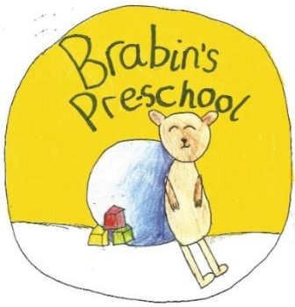
Brabin’s Pre-School
Newsletter
June 2021

Welcome to Miss Eccles  We are delighted to welcome Miss Eccles to the Brabin’s team as our Early Years Apprentice. Miss Eccles will be in the Preschool room everyday working alongside Miss Strickland.  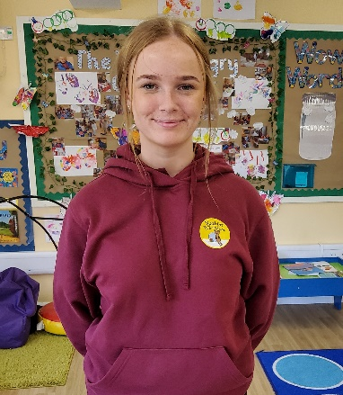    Sun Safety  It’s been lovely to see the sunshine back! We love to get the children learning outdoors so please ensure, when appropriate, that the children have a sun hat and suncream in school. Please can children also bring a water bottle.    September  Pre-school places are available for September but numbers are limited on certain days. Forms regarding hours for September have been sent home, please could you return these as soon as possible.  Please contact Mrs Wallace if you would like further information about places for the next school year. |  | Revised Early Years Framework  Staff are busy taking part in training sessions and making preparations for when the ‘Early Years Framework’ changes in September 2021. For futher information, please see the attached document.    Sports day  This will take place on Wednesday 23rd June 2021. Unfortunately, due to current guidelines, we are not able to invite parents to join us for our sports day this year but we will ensure the children still have the opportunity to take part in activities and races and enjoy the full experience! Teachers will post pictures and video clips of the races on Seesaw for you to enjoy.  Please could all children please wear appropriate footwear on this day.    Graduation  At the end of the school year will be saying goodbye to some of our children as they move up into reception class. On Tuesday the 20th July, we will be holding a special graduation ceremony followed by a party.  Unfortunately, due to current guidelines, we are not able to invite parents to join us. But dont worry, we will post videos and pictures on Seesaw for you to enjoy.
Dates For Your Diary

Sports day - Wednesday 23rd June 2021
First school taster session – Thursday 24th June 2021
Pre School Graduation Tuesday 20th July 2021

School closes on Tuesday 20th July 2021
School re-opens on Thursday 2nd September
Current topic

Our current topic at the moment is “colour”. Over the next couple of week we will be exploring colour and how it can be changed, Colours in the enviorment, and much more.



