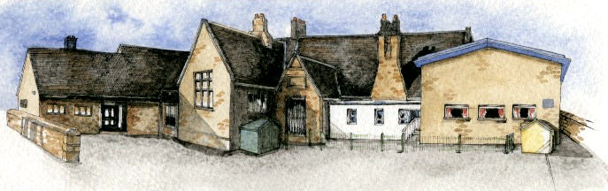

**BRABIN’S ENDOWED PRIMARY SCHOOL**

Key Learning Overview;-

Science: the children will learn about forces such as magnetism and air resistance.

DT: the children will learn all about mechanical levers and linkages.

History: the children will learn about the Great Plague, comparing our time to then and contrasting the differences.

Authentic outcomes: the children will send the diaries they have written about famous people to their chosen person via social media.

Writing Opportunities- we will write: playscripts based on the Iron Man and recounts (diaries) as well as explanation texts and non- chronological reports.

**Class: Sycamore Year 3/4 Term: Summer 2 Cycle B Curriculum Unit – The Iron Man**

Class Novel, key texts and extracts-

The Iron Man, Diaries of famous people, non-fiction pieces on the Great Plague.

**Curriculum Shapers**

**Key Questions**

What was London like in the time before the Great Fire of London in 1666?

What other sources can we use to imagine what London might have been like?

What was the plague and why was it a problem?

Why did plague spread so quickly?

What help was available?

How did people cope with being incarcerated with dying relatives and friends?

What were the plague pits and why were they necessary?

How do we know about the London Great Plague victims?

How many did it kill?

Did the plague spread outside of London? What happened at Eyam?

Does the plague still exist today? What materials are attracted to magnets?

When and where are magnets useful?

How strong are magnets?

Are all magnets the same strength?

Will a magnet attract plastic covered paperclips?

What if everything was magnetic?

How can we make objects move?

How can we stop things moving?

How can we change the movement?

How can we slow down a moving object?

Do different surfaces make a difference? What if we could only push but not pull?

* Be Curious: engage in first-hand experiences and experience contrasts between periods of history.
* Be Knowledgeable: nurture a thirst for knowledge and apply cross -curricular skills
* Be Adventurous: develop problem solving skills
* Be Ambitious: develop an open outlook
* Be Creative: develop creative thinking skills and question why
* Be Collaborative: Develop Empathy and social skills.
* Be Reflective: listen to and act on advice
* Be Positive: develop self-esteem