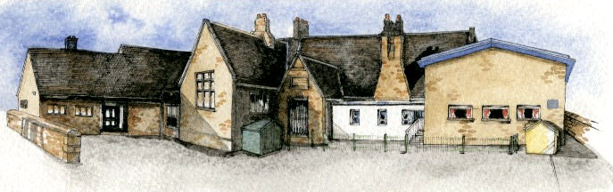

**BRABIN’S ENDOWED PRIMARY SCHOOL**

Key Learning Overview;-

Science: the children will be learning all about the habitats of animals

Geography: Enrichment day

Art: children will be using textiles to design art pieces based on the natural world

DT: children will be using their knowledge of structures to make flower pots and planters to add to the biodiversity of our environment.

Authentic Outcome: the children will decide a way that we can increase the biodiversity of our school environment and once completed send pictures and writing to a environmental organisation

Writing Opportunities- we will write: discussions that present both sides of a topic and present them in writing and verbally, and poems on a theme such as animals and our world.

**Class: Sycamore Year 3/4 Term: Summer 1 Cycle B Curriculum Unit – Animals and our world**

* How are animals / plants adapted or suited to live in our school grounds / local area?
* Why does it like it there?
* What does it eat?
* Does anything eat it?
* How many different living things are there in the world?
* What makes an animal an animal?
* Are they all the same?
* How are animals different?
* How many different animals are there?
* How do scientists group them/identify them?
* Why are some species under threat while others are not?
* What happens if we remove a species from the food chain?
* What threats are there to different habitats / ecosystems?
* How can humans help?
* Be Curious: develop a sense of responsibility for the environment.
* Be Knowledgeable: develop subject specific language around the science of animals.
* Be Adventurous: work practically to make planters.
* Be Ambitious: develop an open outlook for the world around us.
* Be Creative: develop creative thinking skills and question why
* Be Collaborative: respect the opinions of others
* Be Reflective: listen to and act on advice
* Be Positive: develop self-esteem

Class Novel, key texts and extracts-

Brer Rabbit folk tales and other stories, Peter and the Wolf, My Mother saw a dancing bear, as well as various discussion texts.

**Curriculum Shapers**

**Key Questions**