Online Safety

Keeping children safe online is a key priority for our school. We will try to keep you informed of useful sites and information, including local and national guidance. You will also find this information on the online safety section through the curriculum part of our website.
Below are some websites with useful online safety information linked to e safety:



 | www.thinkuknow.co.uk  www.ceop.police.uk/report-abuse/  www.youtube.com/ceop
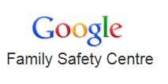 | http://www.beatbullying.org/ http://www.google.co.uk/familysafety/tools.html http://www.safenetwork.org.uk
 | www.childnet-int.org  www.education.gov.uk/ukccis
 | www.parentscentre.gov.uk  www.saferinternet.org.uk/advice-andresources/parents-and-carers/parents-guide-totechnology

