Brabin’s Newsletter
24th May 2021
BRABIN’S ENDOWED PRIMARY SCHOOL

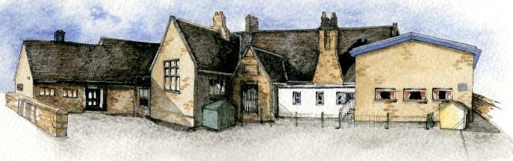

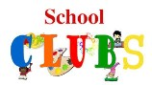  Extra-Curricular Clubs –  Summer 2  After school activities on offer during the next half term are:  STEM Club for Y3/4 pupils. This course has now been re-arranged (finally we might get to do it!) and places have been allocated to pupils who originally signed up. If your child no longer wishes to attend the club, please inform the office so places can be reallocated. 5 sessions on, Mondays 3.15-4.15pm (14th June – 12th July 2021).  Y5/6 Sports Club - Thursday  Reception, Y1/2 Sports  Club- Tuesday  A letter has been emailed with further information  regarding the sports clubs.  Parents need to sign up and pay the sports company  directly. School will subsidise 50% of the cost.  French – September 2021 Unfortunately, there was little interest shown regarding a French after school session during the summer term. We will send booking forms to sign up for September in the near future, but this will be dependent on numbers. |  | Latest Dfe guidance relating to school attendance  “School attendance continues to be mandatory for all pupils  and the usual rules on school attendance apply. This  includes parents’ duty to  ensure their child regularly  attends school, and schools’  and local authorities’ ability to issue sanctions, including fixed penalty notices, for poor  attendance." (DfE Guidance  issued to schools, May 2021)  We appreciate it has been a very difficult year, but, as  usual, we would appreciate it if families avoid taking their  children out of school during term time.  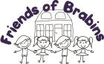  Obviously, there has been little opportunity to hold fundraising events recently.  As we are raising funds to update our outdoor play areas, we would appreciate your support!  The first event is our virtual balloon race- please see the flyer sent separately. The closing date is Thursday 27th May. The winning balloon wins a family hamper.  Further events to follow! |  | School Office  Dinner payments are now due:  £78.20 Milk - reminder for R & KS1 children to order milk for September. Letter sent out via Parentpay 14th May.  Please ensure that all dinner money and Afterschool payments are up to date before we finish for half term.  Number Fun Day  We raised £152.69  Thank you for your support!  Star of the Week  14th May  Reception: Aurora B  Y1/2: Mia T  Y3/4: Thomas V Y5/6: Emma  21st May  Reception: Hettie J  Y1/2: Kenny H  Y3/4: Issac W Y5/6: George  Headteacher Award: Phoebe J,  Tommy W and Archie F  Kindness Award: Isaac M
What we’ve been learning in school:
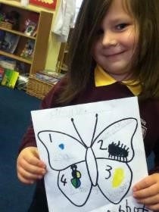
Reception Class- Willow Class
Reception Class have loved learning all about the life cycle of a butterfly. They have used vocabulary such as chrysalis and metamorphosis. The children created their own life cycle using collage and felt tips. “Out of the egg comes a caterpillar,” Izabelle.
“The butterfly has wings and can fly,” Xander.
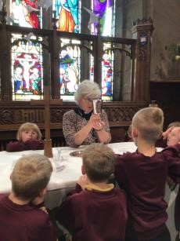
Y1/2 – Elm Class
The children in Elm Class enjoyed visiting St. Bartholomew's Church and having a guided tour with Rev. Fiona. The children learnt about the features of a church and some of the history of St. Bartholomew's.
Scarlett - People can get Christened at the font.
Hamish - I found out that there are symbols on the font. Mia - I really liked learning about the church.

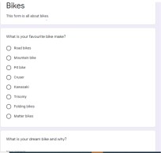
Y3/4- Sycamore Class
In Computing lessons, Year 3/4 we have been learning how to create online forms to gather information using Google Forms.
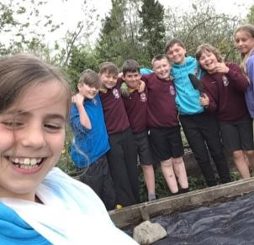
Y5/6 – Oak Class
Over the past few weeks, year 5/6 have been very busy helping to tidy and clear the garden. They are excited to get planting again!

Diary Dates:

Monday 24th May Tri Golf coaching sessions – Y5/6
Tuesday 25th May Creepy Crawly Workshop for Reception pupils Y3/4 Tennis skills competition
Half term holiday: Monday 31st May-Friday 4th June Inset Days: 7th and 8th June

School re-opens on Wednesday 9th June 2021

