What we’ve been learning in school:
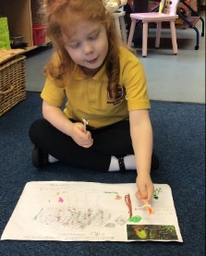
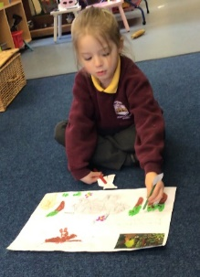
Reception Class- Willow Class We have been reading the story, ‘Monkey Puzzle’ linked to our author study on Julia Donaldson. The children have created their own story maps and props to retell the story using their own ideas.
“No no no that’s not mum, her tail coils around trees,” Coral. “Yes yes that is my mum,” Jack. “No no no that’s not my mum, my mum looks like me,” Aurora.
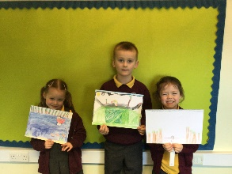
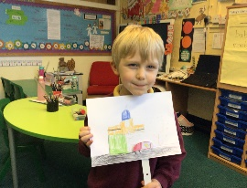
Y1/2 – Elm Class
Hamish - We made a Wind in the Willows moving picture. It was tricky getting the picture for the moving part the right size.
Ava - We made our pictures move left and right, using sliders.
Louie - We used card and card levers to make our moving pictures. We had to draw the pictures and colour them in.

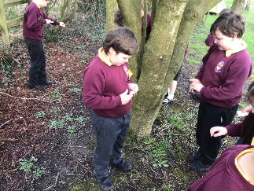
Y3/4- Sycamore Class
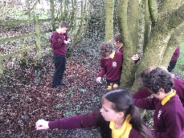
In Sycamore class, we have been making plans as an Eco Committee and coming up with ideas to help the environment in school. We have begun by planting a wildflower garden near the Mini beast house on the field.

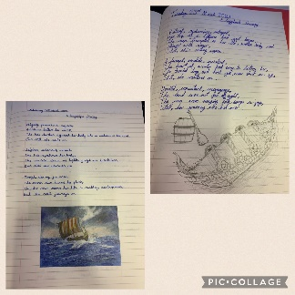
Y5/6 – Oak Class
To finish off our history topic on Anglo Saxons and Vikings, the children have been working hard to create a poem all about a Longship’s Journey. We are very proud of what we have created!

Diary Dates:

Thursday 15th April | U9’s Football Skills Competition – separate letter
Tuesday 27th April | Y2 Mini Skills Competition - pm
Monday 3rd May | Bank Holiday Monday – School Closed
Friday 7th May | NSPCC Number Fun Day – whole school. More information to follow.
Wednesday 19th May | Whole School Storytelling Day
Half term holiday: Monday 31st May-Friday 4th June
Inset Days: 7th and 8th June
School re-opens on Wednesday 9th June 2021

