BRABIN’S ENDOWED PRIMARY SCHOOL  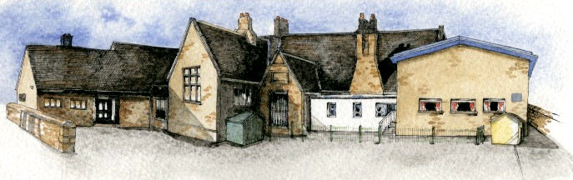 | Year 3/4 Creative Curriculum Overview 2020/2021

 | Reuse, Reduce, Recycle | Ancient Egypt | Human Fuel | Rotten Romans | Animals and our World | The Iron Man
Term  Weeks | Autumn 1  7 weeks | Autumn 2  8 weeks | Spring 1  6 weeks | Spring 2  6 weeks | Summer 1  5 weeks | Summer 2  5 weeks
Kick start, visit or visitors | Visit a recycling centre | Egyptian museum |  | Ribchester visit | Walk around local area
Authentic Curriculum outcomes  (Ideas) | The children will create some how to guides, explaining how people can reuse household items for useful things that will be published as a eBook (Geography/ Art/ Computing/ English) | Musical performance in an assembly/ class/recording for the website.  (Music) | Children can organise and cook a meal at home for their families and share their outcomes online (class page) and in school.  (DT) | The children will use what they have learnt to create a booklet about the romans which will include their artwork and non-chronological reports which will be sent to the Roman Museum in Ribchester. Could also be published as an eBook.  (History/ English) | The children will decide a way that we can increase the biodiversity of our school environment and once completed send pictures and writing to an environmental organisation.  (Science and Geography) | The children will send the diaries they have written about famous people to their chosen person via social media.  (English)
Class Novels | Why the Whales Came | Charlotte’s Web | A selection of Aesops Fables | The Lion, the Witch and the Wardrobe | Brer Rabbit Stories | The Iron Man
Reading/ other key extracts and texts | Macavity the Mystery Cat, The Pied Piper, Cinderella, Little Red Riding Hood, Goldilocks, Hansel and Gretel | Mousehole Cat, The Waterhorse, Water Dance poem | Aesops Fables, Georges Marvellous Medicine, Shape poems and Calligrams | Horrible Histories (Rotten Romans), Roman non fiction, Romans on a Rampage, Play time by Julia Donaldson | Brer Rabbit Folk Tales, Peter and the Wolf, My mother saw a dancing bear. | Diaries of famous people, Non fiction about the Great Plague
English | Fairy Tales  Classic Narrative Poetry (Performance Poetry)  Recount: Newspapers | Novel as a theme (based on Charlotte’s Web)  Non-chronological report | Fables  Poems with a Structure (Shape, Calligrams and concrete)  Persuasion Letters | Myths (Romulus and Remus and other Roman myths)  Explanation texts | Discussions: For and Against  Poems on a theme: Animals and our World | Playscripts  Recounts: Diaries
Maths
Science | Sound | States of Matter | Healthy Lifestyles and Nutrition | Investigations | Habits and animals | Forces
Computing | Coding- Programming an animation | Digital images- manipulating images |  | Audio- producing digital music | Opinion pollsters- collect and analyse data | Network engineers- explore computer networks.
RE | Called by God  Harvest | Christmas  Light | What is prayer?  Non christian faith | Easter- betrayal and trust  No Christian- trust | Are all churches the same? | Are all places of worship the same?
PSHE

PE | Invasion games  Swimming | Invasion games  Swimming | Gymnastics  Invasion games | Dance  Invasion games | Athletics  Striking and fielding | Athletics  Striking and fielding
French | Travel | Travel | Growing things | Growing things | Pocket money | Pocket money
History |  | Ancient Civilisations (Egyptians) |  | Romans in Britain |  | The Great Plague
Geography | The Environment (Reduce, Reuse, Recycle) |  | Rivers |  | Enrichment
Art | Junk modelling and Natural sculptures |  |  | Roman Art/ Mosaics | Textiles and the natural world
DT |  |  | Food Product for a purpose  Eatwell plate |  | Structures and support | Mechanical Systems- Levers and Linkages
Music |  | Musical Notation  Glockenspeil 2 (notation and performing) |  | Film score and trailers (Iron Man)
Links to British Values /Global Learning

