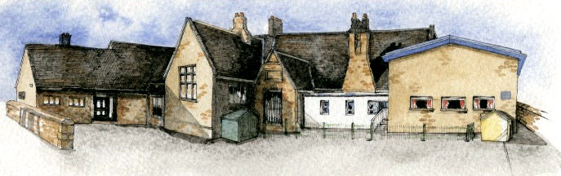

**Writing Opportunities**-

The children will write:

* Innovated animal stories based on Wind in the Willows
* Character Descriptions
* Instructions for their puppets
* New verses to make their own poems

**Key Learning Overview;-**

**Science -** The children will learn about the different habitats found in the story Wind in the willows. They will explore the different animals that live there and how they adapt to live in their environments. They will also learn about food chains.

**DT -** The children will design and make their own animal finger/hand puppet based on a character from the story.

**Music -** The children will listen with purpose to music for the book by the composer John Rutter. They will choose percussion instruments to match the characters of the story.



Class: Elm Class Year 1/2 Term: Summer

**Curriculum Unit – Wind in the Willows**

**Class Novel, key texts and extracts-**

The Wind in the Willows by Kenneth Williams

Extracts of stories by Dick King Smith

Different examples of instructions – including finger puppets and shadow puppets

Poetry

What is a habitat?

What habitats can be found around our school/in ‘The Wind in the Willows’?

How does an animal adapt to their environment?

What is a food chain?

How do you make a template for a puppet?

How can you join two pieces of felt together?

What is the best way of joining felt together to make a puppet?

What is good about my puppet?

How could I improve my puppet?

* Be Curious: Engage in first hand experiences *Develop an understanding and responsibility for the environment
* Be Knowledgeable: Observe and record findings
* Be Adventurous: Work in the real world with first-hand experiences *Work practically
* Be Ambitious: Strive for improvement when making a puppet
* Be Creative: Apply new skills to new situations *Explore alternatives in problem solving situations *Question ‘What if ..?
* Be Collaborative: Work with others to sing songs and produce music
* Be Reflective: Evaluate their own puppets to make improvements
* Be Positive: Secure and articulate preferences

**Curriculum Shapers**

**Key Questions**