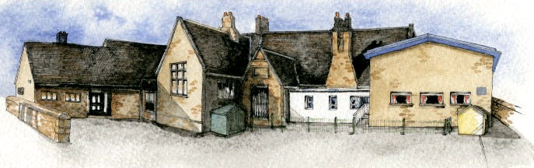

**Writing Opportunities**-

The children will write

* an innovated story based on the book Man on the Moon (A Day in the Life of Bob)
* character profiles
* recounts of the Apollo 11 space mission
* letters in role as Christopher Columbus
* non-chronological reports about Mugurameno.

Key Learning Overview;-

**Science –** The children will continue to observe changes to the weather across the half-term.

**Geography-** Thechildren will learn about Mugurameno village in Zambia. They will find the country and continent in which it is located. The children will ask simple geographical ‘where’ , ‘what’ and ‘who’ questions about Mugurameno. They will explore what the lives of children will be like in this area and compare the human and physical features of Mugurameno to the features of Chipping.

**History** **-** The children will learn about the explorers Christopher Columbus and Neil Armstrong. They will identify similarities and differences between their lives.

**Computing –** The children will learn to write instructions to programme a toy and things on screen.



Class: Elm Class Year 1/2 Term: Spring

**Curriculum Unit – Great Explorers**

**BRABIN’S ENDOWED PRIMARY SCHOOL**

**Class Novel, key texts and extracts-**

Man on the Moon (A Day in the Life of Bob), Bob’s Best Ever Friend and Bob and the Moon Tree Mystery

by Simon Bartram

Where the Wild Things Are by Maurice Sendak

Extracts and reports about the Apollo 11 Space Mission

Fact files about Mugurameno

* Be Curious: Invoke a sense of awe and wonder
* Be Knowledgeable: Develop subject specific language *Manage, receive, record and apply information
* Be Adventurous: Experience exhilaration, challenge and achievement
* Be Creative : Apply programming skills to new situations
* Be Reflective: Move towards the understanding of a wide range of feelings (success/failure, apprehension, anticipation)
* Be Positive: Secure and articulate preferences

What is an explorer?

Who was Christopher Columbus? Why is he still remembered today?

Who was Neil Armstrong and what is he famous for?

Where in the world is Mugurameno?

What are the similarities and differences between Chipping and Mugurameno?

**Curriculum Shapers**

**Key Questions**