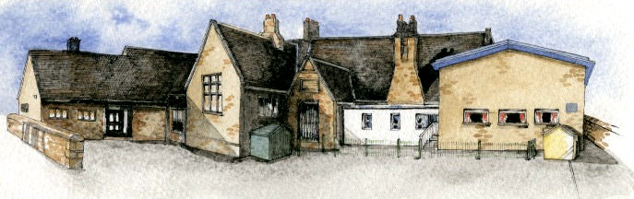

Writing Opportunities- we will write: myths based on Roman myths (such as Romulus and Remus), and explanation text and non-chronological reports about Rome.

Key Learning Overview;-

Science: the children will take part in different investigations learning how to work scientifically.

History: the children will be learning about Romans in Britain and how they changed the UK.

Art: the children will develop their collage skills looking at Roman Art and Mosaics.

Music: the children will be learning about film scores and soundtracks.

Authentic outcomes: the children will use what they have learnt to create a booklet about the romans which will include their artwork and non chronological reports which will be sent to the Roman Museum in Ribchester.

**BRABIN’S ENDOWED PRIMARY SCHOOL**

**Class: Sycamore Year 3/4 Term: Spring 2 Cycle B Curriculum Unit – Rotten Romans**

Class Novel, key texts and extracts- The Lion the Witch and the Wardrobe, Horrible History Rotten Romans, Roman non-fiction books.

**Curriculum Shapers**

**Key Questions**

Why was Rome so powerful?

Why did the Romans want to invade Britain?

What buildings and events did the Romans introduce to Britain?

How significant were the Romans for Britain?

Why did the Roman Empire fall?

How did the Roman invasions change the way people lived, traded and socialised?  
How did the Roman invasions affect the cultural development of Britain?  
What were the political issues surrounding the invasion?

What effects did the Roman invasions have?  
How did the Roman invasions change the British landscape?

Can children identify adjectives to describe how the music sounds to them? Do these words reflect what a good trailer should be like? What is the purpose of a film trailer?

Can children list the instruments they can hear throughout the examples?

Can children respond to the speeds of the music, stating whether each excerpt is slower or faster than the previous one?

Can they describe whether melodies are long and sustained or short and disjointed?

Can they discuss the dynamics (volume) of the music using musical terms?

* Be Curious: engage in first-hand experiences and experience contrasts between periods of history.
* Be Knowledgeable: nurture a thirst for knowledge and apply cross -curricular skills
* Be Adventurous: develop problem solving skills
* Be Ambitious: develop responsibility for ones own learning
* Be Creative: develop creative thinking skills and question why
* Be Collaborative: work as a team to complete scientific investigations
* Be Reflective: listen to and act on advice
* Be Positive: develop self-esteem

**Prior Knowledge**