
Brabin’s
Newsletter
8th February 2021
BRABIN’S ENDOWED PRIMARY SCHOOL

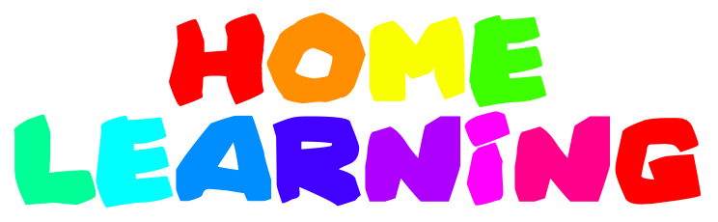  Thank you to parents for your continued efforts in supporting your children with their remote learning. We realise how difficult it can be but you’re doing an amazing job and as a result, your children are continuing to make good progress with their learning.  We would be grateful to know in advance, wherever possible, if your child is not going to attend a given session as registers are taken, just as during a normal school day. If you’re struggling with an online session for any reason, please just contact school and we will assist.  Online engagement is excellent - fantastic, keep it up!    School Support  Please contact school if you feel that your child would benefit from an encouraging call from their class teacher. We are here to support in any way we can!  Thank you for your messages of support, they really lift us! |  |   Parents Evening  Once again, we are offering telephone appointments this term. These will take place the week commencing, Monday 1st March 2021.  The focus of the meeting will be to discuss your child’s progress during the autumn term and to share the next steps when the children return to school. This will also be an opportunity to share any concerns arising.  A letter will be emailed with further information and details regarding booking an appointment.  Half term Holiday  Monday 15th -19th February 2021. Inset day: Monday 22nd February. (Parents Inset Day focus- rest and well-being!)  Remote Learning will recommence on Tuesday 23rd February 2021.  Enjoy the holiday- you have all earned it! Let’s hope the weather is kind and we can all get outdoors. |  | Celebration Corner  We want to celebrate through the newsletter some fabulous work/ achievements whilst remote learning… Xander (R) has had a fantastic attitude and regularly shares his ideas.  Gracie (R) has worked hard in our online lessons and produced some super writing in the Phonic sessions.  Evie (Y1)- working incredibly hard and responding to feedback.  Scarlett (Y2)- engaging well in lessons and sending lots of great work.  Eli & Kaiden (Y3) have produced fantastic fables.  Scarlett U (Y4) has produced a detailed and interesting Geography project.  Eden (Y6)- for great enthusiasm and an innovative and creative approach to her home learning.  Emily (Y5) - for a mature attitude to her home learning. She’s never afraid to ask a question which can help her learning!  Fantastic – well done and keep up the good work! We will celebrate some more achievements in the next newsletter as there is lots of great work going on at home! I would also like celebrate and thank the teachers and school staff for all their hard work and commitment to the school this half term. They have been working extremely hard and I’m proud of each and every one of them.

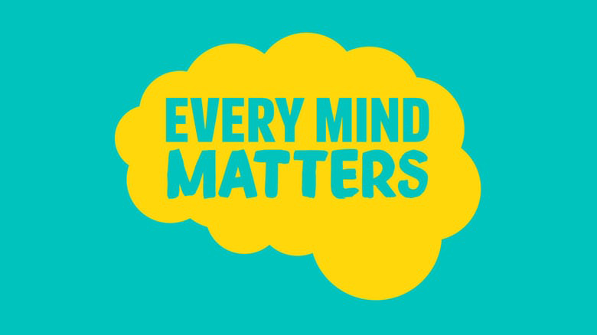

Every Mind Matters Campaign
There are things we can all do to look after our mental wellbeing. ‘Every Mind Matters’ can get you started with a free NHS online plan, showing you simple steps to help manage anxiety, to sleep better and boost your mood.
Get your own Every Mind Matters mental health action plan here:
https://www.nhs.uk/oneyou/every-mind-matters/your-mind-plan-quiz/
The latest ‘Better Health Every Mind Matters’ campaign provides lots of advice on
specific issues such as anxiety, low mood, stress, sleep and
Coronavirus. The advice is for everyone - parents, children and young people.
https://www.nhs.uk/oneyou/every-mind-matters/

