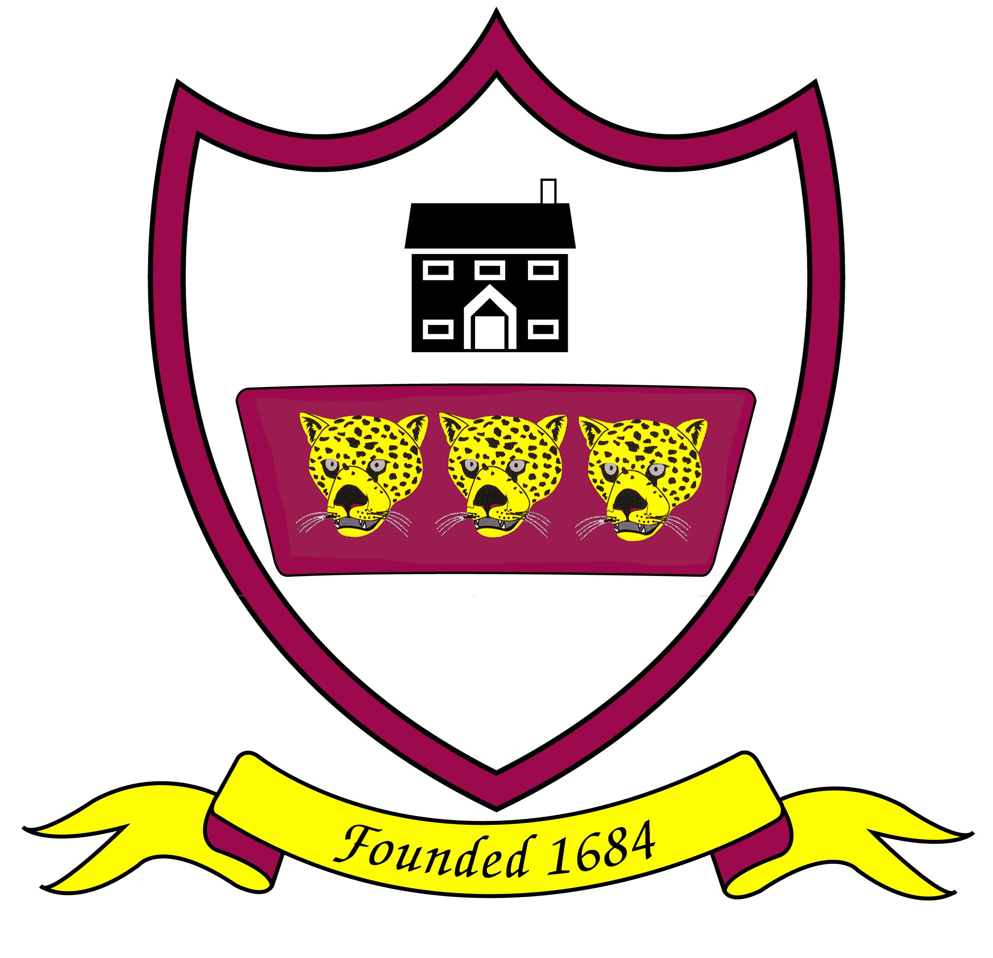
Brabin’s Endowed Primary School

Remote Learning Agreement
(Keeping Safe Online)

During the school closure, we will expect all pupils (supported by parents) to:

- Only use accounts provided by Brabin’s for school purposes as directed by my teacher.
- Only use technology when there is an adult in the house and they know I am using it.
- Keep my passwords secure.
- Be responsible for my behaviour and actions when using technology, including the resources I access and the language I use.
- Make sure that all my communication with students, teachers and others using technology is responsible and sensible.
- Not to deliberately browse, download, upload or forward material that could be considered offensive or illegal. If I accidentally come across any such material I will report it immediately to my teacher or my parent.
- Understand that when using applications provided by the school that my use can be monitored and logged and be made available to my teachers.

During Microsoft Team Sessions:
- I will not record or take photos/screenshots of my classmates or teachers during video sessions.
- I understand that Teams is an extension of the classroom and that I should conduct myself as I would in a classroom environment. This includes: taking part in a team’s meeting in an environment that is safe, quiet and free from distractions
- Being on time for the virtual meeting being dressed appropriately for learning
- Remaining attentive during sessions.
- Interacting patiently and respectfully with your teachers and peers.
- Not recording each other’s online interactions.
- Finishing the session when your teacher instructs you to do so.

I understand that these rules are designed to keep me safe and that if they are not followed, school staff will alert my parents and sanctions may be applied if necessary in line with the school’s behaviour policy.

